About the FDA

The Food and Drug Administration has been both helpful and harmful concerning the safety of the current anthrax vaccine. On the one hand, the FDA detected the squalene (also called MF59) contamination in the 5 lots of anthrax vaccine in parts per billion (ppb) at Dover Air Force Base, in October of 2000, and had those bad lots quarantined. Unfortunately, soldiers were already becoming severely ill as documented in Dr. Walter Schumm’s article in Medical Veritas, vol. 1, of 2004, titled “Anthrax vaccine and Gulf War illness symptoms in Captain Jean Tanner’s Dover Air Force Base survey” (163-5). In 2005, the FDA also stated that five more people’s deaths can be attributed to the anthrax vaccine, bringing the total number up to 21 people who have died since 2000 from the anthrax vaccine; and, 5,120 people have reported adverse reactions (via Vaccine Adverse Event Reporting System) from the anthrax vaccine since the early 1990s. These numbers only include those who have taken the initiative to report their reactions. We do not know how many adverse reactions go unreported. The FDA inspected Bioport’s anthrax vaccine plant on 4 separate occasions. Bioport failed these inspections, and after dozens of violations (such as unknown particulates, temperature violations, tampering with expiration dates on labels, potency levels, and more) went uncorrected, the plant was shutdown in 1999. The American public, especially our military members, are grateful for the FDA’s role in these safety measures that were taken concerning the anthrax vaccine.

On the other hand, the FDA allowed Bioport to continue using the old “harvester” to make the new lots of anthrax vaccine when Bioport’s plant reopened in January of 2002 which could result in continued problems with the vaccine, according to Dr. Meryl Nass. The FDA has not actively checked new lots of anthrax vaccine for unknown particulates, contaminants, for proper potency levels, and the like. Rather, Bioport is responsible for checking its own product and submitting those tests which do pass to the FDA. It is as though the fox is guarding the hen house, because the FDA is trusting a company with a history of problems to maintain sterility, quality and potency standards. According to Dr. Meryl Nass, the FDA allows the anthrax vaccine to be put through a very fine sieve for sterilization rather than using the more effective method of heat-sterilization. Therefore, safety measures to prevent these many dangers from wreaking further havoc have not been put into place. Has the FDA investigated the squalene contamination to reveal who actually put the squalene in those 5 lots of anthrax vaccine? No. Has the FDA investigated why the squalene was found in incremental dosages, which immunologist Dr. Pamela Asa stated was clearly “a dose range experiment”? No. Most importantly, in the face of these tragic deaths and vaccine injuries, the FDA has not revoked the license of the current anthrax vaccine.

In fact, after the deadly side-effects of Vioxx, Celebrex, and certain anti-depressants came to light, the FDA now appears to be negligent in ensuring the safety of many new drugs. One of the news articles below states the Department of Defense Joint Vaccine Acquisition Program Product Management Office received permission to put new biological drugs and vaccines on a “fast-track” through the FDA. Is the FDA protecting the American people or the pharmaceutical and biologics companies? Read the information on the FDA below and come to your own conclusions.

Perhaps, when concerned citizens start calling for accountability, Congress will put an oversight group in place to protect troops from the tainted anthrax vaccine. Protecting our Guardians has strongly urged Congressional leaders to introduce draft legislation regarding the need for a Congressional oversight group to numerous Senators and Congressmen in June of 2005.

FDA says Anthrax vaccine is safe and effective, even against inhalation:
http://www.foxnews.com/story/0,2933,178890,00.html
FDA: Anthrax Vaccine Given to Military is Safe, Effective
Thursday , December 15, 2005
WASHINGTON — The Food and Drug Administration on Thursday confirmed its previous finding that the anthrax vaccine being given to members of the U.S. military is safe and effective.
The drug has been at the center of a multiyear lawsuit that began when six members of the military challenged the Pentagon's use of a mandatory vaccination against anthrax in some military troops.
Published in the Federal Register Thursday, the FDA review on the Anthrax Vaccine Absorbed, or AVA, "determines AVA to be safe and effective and not misbranded."
FDA spokeswoman Julie Zawisza said the agency found no evidence to alter its previous determination that the vaccine was safe.
"We believe the vaccine is safe and effective for intended use, which would include (prevention of) inhalation anthrax," she said. The agency also received public comments about the vaccine, but Zawisza was unable to characterize them Thursday.
Since 1998, 1.2 million troops have been vaccinated against anthrax in six-shot regimens. Hundreds of service members had been punished or discharged for refusing them until U.S. District Judge Emmet Sullivan in December 2004 suspended the vaccinations after he found fault in the FDA's process for approving the drug. Several months later Sullivan said the Pentagon can resume giving vaccinations, but only to troops who volunteer for them.
Thursday's findings were the result a court-ordered review of the drug.
Earlier this month, the Bush administration appealed to reinstate mandatory inoculations for many military personnel.
Dr. William Winkenwerder, Assistant Secretary of Defense for Health Affairs, released a statement saying the military will continue to provide anthrax vaccines on a voluntary basis. Service members will still be able to refuse the vaccines.
"The threat of anthrax as a weapon remains real. It is very important to provide our service members with maximum protection against this threat, particularly when operating in certain areas of the world," he said.
He added that, "For people at increased risk of exposure, the benefits of the vaccine far outweigh the risks when all factors are considered. Vaccination against anthrax is the best round-the-clock protection available to protect our forces at risk."

FDA and Anthrax vaccine’s EUA:

Authorization of Emergency Use of Anthrax Vaccine Absorbed for Prevention of Inhalation Anthrax by Individuals at Heightened Risk of Exposure Due to Attack With Anthrax Availability

Federal Register
Vol. 70, No. 21/Wednesday, February 2, 2005

Department of Health and Human Services

Food and Drug Administration

[Docket No. 2005N-0040]

Agency: Food and Drug Administration, HHS
Action: Notice

Summary: The Food and Drug Administration is announcing the issuance of an Emergency Use Authorization (EUA) (TheAuthorization) for Anthrax Vaccine Absorbed (AVA) for prevention of inhalation anthrax for individuals between 18 and 65 years of age who are deemed by the Department of defense (DoD) to be at heightened risk of exposure due to attack with anthrax. FDA is issuing this Authorization under the Federal Food, Drug, and Cosmetic Act (the act) , as requested by DoD.

Dates: The Authorization is effective as of January 27,2005. (p.5452)

Individuals subject to the vaccination program may be informed that their military and civilian leaders strongly recommend anthrax vaccination, but such individuals may not be forced to be vaccinated. In addition, the issue of mandatory vaccination will be reconsidered by DoD after FDA completes its administrative process, which DoD expects to occur later this year. (p. 5455)

FDA’s CBER Head states No Data on Long-term Effects of Anthrax vaccine:

Kathryn Zoon, the head of the FDA’s Center for Biologics Evaluation and Research, pointed out in a letter from May of 1998 that data on the long-term side effects for this vaccine have never been submitted to the FDA.
http://www.dallasnw.quik.com/cyberella/Anthrax/nass4_29oral.htm

FDA-approved Ingredients?:

- According to the US Government Material Data Safety Sheet, formaldehyde, a principal component of the anthrax vaccine, is not approved for human consumption.

- Another component, benzethonium chloride, is not approved for human consumption.

- Aluminum hydroxide is another component. Dr. Meryl Nass has noted that the aluminum and the large number of shots required (six in the series plus an annual booster) could have a cumulative effect that makes the anthrax vaccine more dangerous than others. http://www.dallasnw.quik.com/cyberella/Anthrax/DOD_answ.html
…more below
Letter from HHS on FDA Letterhead addresses deviations within DoD’s vaccine immunization program for biological warfare defense:

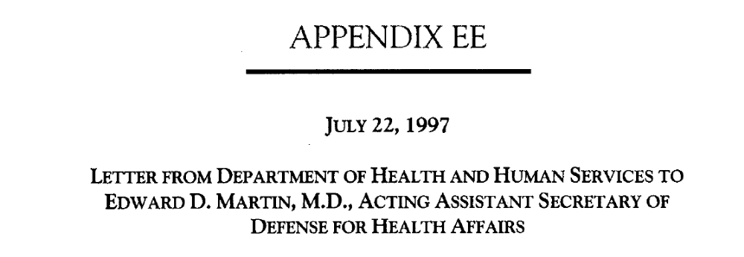

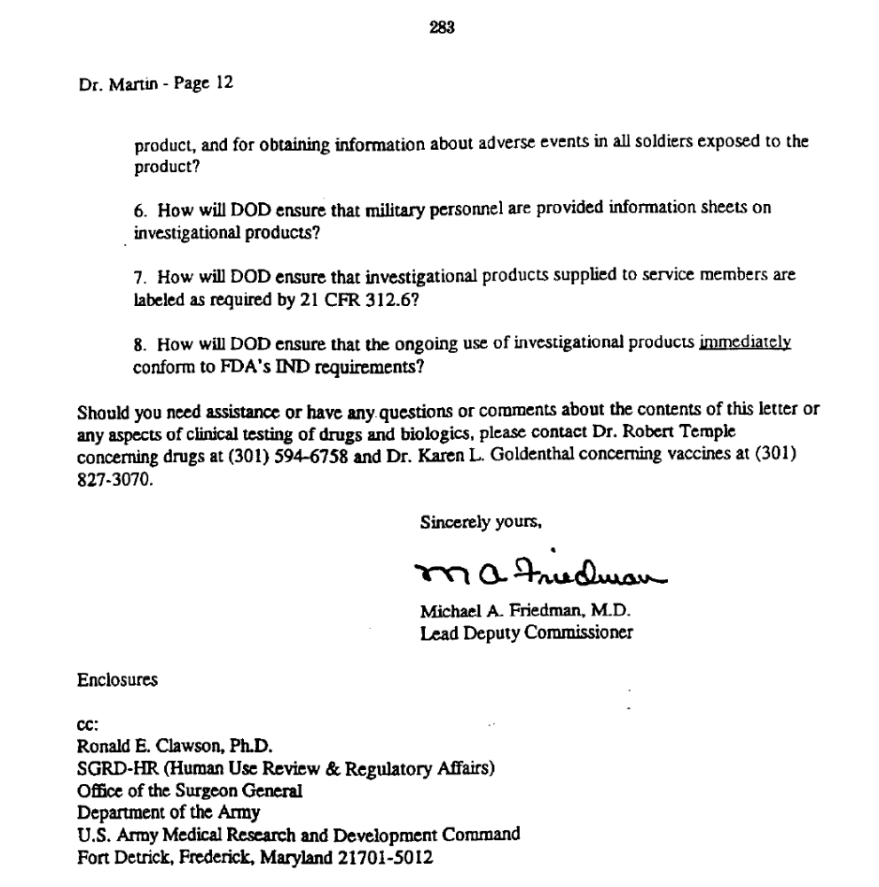

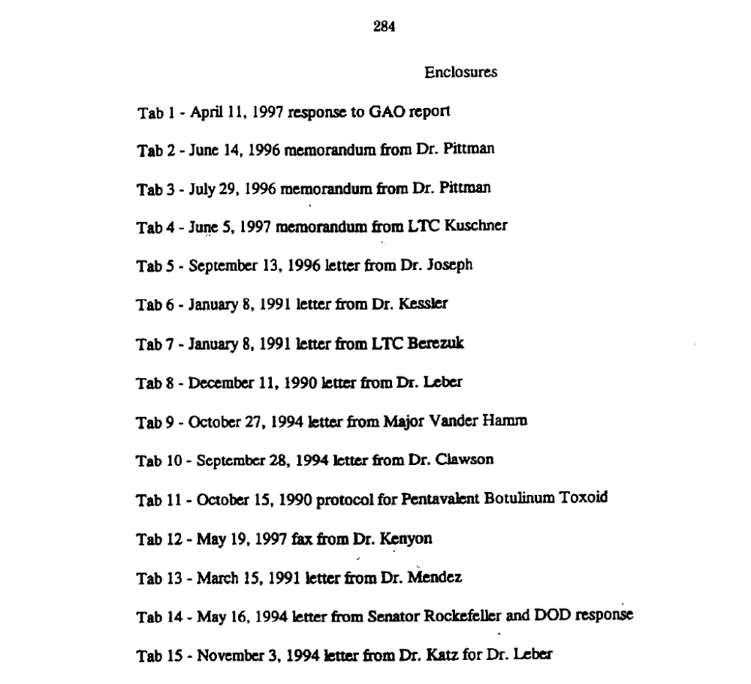
Some articles on problems within FDA:

FDA Official Defends Agency’s Safety Role

Friday, November 19, 2004

Associated Press

WASHINGTON – An official of the Food and Drug Administration said Friday “we categorically reject” accusations the agency has done a poor job of protecting the public against dangerous drugs.

“All the drugs that are on the market have risks,” asserted Dr. Steven Galson, acting director of the FDA’s Center for Drug Evaluation

Dr. Sidney Wolfe, health research director for Ralph Nader’s watchdog group, Public Citizen, said Friday he believes many more physicians and others at FDA should have the opportunity to air their concerns about drugs on the market.

The committee chairman, Sen. Charles Grassley, told the hearing he believes an independent board of drug safety may be necessary to ensure the safety of medications after FDA approval.

An “awful lot of red flags” were raised before Vioxx was withdrawn, said Grassley, R-Iowa., and the agency disdained, rather than listened to, its own reviewers.

Graham contended that FDA has an inherent conflict of interest that triggers “denial, rejection and heat”: when safety questions emerge about products it has approved.

In his testimony, Graham said the FDA’s Office of New Drugs unrealistically maintains a drug is safe unless reviewers establish with 95 percent certainty that it is not. That rule does not protect consumers, Graham told the Senate committee. “What it does is it protects the drug,” he said.
Testimony of David J. Graham, MD, MPH, November 18, 2004

(excerpts)
“My name is David Graham, and I am pleased to come before you today to speak about Vioxx, heart attacks and the FDA. By way of introduction, I graduated from the Johns Hopkins University School of Medicine, and trained in Internal Medicine at Yale and in adult Neurology at the University of Pennsylvania. Over my 20 year career in the field, all of it at FDA, I have served in a variety of capacities. I am currently the Associate Director for Science and Medicine in FDA’s Office of Drug Safety.”

“Today, in 2004, you, we, are faced with what may be the single greatest drug safety catastrophe in the history of this country or the history of the world. We are talking about a catastrophe that I strongly believe could have, should have been largely or completely avoided. But it wasn’t, and over 100,000 Americans have paid dearly for this failure. In my opinion, the FDA has let the American people down, and sadly, betrayed a public trust.” (reference to Vioxx)

“It is important that this Committee and the American people understand that what has happened with Vioxx is really a symptom of something far more dangerous to the safety of the American people. Simply put, FDA and its Center for Drug Evaluation and Research are broken. Now, I’m sure you have read the recent proposal to have the Institute of Medicine perform a review of CDER and its drug safety program and make recommendations for fixing things up. Don’t expect anything meaningful or effective from this exercise.”

“The organizational structure within CDER is entirely geared towards the review and approval of new drugs. When a CDER new drug reviewing division approves a new drug, it is also saying the drug is “safe and effective.” When a serious safety issue arises post-marketing, their immediate reaction is almost always one of denial, rejection, and heat. They approved the drug so there can’t possibly be anything wrong with it. The same group that approved the drug is also responsible for taking regulatory action against it post-marketing. This is an inherent conflict of interest. At the same time, the Office of Drug Safety has no regulatory power and must first convince the new drug reviewing division that problem exists before anything beneficial to the public can be one. Often, the new drug reviewing division is the single greatest obstacle to effectively protecting the public against drug safety risks. A close second in my opinion, is an ODS management that sees its mission as pleasing the Office of New Drugs.”

“The corporate culture within CDER is also a barrier to effectively protecting the American people from unnecessary harm due to prescription and OTC drugs. the culture is dominated by a world-view that believes only randomized clinical trials provide useful and actionable information and that post-marketing safety is an afterthought. This culture also views the pharmaceutical industry is it supposed to regulate as its client, over-values the benefits of the drugs it approves and seriously under-values, disregards and disrespects drug safety.”

“Finally, the scientific standards CDER applies to drug safety guarantee that unsafe and deadly drugs will remain on the US market. When an OND reviewing division reviews a drug to decide whether to approve it, great reliance is placed on statistical tests. Usually, a drug is only approved if there is a 95% or greater probability that the drug actually works. From a safety perspective, this is also a very protective standard because it protects patients against drugs that don’t work. The real problem is how CDER applies statistics to post-marketing safety.”

“When it comes to safety, the OND paradigm of 95% certainty prevails. Under this paradigm, a drug is safe until you can show with 95% or greater certainty that it is not safe. This is an incredibly high, almost insurmountable barrier to overcome. It’s the equivalent of “beyond a shadow of a doubt.” And here’s an added kicker. In order to demonstrate a safety problem with 95% certainty, extremely large studies are often needed. And guess what. Those large studies can’t be done.”

“There are 2 analogies I want to leave you with to illustrate the unreasonableness of CDER’s standard of evidence as applied to safety, both pre- and post-approval. If the weatherman says there is an 80% chance of rain, most people would bring an umbrella. Using CDER’s standard, you wouldn’t bring an umbrella until there was a 95% or greater chance of rain. The second analogy is more graphic, but I think it brings home the point more clearly. Imagine for a moment that you have a pistol with a barrel having 100 chambers. Now, randomly place 95 bullets into those chambers. The gun represents a drug and the bullets represent a serious safety problem. Using CDER’s standard, only when you have 95 bullets or more in the gun will you agree that the gun is loaded and a safety problem exists. Let’s remove 5 bullets at random. We now have 90 bullets distributed across 100 chambers. Because there is only a 90% chance that a bullet will fire when I pull the trigger, CDER would conclude that the gun is not loaded and the drug is safe.”

Fear of bias puts spotlight on drug approval

Meredith Wadman
(excerpts)
[Washington] The past decade has seen the pace of drug approval by the US Food and Drug Administration (FDA) accelerate dramatically. But the agency is now facing mounting scrutiny over possible conflicts of interest in its approval process.

“We have to be absolutely sure that there are no conflicts of interest in the drug-approval process,” says Congressman Dan Burton (Republican, Indiana) whose House Committee on Government Reform is planning the hearing. “If the American people thought that there was even a possibility that the drugs approved by the FDA made it to market because some doctor or scientist had a financial stake in the products, then they would lose confidence in the entire system.”

A study published last summer by the newspaper USA Today looked at conflicts of interest among some 300 experts on the 18 FDA committees that advise on drug approvals. It found that during two-and-a-half years beginning in January 1998, the agency waived conflict-of-interest rules 800 times. At 102 meetings dealing with the fates of specific drugs, 33% of the voting members had admitted a financial stake in the outcome.
(Nature 411(28 June 2001): 981)
http://www.nature.com/cgi-taf/DynaPage.taf?file=/nature/journal/v411/n6841/full/411981a0_r.html

Former FDA Inspector, Sammy Young, speaks out about anthrax vaccine:

Sammy Young, a former FDA official, stated the anthrax vaccine was never made or approved for inhalation anthrax; that Bioport never should’ve shipped the anthrax vaccine in interstate commerce because it was “adulterated.”

JAMA
Postmarketing Surveillance – Lack of Vigilance, Lack of Trust (excerpts)
http://jama.ama-assn.org/cgi/content/full/292/21/2647
Phil B. Fontanarosa, MD; Drummond Rennie, MD; Catherine D. DeAngelis, MD, MPH

Since adoption of the 1992 Prescription Drug User Fee Act, which augmented the budget of the Food and Drug Administration (FDA_ by charging “user fees” to pharmaceutical firms, the FDA has received approximately $825 million in fees from drug and biologic manufacturers from fiscal years 1993 through 2001.

In addition, an investigation of 18 FDA expert advisory panels revealed that more than half of the members of these panels had direct financial interests in the drug or topic they were evaluating and for which they were making recommendations.

“…so it is no wonder that, in 2003, the pharmaceutical industry earmarked $4.9 million to lobby the FDA.”

“While these concerns are noteworthy, they pale in comparison to the shortcomings and failures of the current imperfect system for postmarketing surveillance. This system is intended to detect adverse drug events and reactions once new products are in widespread use, and thereby limit exposure of the public to hazards of new medications. The inadequacies of the postmarketing surveillance system (ie, FDA’s MedWatch program with passive collection of spontaneous reports of adverse drug reactions) for ensuring safety are well known and include: reliance on voluntary reporting of adverse events by physicians and other health care professionals; poor quality of submitted reports, often with inadequate documentation and detail; underreporting of adverse outcomes with capture of only a small fraction of adverse events that actually occur; difficulty in calculating rates of adverse events because of incomplete numerator data on events, together with unreliable denominator data on exposure; limited ability for spontaneous reports to establish causal relationships; and difficulty in determining whether the adverse event resulted from the drug or the disease it was intended to treat.

Yet the major problem with the current system for ensuring the safety of medications is that drug manufacturers are largely responsible for collecting, evaluating, and reporting data from postmarketing studies of their own products. This approach has many inherent problems. For instance, it appears that fewer than half of the postmarketing studies that manufacturers have made commitments to undertake as a condition of approval have been completed and many have not even been initiated. Moreover, despite the mandatory adverse event reporting system for companies subject to the FDA’s postmarketing safety reporting regulations, drug manufacturers may be tempted to conceal available data that may signal the possibility of major risks. In some cases, the FDA and drug manufacturers may fail to act on that information and fail to conduct appropriate studies to examine a potential risk rigorously and promptly.

Above all, the agency must be completely independent of influence from the pharmaceutical industry, biotechnology firms, and medical device manufacturers.

To enhance effectiveness of the postmarketing safety system, several guidelines should be considered. Manufacturers should be required to conduct clinical studies to assess safety for all new products, not only for the 2 categories for which postmarketing studies are now mandatory (ie, fast-track products approved on an accelerated basis, and products for which deferred pediatric studies are needed to establish safe use in children).

Protocols for adequately powered postmarketing studies would be mandated at the time a new drug is launched and the studies must be completed at least within the first 2 years after the new drug is marketed, with additional studies conducted as deemed necessary by the independent drug agency. The conduct and progress of these studies would be monitored by the independent drug agency, and all data from these investigations as well as all reports and data on serious adverse drug events would be required to be reported expeditiously and directly to the independent agency by the researchers conducting the studies, with summary data reported at least annually. Companies that withhold or conceal data, including data from any studies conducted before or after drug approval, would be subject to legal penalties. In addition, if adverse events are detected, especially early after marketing and even if at low frequency, the manufacturer would be required to make information about those adverse events widely available, with clear information about those risks included on the drug label and on package information, communicated directly to physicians and other health professionals, and prominently mentioned in all product promotional materials, including direct-to-consumer advertising.

The postmarketing surveillance system requires a long overdue major restructuring.
JAMA. 292 (1Dec. 2004): 2647-2650

Barbara Lowe Fisher, of National Vaccine Injury Center, stated in conference in DC:

Fast tracking these biodefense vaccines could well result in vaccine manufacturers being allowed to by-pass former standards for proof of safety and efficacy. Fast tracking may well mean that these vaccines will be targeted for not only mandatory use by the military but also mandatory use by civilian populations. Whenever vaccine manufacturers spend considerable sums of money developing a new vaccine and public health officials allocate considerable sums of taxpayer monies supporting the development and use of a new vaccine, both stockholders and politicians expect widespread public use of the new vaccine. Mandates soon follow licensure. There is no reason to believe it will be any different for these biodefense vaccines.

What are the risk factors for adverse responses when given singly or in combination with other vaccines? Who will evaluate the cumulative effects of repeated atypical manipulation of the human immune system with the mass use of these and other vaccines on the biological integrity of the US population?

FDA Grants Fast Track Designation to DVC Biodefense Vaccine Development Programs
http://www.csc.com/newsandevents/news/4469.shtml
Wednesday September 14, 9:00 am ET

EL SEGUNDO, Calif., Sept. 14/PRNewswire-FirstCall/ -- Computer Sciences Corporation (NYSE: CSC – News) today announced that DVC LLC, a CSC company, has received Fast Track designation status from the U.S. Food and Drug Administration (FDA) for three biodefense vaccine development programs it is working on for the Department of Defense Joint Vaccine Acquisition Program (JVAP) Product Management Office.

DVC programs to develop recombinant vaccines for plague and botulinum neurotoxin serotypes A and B, and the company’s program to develop a live, attenuated vaccine for Venezuelan equine encephalitis have received the Fast Track designation. Fast Tract status allows the FDA to expedite review of drugs and biologics that demonstrate the potential to address unmet medical needs are are intended to treat serious or life-threatening conditions.

“At DVC, our mission is to expedite the development of biodefense products to protect the nation’s operating forces and citizens,” said DVC Chief Scientific Officer Dr. Robert V. House. “We do this by applying for Fast Track status, which enables us to work closely with the FDA to more efficiently meet military biodefense needs.”

JVAP’s mission is to develop, produce and stockpile FDA-licensed vaccine products to protect the warfighter against biological warfare agents. JVAP consolidates Department of Defense efforts of the advanced development, testing, FDA licensing, production and storage of biological defense vaccines.

The safety and efficacy of these vaccines in humans has not been established. These products are currently under clinical investigation and have not been licensed by the FDA.

Soldiers as test subjects:

http://www.veteransforcommonsense.org/index.cfm/Page/Article/ID/1570

Army Proposal to use U.S. Soldiers as Human Test Subjects
By: Alexander Otto
Bureau of National Affairs
(Excerpts)
Author’s introduction:
The U.S. Department of Defense (DoD and the Federal Drug Administration (FDA) are facing a tough lawsuit by soldiers questioning the safety of the experimental anthrax vaccine. In response, DoD and FDA want a new drug category and bypass human test subject rules. This plan by DoD and FDA represents a major attempt to undermine the health and safety rights of soldiers. Congress must stop the DoD and FDA plan. We urge readers to familiarize themselves with the Nuremberg Code that prohibits using humans as experimental test subjects unless there is informed consent and the right to refuse.
Under a plan proposed by U.S. Army human research regulators, the Department of Defense could ignore key Food and Drug Administration safety standards when administering experimental products to soldiers, according to an October memorandum recently obtained by BNA from the U.S. Army Medical Research Institute of Infectious Diseases' Office of Human Use and Ethics.
The plan would exempt the military from the clinical trial requirement. Instead, a joint military and FDA panel would review the safety and efficacy of the agent, determine whether a clinical trial is feasible, identify ethical obligations, and approve the product under a new FDA category: “licensed for contingency.”
The category would be reserved for “products unlikely to receive FDA approval under current rules but that have sufficient human safety and animal efficacy experience to permit military use.” The memo noted, however, that the military often fields products that have not been tested in humans “because of the great danger to individuals of conducting human clinical efficacy trials.”
…[Dr. Arthur O.] Anderson is chief of the USARMIID Office of Human Use and Ethics and Department of Clinical Pathology. He co-authored the memo with Chris Beardmore, an administrator in the Office of Human Use and Ethics.
...Dr. Meryl Nass, an advocate for soldiers injured by anthrax vaccine, botulinum toxin, nerve gas antidote, and other experimental products, takes a dim view of the initiative. It is part of an ongoing DOD campaign to free the military from basic human subject protections, she said.
Soldiers are subject to military discipline if they refuse an experimental product. Those injured have no recourse; soldiers cannot sue DOD for injuries received while in the service, Nass noted.

ALLIANCE FOR HUMAN RESEARCH PROTECTION (AHRP)
Promoting Openness and Full Disclosure
www.ahrp.org

“Dickinson and Newsday (excerpt below) provide insight into how the FDA became the permissive lap dog of the food, drug, and cosmetics industry when Troy, a political appointee with long standing ties to industry, ran the agency and methodically downgraded public safety issues.

Growing public criticism of FDA’s failure to protect the public from hazardous drugs and the agency’s continued failure to monitor drug safety, coupled with the inordinate influence of industry in setting policy. Troy’s active intervention on behalf of drug manufacturers in lawsuits filed by individuals who had been harmed by drugs or devices – whose adverse effects were concealed – was a radical departure from FDA policy. Troy’s legal argument rested on the infallibility of FDA’s scientific judgment” about safety.
One of the legal briefs submitted by Daniel Troy denied the need for a suicide warning on the drug label. However, FDA’s judgments have been shown to be unscientific – inasmuch as crucial safety evidence from clinical trials had been concealed. Industry selectively reported clinical trial results, hiding the adverse findings. When challenged publicly with evidence from antidepressant pediatric trials, the FDA was forced to re-analyze the complete data. Only then did the FDA reach a scientifically valid judgment: Black Box warnings were issued (Oct 15, 2004), acknowledging a causal relation between antidepressants and increased suicide risks.

The basis for Troy’s claims rested on scientifically faulty FDA-judgments that had relied on partial therefore unscientific information. This demonstrates that entrusting health/safety issues to a single agency is bad public policy. It invites manipulation by powerful stakeholders, undermining rational, science-based health/safety determination. Neither the FDA nor any of us mortals is infallible; we are all prone to errors in judgment.

FDAers Think Troy Weakened Them, Worry About Masoudi
FDA Webview Reports/Review/Update/DTC Marketer)_
11/17/2004

As chief counsel Daniel E. Troy’s impending departure from FDA is being noisily applauded by external critics, it is also being welcomed, quietly, by many program managers inside the agency who say that he has weakened them in meeting new regulatory and scientific public health challenges.

In a lengthening stream of such narrowing decisions, Troy managed to restrict FDA’s ability to use its statutes creatively, and this in turn deterred mid-level managers from advocating new approaches to emerging scientific issues, leaving the agency looking and feeling weak.

Meanwhile, outside critics of Troy have raised their rhetoric against him. In a public e-mail to acting commissioner, Lester Crawford, the Alliance for Human Research Protection director, Vera Hassner Sharav, charged that Troy was a symbol of what is rotten at the FDA; the pharmaceutical industry’s influence has ensured that business interests take precedence over public safety.

Industry-influenced advisory committees, she continued, have led to the approval of lethal drugs that were widely marketed until the death toll became publicly known. Troy actively intervened on behalf of pharmaceutical companies in civil cases brought by individuals who sought justice in the court. Let us hope that other senior FDA officials who have similarly disregarded their role as public servants and have shielded drug manufacturers who concealed the hazardous effects of their products, resulting in preventable deaths, will resign as well.

The FDA has been derailed from its mission, which is to ensure that the public is protected from unsafe and ineffective drugs, and that physicians and the public are provided scientifically accurate information.

According to Hinchey, Troy worked tirelessly to weaken FDA’s ability to face challenges such as the withdrawal of Vioxx and the flu vaccine shortage. Under Troy’s direction, he said, the agency has argued in court that manufacturers, some of whom he represented in private practice, should not be held responsible if their products injure customers. He wasted precious taxpayer dollars on other personal ideological pursuits as well. Instead of working to strengthen FDA’s mandated role as a guardian of public health, Troy has made it the agency’s mission to protect corporate profits.

ERASING THE RULES Industry has some friends on the inside
Bush-appointed administrators at the FDA have consistently sided with the interests of business
NEWSDAY
BY THOMAS FRANK
October 11, 2004

http://pqasb.pqarchiver.com/newsday/access/710366011.html?dids=710366011:710366011&FMT=ABS&FMTS=ABS:FT&date=Oct+11%2C+2004&author=THOMAS+FRANK.+WASHINGTON+BUREAU&pub=Newsday&edition=Combined+editions&startpage=A.04&desc=Erasing+the+RULES%2C+Industry+has+some+friends+on+the+inside%2C+Bush-+appointed+administrators+at+the+FDA+have+consistently+sided+with+the+interests+of+business+Series%3A+ERASING+THE+RULES%3A+Second+of+a+series

(excerpts)
In a dramatic legal novelty, the FDA has intervened for manufacturers in lawsuits, urging courts to dismiss damages claims against them. FDA briefs have helped the world’s two largest drug companies win product-liability cases.

Litigating for the legal foundation, which drug-company foundations help fund, Troy challenged the FDA’s restrictions on promoting drugs for uses the FDA has not approved.

Usually the FDA chief council and FDA commissioner rarely meet with lobbyists or companies with issues, but Troy had 129 meetings with them in 3 years.

FDA Tries to Limit Drug Suits in State Courts: Agency’s ‘Federal Preemption’ Policy Included In Labeling Guidelines for Medications
By Marc Kaufman
Washington Post Staff Writer
Thursday, January 19, 2006; A02
(excerpts)
http://www.washingtonpost.com/wp-dyn/content/article/2006/01/18/AR2006011802320.html

People who believe they were injured by drugs approved by the Food and Drug Administration should not be allowed to sue drug companies in state courts, the agency said yesterday in a formal policy statement.

The FDA’s controversial assertion of “federal preemption” was included as a preamble to long-awaited guidelines designed to make drug labeling information more accessible and readable for doctors and consumers. Agency officials said that though the preemption policy does not have the weight of law or formal regulation, they hope state judges will accept their position.

“We think that if your company complies with the FDA processes, if you bring forward the benefits and risks of your drug, and let your information be judged through a process with highly trained scientists, you should not be second-guessed by state courts that don’t have the same scientific knowledge,” said Scott Gottlieb, the FDA’s deputy commissioner for medical and scientific affairs.

…Without state product liability laws, the critics said, drug companies could escape responsibility for injuries and deaths caused by drugs such as Merck & Co.’s Vioxx, which an FDA medical officer estimated had killed as many as 55,000 Americans.

Eliminating the rights of individuals to hold negligent drug companies accountable puts patients in even more danger than they already are in from drug company executives that put profits before safety,” said Kenn Suggs, president of the Association of Trial Lawyers of America.

“The fact that the drug industry can get the FDA to rewrite the rules so that CEOs can escape accountability for putting dangerous and deadly drugs on the market is the scariest example yet of how much control these big corporations have over our political process,” he said.

“It’s a typical abuse by the Bush Administration – take a regulation to improve the information that doctors and patients receive about prescription drugs and turn it into a protection against liability for the drug industry,” he [Sen. Edward M. Kennedy (D-Mass.)] said in a statement.

The Bush administration has intervened in a number of state liability cases against drug and medical device manufacturers with friend-of-the-court briefs supporting the companies. Yesterday’s policy statement was just a way to make some points on a broad and general basis, Gottlieb said.

The new labeling – the first revision of its kind in 25 years – is required for all new drugs that come on the market and those approved in the past five years.

Some articles on the squalene scandal at Dover AFB:

Colorado mother waging war on military’s anthrax shot

Article Published: Monday, November 15, 2004
By Elizabeth Aguilera
Denver Post Staff Writer
http://www.anthrax-protection.org/articles/anthrax-vaccinations.html

When the news she had waited years to hear finally arrived, Lori Greenleaf was strangely unmoved.

A federal judge had ordered the military to stop forcing soldiers to be injected with an anthrax vaccine.

Greenleaf, 46, of Morrison first took issue with the anthrax vaccination program five years ago when her son became one of the first sailors to receive it.

She started asking questions. Before long, Greenleaf had become a clearinghouse on the anthrax vaccine for service members around the world.

At one point she was in contact with more than 7,000 service members via e-mail and telephone.

Although the Pentagon insists the vaccine is safe and it has been approved by the Food and Drug Administration, doctors have documented cases of vaccine-related autoimmune diseases, such as lupus, multiple sclerosis, and rheumatoid arthritis.

Doctors at Tulane Medical School had been testing the blood of service members since 1994 and finding antibodies to fight an oil called squalene in many of those they tested. They had also tested service members’ blood before and after the vaccination and found they developed the antibodies after injection.

In 2000, Dr. Pam Asa found squalene antibodies in veterans who were given certain lots of the vaccine, including Greenleaf’s son. The FDA backed up her findings with its own tests of five of the six lots.

Scientists say squalene has been known to cause problems for decades in animals. Squalene is a natural oil in and on humans, but when injected, it triggers an autoimmune reaction that then looks to expel all squalene from the body, Asa said.

Just how the squalene could have gotten into the anthrax vaccine is the source of contention between the scientists and the Pentagon.

Several researchers, including Asa, suspect the Department of Defense added squalene in an experiment to see whether more anthrax vaccine could be given in a shorter period of time – protecting soldiers sooner for battlefield duty.

“If you know the dangers and hazards of this stuff in people and how it causes strokes and cardiac anomalies and how it affects memory and causes seizure disorders, you don’t do this to people going into combat,” said Asa, an immunologist and visiting professor at Tulane Medical School.

On Oct. 27, a lawsuit filed by six service members and civilians against the Department of Defense ended when U.S. District Judge Emmett Sullivan declared that the government had failed to properly license the vaccine and ordered the military to discontinue the forced injection into soldiers without informed consent or a presidential waiver. The Pentagon is expected to appeal.

Also last month, one of the first books about he controversy was published., “Vaccine A,” by former NBC and Fox News correspondent Gary Matsumoto, outlines the fight over the vaccine, explains the medical concerns and conveys the difficulty of stopping the program. He calls Greenleaf the “Dear Abby of Anthrax.”

“I don’t have a problem with the vaccine; it’s the experimenting that I have an issue with,” Greenleaf said. “When it comes to jeopardizing anybody’s health, I think they should have a choice. They shouldn’t be experimenting without informed consent.”

Retired Army Chaplain Dave Hodge of Carlsbad, N.M., came down with rash, fatigue, joint aches and other symptoms of lupus after he was injected with anthrax vaccine in the late 1990s. His blood tested positive for squalene antibodies, and he had colorectal cancer.

He dismisses Asa’s and the FDA’s findings of squalene in the lots as traces left by fingerprints. Squalene, also found in the liver, is a precursor to cholesterol.

“We believe the most likely explanation for those very small amounts that were fond was incomplete washing of the lab glassware,” Grabenstein said. “We don’t believe there was squalene in the lots; we believe the tester left a little bit of his own fingerprints behind.

Asa counters that the fingerprint had 13 other fatty acids besides squalene and none showed up in the vaccine. Naked hands do not touch any of the vials, vaccine or tubes during manufacturing or chemical analysis, she said.

“The judge’s order will save lives,” Asa said. “This whole thing needs to be investigated. This is awful; we don’t know how many people have received this adjuvant.”

The Pentagon will do what it can to resume the vaccinations, Grabenstein said about the judge’s order.

Anthrax blamed for illness
Book claims Gulf War GIs were guinea pigs
http://www.thepowerhour.com/news/book_guineapigs.htm

By Bartholomew Sullivan
sullivanb@snhs.com
November 17, 2004

WASHINGTON- Mark Ammend of Collierville can’t talk about it now.

The former fire chief for the 164th Air National Guard unit based at Memphis International Airport got vaccinated against anthrax five years ago. Now, as he lies in a specially designed bed, the only thing he can move is his left eye.

Fully conscious and aware, Ammend, 55, is a quadriplegic with amyotrophic lateral sclerosis (ALS), or Lou Gehrig’s disease.

In his just –published “Vaccine A: The Covert Government Experiment That’s Killing Our Soldiers and Why G.I.’s Are Only the Fist Victims,” author Gary Matsumoto suggests Memphis was the key to the immunological puzzle.

That idea came from Pamela B. Asa, a former Memphis immunologist now living in Tupelo who collaborates with Robert F. Garry, a professor of microbiology at the Tulane University Medical School in New Orleans. Asa and Garry made the connection between squalene, which has not been authorized for use in humans in the United States, and what has been called Gulf War Syndrome in an article in Experimental and Molecular pathology in 2002.

Auto-immune diseases such as ALS, lupus and rheumatoid arthritis are chronic and increasingly debilitating. They occur when the body can’t distinguish between itself and foreign substances it’s supposed to attack. Thirty years of scientific literature has shown squalene and other oil adjuvants have induced auto-immune-like illnesses in four species of lab animals. Squalene has never been licensed for use in humans in this country, although it is an element of a variety of experimental drugs.

Asa began looking into the connection between the constellation of symptoms associated with the soldiers’ syndrome in 1994, and went to the Pentagon with her concerns. She said she found that many of the soldiers complaining of rashes, fatigue, blackouts, seizures, and joint and muscle pain looked like they had systemic lupus erythematosus, a multi-symptomatic auto-immune disease.

“I understand why it was done, or why it was needed,” Mary Ammend said. “But I just feel it could – there should have been more care taken for the FDA to study it before they started dishing it out to the guys.”

Three members of the 164th ANG unit in Memphis approached Asa after the Vanity Fair article and asked her to test heir blood for antibodies to squalene before they were administered their mandatory anthrax shots. Before the shots, they had no antibodies to the substance. Afterward, two did.

“Had they (soldiers) not been given this stuff, we would not be finding antibodies to it in people who are sick with auto-immune diseases that squalene has been chronicled to cause for decades.”

Absurd or not, it is Matsumoto’s most explosive claim, and it’s backed by Asa. He says in the book that FDA tests show that he amounts of squalene found in different “lots” or batches of the vaccine administered to some troops shows a pattern. That pattern establishes someone was trying to determine the response to a progression of different doses, he claims.

“This is an experiment,” Asa said Tuesday. “This is a dose-range experiment.”

Asa agrees, and so does a federal judge in Washington. U.S. Dist. Judge Emmett Sullivan ruled Oct. 27 that the mandatory use of anthrax vaccine on soldiers is illegal and must stop because authorities can’t prove it actually works against the inhaled anthrax expected to be used as a weapon in wartime.

Since the mid 1980’s, the FDA had never found the vaccine effective in other than occupational settings, such as for protection of workers exposed to infested animal hides. But in December 2003, after the mandatory inoculations had been under way for five years, the FDA found that the vaccine was effective for inhaled anthrax. Sullivan said the agency failed to follow its own protocols in reaching that conclusion and ruled the vaccine can be used only in the case of informed consent or a presidential waiver.

Asked Tuesday why the Pentagon would want to vaccinate soldiers with a shot that couldn’t accomplish its purpose, Asa said she doesn’t know. But in her decades of research, she knows the Department of Health and Human Services has been looking for an oil adjuvant to boost potential anti-AIDS vaccines. She says agency researchers are trying to “make the science fit their wish list.”

FDA Official says squalene in anthrax vaccine should’ve been investigated:

http://www.idir.net/~krogers/vantyfair.html

“….Some critics, including FDA officials contacted by Insight, worry that an FDA discovery in 1999 that found trace amounts of squalene in various batches of anthrax vaccine could cause illness because of the substance’s known adjuvant properties.

“Something is wrong when we find a contaminant in the vaccine [lots tested] that shouldn’t be there,’ an FDA official tells Insight. ‘That tells me an investigation should have been launched. It wasn’t, because of pressure, and that’s not right; this vaccine should not be used until DoD finds out how squalene got into those tested batches, whether other batches are contaminated and what are the health consequences from the contamination.”

Article about effects of squalene:

Abstract from Infection and Immunity, 8/77 (August 1977):

-“…Mycobacterial delipidated cells in squalene (squalene-type adjuvant) produced severe arthritis with almost 100% incidence even in the less susceptible rat strains….”

- P. 245: “The squalene-type adjuvant produced extremely severe disease. The clinical signs began to appear 10 to 12 days after inoculation”

Some Major Findings of Congressman Metcalf’s Report:
(from Appendix 26, FDA 3/20/00 Ltr)

-FDA proved squalene in AVA a year earlier after testing only 5 lot samples for squalene parts per billion (DoD tested only parts per million and thus denied squalene presence)

-Baylor U. Immunology expert verified squalene quantities could induce immune response

-Quantities in each lot were of a non-random nature suggesting an experiment

-3 other AVA lots mentioned by FDA letter also contain squalene; no lot numbers given. Why? Lots used extensively?

-FDA discovery constitutes a DoD violation of the Food, Drug, and Cosmetic Act, yet FDA allowed continued use on troops and actually approved Bioport in February of 2002 without resolving the squalene issue.

Comments on squalene in anthrax vaccine at Dover Air Force Base:

-Squalene, an oil-based adjuvant, found by FDA in 5 anthrax vaccine lots (in incremental amounts indicates experimentation) at Dover AFB, Mich. Is only legally used in experimental new drugs. Illegal in licensed drugs that are being given to people.
http://www2.delawareonline.com/newsjournal/local/2004/10/10exdafbcommander.html
http://www.anthrax-protection.org/articles/anthrax-vaccinations.html

Dr. Pamela Asa, immunologist, Tulane Univ., “This is an experiment. This is a dose-range experiment,..” (Bartholomew Sullivan’s article “Anthrax vaccine blamed for illness: Book claims Gulf War GIs were guinea pigs” on Nov 17, 2004
http://www.thepowerhour.com/news/book_guineapigs.htm

-In 1999, Col Felix Grieder, Commander, halted the AVIP at Dover AFB, saying “In my opinion, there was illegal experimentation going on.” http://www2.delawareonline.com/newsjournal/local/2004/10/10exdafbcommander.html

FDA allows Bioport to reopen:

FOR IMMEDIATE RELEASE  P02-04  January 31, 2002 | Media Inquiries: 301-827-6242  Consumer Inquiries: 888-INFO-FDA

FDA APPROVES LICENSE SUPPLEMENTS FOR ANTHRAX VACCINE

Lots From Renovated Facility Can Be Released And Distributed
FDA today took the final actions necessary to allow the BioPort Corporation to begin routine distribution of licensed anthrax vaccine from its renovated facility.
Today's action was the approval of a supplement to BioPort's biologics license approving Hollister-Stier Laboratories LLC in Spokane, Wash., as a contract filling facility for the Anthrax Vaccine Adsorbed (AVA). This approval follows an FDA inspection of that facility from January 7 through 10, 2002, and a satisfactory response to deviations noted during that inspection.
On December 27, 2001, FDA approved BioPort's facility in Lansing, Mich., where AVA is manufactured. The pre-approval inspection for this facility was completed December 19, 2001.
"FDA has worked as quickly as possible to review these license supplements, including resolving outstanding issues with the firm, for the supplement to be approved. Our goal has always been to assure that the anthrax vaccine meets high standards for safety and efficacy," said Bernard A. Schwetz, DVM, Ph.D., FDA's Acting Principal Deputy Commissioner. Due to the complex nature of biological products, the Public Health Service Act and FDA regulations require approval of a supplement for major changes made to a facility in which a licensed product is manufactured.
In addition, each lot of anthrax vaccine undergoes thorough testing for purity, potency, identity and sterility. No lot of anthrax vaccine can be distributed from the renovated facility until FDA's Center for Biologics Evaluation and Research releases it based on the results of these tests. This process, called lot release, helps assure product safety by providing yet another quality control check on product specifications. Today, FDA is releasing the three consistency lots submitted in support of the supplements for the facility renovation and contract filling by Hollister-Stier.
The company that had held the license for the anthrax vaccine since its approval in 1970, Michigan Biologics Products Institute, halted production of the anthrax vaccine in January 1998 to begin a comprehensive renovation of the facility. In September 1998, the facility was sold to BioPort. FDA is now satisfied that BioPort's renovated facility can produce a vaccine that meets FDA standards for safety and efficacy.
The Department of Defense (DoD) owns all lots of Anthrax Vaccine Adsorbed produced by BioPort in the renovated facility. Currently, the Centers for Disease Control (CDC) does not recommend vaccination against anthrax for the general public to prevent disease.

Aging vaccines prospects fade
By Jeremy W. Steele
Business Direct Weekly

BioPort holds a $245-million contract to supply anthrax vaccine to the Department of Defense through 2006. VaxGen officials have said they’re interested in pursuing that contract once their product has FDA approval.

The expected competition raises the importance of efforts by BioPort to improve its BioThrax vaccine – its only commercially available product – and to diversify its product line.

Analysts and industry officials say biodefense has become an increasingly popular segment of the pharmaceutical industry since 2001, when anthrax-laced letters were sent via mail to media offices in Florida and New York and congressional offices in Washington, D.C. No one has been charged in those attacks.

Vax Gen, however, already is picking up market share against BioPort. This month it was awarded an $877.5 million contract from U.S. Department of Health & Human Services to be the main supplier of anthrax vaccine to a national stockpile of medications as part of the Project Bioshield program. The National Institutes of Health is spending nearly $100 million more to accelerate development of the vaccine.

The government grants and contracts saved VaxGen from a precarious situation. The company’s main program to develop an HIV vaccine had failed and its stock was delisted form Nasdaq in August following a postponement of filing two quarters of financial statements.

“That designation likely will increase pressure on the military to move to the VaxGen product, as well, she said. The military cannot use the vaccine until it wins FDA approval, which is expected in 2007.

“That would certainly be one potential customer for us once it’s licensed,” said Lance Ignon, VaxGen vice president for corporate affairs. “We will be going our utmost to sell this to as many appropriate markets as possible.”

VaxGen’s vaccine is a three-dose series based on a purified recombinant protective antigen, a single protein that elicits antibodies to counter anthrax toxins.

BioPort’s vaccine is a complex cocktail of proteins filtered in a decades-old process from a nonthreatening strain of anthrax. The vaccine is given in a series of six injections over 18 months.

Because the BioPort vaccine contains more than the protective antigen, it is more prone to side effects than VaxGen’s recombinant vaccine, VaxGen officials said.

The FDA License is Problematic:

The following changes in the anthrax vaccine manufacturing and product use support the argument that this product can no longer operate under the old FDA license:
- Pentagon now uses it for terrorist arena, not livestock handlers and mill workers. Different purpose. Given to soldiers, not a small group of workers. Recipients are in millions instead of hundreds.
- The shot schedule has been slightly changed.
- The number of shots the recipient must take has changed.
- Used for immunizing against inhalational anthrax, a different disease, instead of cutaneous anthrax.
- Used for weaponized powder that is inhaled not for spores that are found in natural environment. Different toxin to inoculate against.
- New formula from 1990s is much more potent than old one from 1970s. Thus, the anthrax vaccine is now “experimental”, and IND (investigational new drug)

The FDA must retest the anthrax vaccine before even considering giving it a new license.

FDA and VAERS data:
http://www.anthrax.osd.mil/event/default.asp
The FDA’s own report by several doctors revealing 4, 136 VAERS (vaccine adverse event reporting system) reports since 1990s and 16 fatalities since 2000 due to anthrax vaccine. It is was written on Dec. 24, 2004 and is titled,
“Adverse Events Following Anthrax Vaccine Reported to the Vaccine Adverse event Reporting System”

FDA’s 90-day Comment Period and POG’s Letter Campaign:

To view some of the letters sent to the FDA during the 90 day comment period, including letters from Protecting Our Guardian’s Board of Directors and members, go to www.fda.gov. In the subject or search box, type Docket No. 1980N-0208. Or just look below. Here are some of those letters:

From: Reid and Marguerite [flyinghi@charter.net]
Sent: Monday, January 31, 2005 12:33 PM
To: Dockets, FDA
Subject: docket no. 1980N-0208 (corrected copy)

January 29, 2005

F.D.A.
Division of Dockets Management
Attn: Astrid Szeto
5630 Fishers Lane
Rm. 1061
Rockville, MD 20852

Protecting Our Guardians
Marguerite Majilton Armistead
428 Park Avenue
Birmingham, AL 35226

Dear FDA and all others concerned,

I am writing to you during the 90 day comment period concerning the anthrax vaccine (docket no. 1980N-0208) because my husband has been forced to take the anthrax vaccines. After his third inoculation he suffered a bad reaction which took 3 months to clear up. A fourth shot would probably disable him permanently. He is a Tanker pilot in the AL Air National Guard and an Instructor Pilot in the Guard. He is a Major. He has been in the Guard for 19 years and has many honors and medals. He loves serving our country. He should not have to choose between the career that he loves and a gamble with his health. The anthrax vaccine license must be revoked before further harm is done to our military and our citizens.

The FDA must do more than a cursory review of the anthrax vaccine; it must protect military members and the public in general from this "adulterated" drug. Yes, according to Sammie Young, who was an FDA inspector for decades, the anthrax vaccine is an "adulterated drug." It is also "unusually hazardous" according to the Secretary of the Army, Louis Caldera, and the former Secretary of the Army, Togo West Jr. in 1992. The FDA must comply with the order of the Federal Judge, Honorable Emmet G. Sullivan. The ruling, on October 27, 2004, specifically states that the FDA must follow their own procedures and rules (see http://www.dcd.uscourts.gov/Opinions/2004/Sullivan/03-707c.pdf). When the FDA officials "review the labeling" of a vaccine the FDA goes through a "two-stage" process wherein 1.) an expert review panel analyzes the scientific data and 2.) submits a report to the FDA Commissioner before a proposed rule. The FDA is now taking a short-cut by not forming a new expert review panel to analyze the new data from the DoD and elsewhere. I have included some of the new data below which must be taken into consideration by a current expert review panel. The FDA is not adhering to its own requirements as it moves directly toward a proposed ruling for full anthrax vaccine licensure without a new review panel.

It is of vital importance to note that this 90 day public comment period does not truly fulfill the Judge's requirements because of the FDA's restrictions on the comments. The FDA clearly states, though it is buried in the 26 page notice, "FDA is not considering comments on the Panel's report in this proposed rule and proposed order," but rather comments "on FDA's responses to the Panel's report, not on the Panel's report directly" -- which concerned numerous bacterial vaccines, not just the anthrax vaccine. The FDA is taking comments on the actions taken in response to a 1985 expert panel, not the current situation and all the new data of illness, injury and death on a product that is forced on 2.4 million people. Nonetheless, the judge's injunction will hold "unless or until" the anthrax vaccine is proven to be safe and effective and until a 90 day period for public scrutiny is held under the FDA's Administrative Procedure Act; or until the anthrax vaccine is given to troops with their informed consent, meaning on a voluntary basis instead of a mandatory basis.

1. The FDA notice about the 90 day comment period requires us to comment on how the FDA proceeded in response to the Dec 1985 expert panel's conclusions. The expert panel's report was called Bacterial Vaccine and Toxoids efficacy review document. According to Astrid Szeto, of FDA's CBER, the expert panel kept the anthrax vaccine in Category I (safe, effective, and not misbranded). In a rather disturbing decision by the FDA, Categories IIIA (products that would remain in market pending the completion of more studies) and IIIB (products for license revocation) were eliminated. All bacterial vaccines were to be reclassified in Categories I and II (unsafe, ineffective, and misbranded). The FDA also put every other bacterial vaccine into Category I unless the manufacturer requested that the license for its vaccine be revoked. None of these vaccines were placed in Category II from the information appearing in the FDA notice: "The FDA does not propose that any products be placed in Category II." More specifically, every bacterial vaccine for Michigan Department of Public Health, License No. 99, is listed as being revoked under the company name change to BioPort and license change to number 1260; yet, no update is given for the status of the anthrax adsorbed vaccine. One must assume it remains in Category I.
In critique of FDA's actions, a scientific study with long-term clinical trials should have been done before Cat. IIIA and IIIB products were put into Cat. I. That shows gross negligence on the part of the FDA and a disregard for its primary duty to protect the public from risky, even deadly, drugs. The FDA did not put any vaccines into Cat. II, which reveals that the manufacturers are of more concern to the FDA than the public safety. In removing Cat. IIIA and IIIB, and placing all remaining bacterial vaccines into Cat. I (unless the manufacturer chose to withdraw the license), the FDA failed to protect the public. It is difficult to believe that out of approximately 42 products, no further study was needed and no licenses were in danger of being revoked. For instance, the FDA notice reveals the fact that the FDA chose to ignore the expert panel's directive to put the Tetanus Antitoxin (for Massachusetts Public Health Biologic Laboratories, License No. 64) into Cat. IIIB; instead the FDA chose to place the Cat. IIIB product, Tetanus Antitoxin, into Cat. I with all the others. The reclassification of a product from having its license revoked to being considered safe and effective illustrates gross negligence on the part of the FDA; and it proves the point that at the very least more testing should have been done before a "shell game" began.

2. The FDA also withdrew a labeling section called "Overdosage" from many bacterial vaccines. Such an action does not take into consideration the cumulative toxic effects of mercury, aluminum, benzethonium chloride, formaldehyde, and other components. Such action is also negligent in not anticipating the possibility of an allergic reaction to repeated doses of a vaccine. The 1985 expert review panel found disparities in the dosage requirements. The expert panel said it should be only 3 inoculations, rather than the 6 shot series given now. The FDA's notice addresses this by claiming it was the same number of shots in the same 18 month time frame, but the wording is not clear. This inconsistency in the dosage requirements is one example of a change made between the anthrax vaccine that was supposedly studied and the vaccine that was actually licensed. In summary, the anthrax vaccine product labeling should include an "Overdosage" section that addresses these vital points.

3. Moreover, the FDA did not offer the contents of the report from the Committee to Assess the Safety and Efficacy of the Anthrax Vaccine, called "The Anthrax Vaccine: Is it Safe? Does it Work?," for public scrutiny -- although it lists other letters and reports in great detail.

4. The FDA also failed to address the problem with the anthrax vaccine license. The anthrax vaccine that was originally licensed is not the one that is currently used today under that same license. The current anthrax vaccine is from a different strain of anthrax, made from different manufacturing processes, and has a different formula from the old one. These unapproved alterations of the anthrax vaccine were reported to the FDA in a Citizen Petition filed on Oct. 15, 2001 (Docket: 01P-0471 Issue the NFR Placement of Anthrax Vaccine as Category II). The FDA took approximately a year to respond to the Petition and did not hold the DoD or BioPort accountable for their illegal actions. This is unacceptable! The FDA must do its job, instead of waiting for the courts to settle the matter. The Citizen Petition was also sent to the General Accounting Office which confirmed the concerns in a report of its own (http://www.gao.gov/new.items/d02181t.pdf). The GAO has estimated that adverse reactions to the anthrax vaccine are 100 times higher than what the DoD first claimed. In Anthrax: a deadly shot in the dark, Ret. Lt. Col. Thomas S. Heemstra writes "The original vaccine's license is being illegally used for the second vaccine. The General Accounting Office (GAO) confirms in a report dated April 29, 1999, Medical Readiness: Safety and Efficacy of the Anthrax Vaccine, that "the anthrax vaccine being administered by the Defense Department is not the same as the one originally tested prior to 1970." Furthermore, no safety testing has been done on the two anthrax vaccines after all this time, according to Kwai Chan testifying for the GAO in a House Government Reform Committee hearing on May 7, 1999. Therefore, a new study needs to be done and perhaps a new license issued on this very different vaccine. No more short-cuts.

5. The FDA notice lists the Brachman study as evidence of the anthrax vaccine's effectiveness. However this data is from the 1950s and 60s, rather than 21st century science. As stated above, it is also from a different version (the current vaccine is even from a different strain of anthrax) of the anthrax vaccine; the FDA notice states "The Brachman study used an earlier version of the protective antigen-based anthrax vaccine...."

Further, Brachman's field trial was an unscientific and vague study. Several reports were published in 2004 by Dr. Walter R. Schumm of Kansas State University, et al. that prove the 1962 Brachman study was incorrect! The reports include "A statistical reanalysis of Brachman et al.'s 1962 study of a human anthrax vaccine," "How 'adequate and well-controlled' was the 'clinical trial' of a human anthrax vaccine, 1955-1959?," and "Anthrax vaccine and Gulf War illness symptoms in Captain Jean Tanner's Dover Air Force Base survey." The Abstract for "A statistical reanalysis..." states,
In late 2003, the Brachman et al. (1960, 1962) field study of an earlier anthrax vaccine became the basis for an FDA regulatory determination that the currently licensed vaccine was effective against B. anthracis strains, regardless of the route of exposure. Here the Brachman et al. (1962) field study is reexamined statistically, analyzing the vaccine's effectiveness as a function of risk levels, levels of vaccination status, types of anthrax infection, mill locations, and two study components (total versus experimental groups). Fisher's exact tests were used to compare the vaccine and non-vaccine groups because Fisher's Exact Tests are more accurate than the traditional chi-square tests, especially when cell sizes or probabilities are small. Numerous limitations of the trial were discovered or reaffirmed. Even taking both cutaneous and inhalation anthrax into account, we found that the vaccine's protective effects were not statistically significant (p<0.05) in 75% of the mills studied. We found no evidence for the effectiveness of incomplete vaccinations, although design or reporting flaws in the original study mitigated against finding such evidence. The reanalysis of Brachman et al. (1962) does indicate that the anthrax vaccine may help provide some marginal protection against cutaneous anthrax infection; however, cutaneous anthrax is seldom fatal and usually easily cured with antibiotics. The data do not provide statistically significant evidence of protection against inhalation anthrax. In conclusion, our reanalysis indicates that Brachman et al.'s (1962) data actually fell far short, as had actually been long acknowledged by leading anthrax experts until some time after 1999, of demonstrating the efficacy of the anthrax vaccine in humans, especially with respect to inhalational anthrax infection. [italics mine]
Dr. Schumm's study reveals that the Brachman field study is not a sound foundation for concluding that the anthrax vaccine is effective against either cutaneous or inhalation anthrax. At the very least, more study is in needed using modern scientific techniques.

Dr. Schumm also reveals pertinent information on the safety of the anthrax vaccine. In his report "Anthrax vaccine and Gulf War illness...," the Abstract states,
Air Force Captain Jean Tanner surveyed 252 members of her unit at Dover Air Force Base in 2000 to attempt to study the unusual symptoms being reported by a large number of her unit members, symptoms she believed to be related to their anthrax vaccinations.... nearly nineteen percent of the unit would have been classified as having Gulf War illness by the CDC definition.... The results cast doubt on the safety of at least the lots of anthrax vaccine that were used at Dover Air Force Base at that time." [italics mine]
Dr. schumm's study indicates that at least 19% of the military members interviewed were seriously ill from the anthrax vaccine. The FDA must launch an investigation, using this current data with a new expert panel, into this unacceptable level of adverse reactions. The anthrax vaccine appears to be undermining military readiness and national security. More importantly, individuals who wanted to "be all that [they] can be" are now unable to much of anything due to poor health.

The Brachman study leaves room for many unanswered questions. Let's find the answers to those questions. For instance, exactly when did the study begin and end? It only included 1249 people, which cannot substantiate a vaccination program for 2.4 million people. Of the 116 who received incomplete inoculations of either vaccine or placebo, how many vaccines did each one receive? As far as the 340 who received no treatment, were they from the 379 who received anthrax vaccine, the 414 who received placebo, or the 116 people in combination with members from the other group/s? Exactly how many of the mill workers had the full series of the anthrax vaccine? What were the long-term effects? No studies have been done on the long-term effects! According to Kathryn Zoon, head of the FDA's Center for Biologics Evaluation and Research, in a May 1998 letter that data on long-term effects for this vaccine have never been submitted to the FDA." This Brachman study data tells us nothing. When will the FDA demand a thorough clinical study from an unbiased, well-qualified, party on the anthrax vaccine's safety, effectiveness in protection against inhaled and cutaneous anthrax, and the vaccine's long-term effects?

In Brachman's study did the observational group for inhalation anthrax receive placebo or the vaccine or both? In the group with cutaneous anthrax, three people had two or three injections of the anthrax vaccine and still contracted anthrax. Therefore the vaccine does not offer an effective means of protection against cutaneous exposure. In four mills, only 5 cases of inhalation anthrax occurred and only 21 cases of cutaneous anthrax. These numbers are too small to support the efficacy of the anthrax vaccine. In the words of the FDA notice "FDA agrees that the five cases of inhalation anthrax reported in the course of the Brachman study are too few to support an independent statistical analysis."

The FDA goes on to write that because no cases of inhalation anthrax occurred in the vaccinated group -- only the five from the placebo group and observational groups -- the route of exposure does not need to be specified on the product label. This is sound science? The FDA is ignoring the fact that 3 people who had received vaccine injections did contract anthrax cutaneously. Obviously the route of exposure is important. The FDA must admit the heavy anthrax spores may have simply fallen to the floor in the mills and kept people from contracting inhalation anthrax by the law of gravity not the vaccine. Basic science asserts that in order to protect against an airborne biological attack, the vaccine needs to be inhaled, not injected. The FDA needs to do a study to see if enough antibodies accumulate in the alveoli air sacks of the lungs to prevent an infection from setting in when anthrax is inhaled. The lungs are vulnerable to attack because they do not have as much of a blood supply compared to other parts of the body, and hence not as many antibodies on the scene of an attack. According to the Virtual Flight Surgeons "A second area of concern is the lack of robust research in demonstrating the effectiveness of the vaccine in preventing the inhalation form of anthrax... Studies in guinea pigs and mice have not shown high rates of protection offered by the vaccine" (http://www.aviationmedicine.com/anthrax.htm). More specifically, Dr. Meryl Mass stated that "Of 33 anthrax strains studied, 27 killed at least 50% of guinea pigs that had received the human anthrax vaccine" (http://www.dallasnw.quik.com/cyberella/Anthrax/DoD_answ.html). A 1985 interim ruling from the FDA stated there is not enough data to claim inhalation protection against anthrax. The FDA's original 1985 review of the anthrax vaccine, published in the Federal Register, reads: "Anthrax vaccine poses no serious special problems other than the fact that its efficacy against inhalation anthrax is not well documented." However, the vaccine is currently being misused against inhalation anthrax by the DoD.

In an article called "Scientist challenges effectiveness of Pentagon's anthrax vaccine" in The Birmingham News on July 18, 2000, written by Thomas E. Ricks of The Washington Post, Dr. George A. Robertson, a molecular biologist who specializes in pharmaceuticals and a biological warfare expert, revealed that the anthrax vaccine does not offer full immunity to anthrax. Dr. Robertson explained that "the monkeys sickened even though they had been given significantly larger doses of vaccine than humans receive, relative to their weight." Thus the article postulates, inoculated soldiers would be sick and unable to fight after anthrax exposure.

Even the Secretary of the Army, Louis Caldera, wrote in a memorandum in September 1998 that the anthrax vaccine "involves unusually hazardous risks associated with the potential for adverse reactions in some recipients and the possibility that the desired immunological effect will not be obtained by all recipients." The manufacturer, BioPort, also made such claims in its request for indemnity in its contract with the DOD.

6. The FDA needs to have a study that is pertinent to the current terrorist situation. Scientists can easily create virulent strains of weaponized anthrax or anthrax that has been genetically altered. The study needs to be done with anthrax that has been milled into a powder. The study should cover all the 60-some-odd known strains of anthrax. The FDA must not give a license for an anthrax vaccine, a mandatory product for the military, based on a study with a weak, naturally occurring anthrax strain from goat hides in the 1950s and 60s. The FDA notice claims that the anthrax vaccine protects against all types of anthrax, but this is impossible given so many different strains of naturally occurring anthrax and the possibility of new strains being scientifically developed by combining these anthrax strains in various ways. Kwai Chan, Director, Special Studies and Evaluations, said "These studies [by the DoD in the 1980s] found that the licensed vaccine protected against some but not all strains of anthrax." in a hearing before the National Security, Veterans Affairs, and International Relations Subcommittee on Government Reform (http://www.gao.gov/AIndexF499/abstracts/ns99148t.htm). It is also important to note that the 1985 expert review panel could not possibly have imagined that the anthrax vaccine would be used on a large scale against inhaled anthrax. According to page 30, footnote 9 of Judge Sullivan's ruling, the attorney for the DOD and FDA said "But it's absolutely right, Your Honor, that the possibility of weaponized anthrax was not in the minds of the advisory panel and probably not in the minds of the FDA." May I repeat: a new expert panel that can assess the current situation and the latest data must be formed to examine whether or not to allow a license for the anthrax vaccine.

7. The FDA is to be commended for updating the anthrax vaccine label/product insert in 2002. The label revision shows the systemic adverse reaction rate to be 5 - 35%. That is 120,000 to 840,000 people with serious reactions such as heart problems and heart attacks, arthritis, auto-immune diseases (Lupus, MS, Guillain Barre Syndrome, Lou Gehrig's disease), seizures, memory problems, migraines, and so on. The anthrax vaccine package insert also cites 6 deaths that have been directly linked to the product. To look at the insert go to www.bioport.com. Even an employee of BioPort (the manufacturer), Richard Dunn, died from severe inflammation due to the anthrax vaccine according to the Medical Examiner (http://www.whale.to/v/dunn.html). At 17 years old, Tyran Duncan of TN, was paralyzed with GBS after the anthrax vaccines. In Feb. of 2003, doctors at Walter Reed Army Medical Center wrote "We have recently encountered numerous service members who have precipitation and exacerbation of headache syndromes with concomitant receipt of the anthrax vaccine. The immunopathogenic mechanism has yet to be established" (http://www.delawareonline.com/newsjournal/local/2004/10/10exdafbcommander.html). There are thousands who are disabled now, account after account in the news, yet the FDA has not revoked the anthrax vaccine's license in the face of this new information.

8. When squalene, an illegal adjuvant, was found in parts per billion testing in eight out of eight anthrax vaccine lots the FDA did not revoke the license and no investigation was done. Please see Congressman Metcalf's Report from March 1999 (GAO/NSIAD-99-5) for more on this or go to http://home.att.net/~dstormmom/metcalf.htm.

9. When Bioport failed 4 FDA inspections and had 18 violations, the FDA temporarily shut down the plant but didn't revoke the anthrax vaccine's license. The FDA's notice reads "FDA believes that the routine inspection of licensed facilities adequately assures that the information held in product licenses is current and that a routine review of safety and efficacy data is unnecessary and burdensome." Though burdensome, it is necessary, as in the case of the Bioport debacle. What is the inspection schedule for Bioport? Is every lot being checked for squalene in p.p.b.? The FDA must ensure the safety of this product or revoke the license.

10. The FDA must not give a license when the anthrax vaccine, as shown by the Panel report in 3. Analysis--, "has not been employed in a controlled field trial." No controlled field trial -- this is unacceptable in a licensed vaccine, and particularly irresponsible in a mandatory vaccine. As far as getting volunteers is concerned, if 8,000 people will volunteer for an AIDS vaccine trial (AIDS UPDATE 2001 by Gerald J. Stine, Ph.D. p.309) for a mere $1,200. each (www.hivresearch.org/opportunities/clinical_trials/vcrc.html), then certainly some will participate in an anthrax vaccine trial.

11. The FDA is guilty of letting the DoD do its job for it: "FDA has reviewed the historical development of AVA and concluded that DoD's continuous involvement with, and intimate knowledge of, the formulation and manufacturing processes of all of these versions of the anthrax vaccine provide a foundation for a determination that the MDPH anthrax vaccine is comparable to the original DoD vaccine." Basically the FDA trusts that the DoD knows what it is doing with this vaccine. Is the DoD a Health Dept in any way, shape, or form? The FDA appears to leave the problem-child/anthrax vaccine in the DoD's capable hands because they don't want to deal with it. It is called "passing the buck." There is absolutely no scientific data to support the FDA's naive conclusion here.

12. FDA's CBER has "a strategic goal of assuring a high quality research program." How can the FDA hope to maintain its high standing in research for biologics or any other area when it gives out a license that has a dearth of testing and concrete data behind it and/or ignores the negative side-effects of a product once it is in use -- as in the case of the anthrax vaccine. Furthermore the FDA notice states: "Through cooperation with international, other Federal, and State health care agencies and the industry and academia, the agency intends that its research resources will reap the benefits of a wide range of experience, expertise, and energy from the greater scientific community while the agency maintains its legal and regulatory obligations." In taking this path, the FDA runs the risk of losing its objectivity and credibility when it becomes entangled in deals and collaborations with other organizations, like the DoD, which often have certain agendas of their own. Currently, the FDA is also in danger of being swayed by lobbyists. According to an article in JAMA, "Postmarketing Surveillance -- Lack of Vigilance, Lack of Trust," in the fiscal year 2003, the FDA received $4.9 million in lobbying money from pharmaceutical companies. Between 1993 and 2001, the FDA received approximately $825 million in "user fees" from drug and biologic manufacturers (http://jama.ama-assn.org/cgi/content/full/292/21/2647). Another article, in Nature by Meredith Wadman, called "Fear of bias puts spotlight on drug approval," reveals that "33% of the voting members [in committees for drug approvals] had admitted a financial stake in the outcome." This is very disturbing. In the words of Congressman Dan Burton, "We have to be absolutely sure that there are no conflicts of interest in the drug-approval process. If the American people thought that there was even a possibility that the drugs approved by the FDA made it to market because some doctor or scientist had a financial stake in the products, then they would lose confidence in the entire system." (http://www.nature.com/cgi-taf/DynaPage.taf?file)

13. The FDA followed the expert panel's advice for setting up compensation to those injured, which was reasonable and just. However, the FDA has fallen short of the goal since (NVICP) the National Vaccine Injury Compensation Program is only for children, not adults. Childhood vaccinations are not the only broadly administered vaccines. Our military members deserve a similar program when a bad product such as the mandatory anthrax vaccine causes injury, disability, or untimely death. As the FDA may be aware, BioPort has indemnity; and, it is difficult for military members to seek justice in the courts due to the Feres Doctrine. Thus, when it comes to military members wrongfully harmed by the anthrax vaccine, no one is accountable. The checks and balances of our governmental branches have thus far failed to save military service members. Therefore, it is time for the FDA to take responsibility as the institution which will protect our military members from further negligence and harm. It is the FDA's duty to protect the public from dangerous products such as the improperly and "illegally" licensed, and "unusually hazardous," anthrax vaccine.

14. The FDA notice claims to welcome "comments on how appropriate informed consent and protection of human subjects can be maintained while assuring that the development and study of useful products is not inhibited." To preserve the right to informed consent and to protect human subjects, the anthrax vaccine should only be given on a voluntary basis, never on a mandatory basis. It is imperative that the FDA mandate that all drugs and vaccines be administered only with informed consent due to ethical and scientific justifications. Everyone's immune system is unique. People's bio-chemistry varies from person to person, varies with age, and varies with gender. Because of such diversity, people react differently to drugs and vaccines. For instance, children receive different vaccine dosages and have pediatric medicines made just for them. In the case of the anthrax vaccine, Ret. Lt. Col. Heemstra asserts that women have a reaction rate two to three times higher than men (see "Information Paper for America's Policy Makers" by Rempfer and Dingle, W. Suffield, CT, Oct. 26, 1999, p. 7). In a DOD meeting in May 1999, Dr. Renata Engler, Colonel, Chief of Allergy-Immunology Dept. at Walter Reed Army Med. Center, acknowledged that there are sex and age differences in vaccine reaction. She went on to say that "since women do tend to be the bulk who get autoimmune disease," women in the military who have strong reactions should be checked "early" for a predisposition to autoimmune disorders that could be triggered by this [anthrax] vaccine" (see Sheila Weller's article in Self, Oct 2001, p.220). Women comprise approximately 16% of the military. These differences in biochemistry and immunity must be taken into consideration. It unlawful, unreasonable, irresponsible, and reckless for the FDA to allow any vaccine or drug to be mandatory, administered without informed consent, across the board. One size does not fit all. Thus, the FDA must insist that individuals make their own choices under the supervision of their own doctors.

15. Is the FDA aware that other biologic-vaccines are in the DoD pipelines? Has the FDA done any research into the effects of turning the human body into a Bioshield, so as to keep individuals in the military safe before more mandatory vaccines are given? It is unconscionable to proceed with mandatory vaccines against bioweapons without extremely thorough testing on the short and long-term effects on the human body's immune system. Is the FDA aware that the DoD has a contract with Bioport for 75 million doses of an "experimental," "not yet licensed," "has not been proven to work" anthrax vaccine? Is it legal to make such a purchase before the drug has been tested and licensed? Please see the article "Mayors Support Anthrax Vaccine for Police, Firefighters" released on July 14, 2004 on Bioport's website (www.bioport.com). Again, where are the checks and balances? Does the DOD have a carte blanche with the FDA?

After looking at the FDA notice, and with the clarity of hindsight concerning the FDA's actions on the 1985 review panel, one can see the need for a new expert review panel that must unabashedly look at the anthrax vaccine debacle and either 1.) make the anthrax vaccine voluntary with informed consent, or 2.) revoke the anthrax vaccine license. The FDA must not condone further wrongful harm, injury, and death as a direct result of the anthrax vaccine which never should have been licensed in the first place due to a dearth of data. The FDA must fulfill its obligations by protecting military members and the public in general from this "unusually hazardous," "adulterated," "illegal" vaccine. Thank you for the opportunity to bring these facts to light.

Sincerely,
Marguerite Majilton Armistead
Protecting Our Guardians

February 3, 2005

F.D.A.
Division of Dockets Management
Attn: Astrid Szeto
5630 Fishers Lane
Rm. 1061
Rockville, MD 20852

Protecting Our Guardians
Elaine Clinton
2148 Whiting Rd.
Birmingham, AL 35216

Dear FDA and all others concerned,

I am gravely concerned about the anthrax vaccine and the DoD's AVIP because my brother is in the military. As a result I am writing to you during the 90 day comment period for the anthrax vaccine (docket no. 1980N-0208). I hope the FDA officials, specifically Commissioner Lester Crawford, will read my thoughts and decide to take quick action to protect our military. A person's health, especially when s/he is in the military, is a serious matter; and, it is the FDA's duty to keep military members safe from dangerous drugs like the anthrax vaccine. The FDA Notice's introduction states that it will "issue a proposed response to recommendations made in the Panel's report…. for assuring the safety and effectiveness of the reviewed products." The FDA has not assured the safety or efficacy of the anthrax vaccine -- after the 1985 expert review panel or any other time since then.

First, I know it is dangerous because my brother had a bad reaction! Actually, it consisted of several of the systemic adverse reactions listed on the anthrax vaccine's product insert, that took months to clear up. Here is what the anthrax vaccine product insert says:

Across these studies, systemic reactions were reported in 5-35% of vaccine recipients and included reports of malaise, chills, rashes, headaches and low-grade fever.
...Pregnancy
PREGNANCY CATEGORY D
.... Approximately 6% of the reported events were listed as serious. Serious adverse events include those that result in death, hospitalization, permanent disability or are life-threatening. The serious adverse events most frequently reported were in the following body system categories: general disorders and administration site conditions, nervous system disorders, skin and subcutaneous tissue disorders, and musculoskeletal, connective tissue and bone disorders. Anaphylaxis and/or other generalized hypersensitivity reactions, as well as serious local reactions, were reported to occur occasionally following administration of BioThrax. None of these hypersensitivity reactions have been fatal.
Other infrequently reported serious adverse events that have occurred in persons who have received BioThrax have included: cellulitis, cysts, pemphigus vulgaris, endocarditis, sepsis, angioedema and other hypersensitivity reactions, asthma, aplastic anemia, neutropenia, idiopathic thrombocytopenia purpura, lymphoma, leukemia, collagen vascular disease, systemic lupus erythematosus, multiple sclerosis, polyarteritis nodosa, inflammatory arthritis, transverse myelitis, Guillain-Barré Syndrome, immune deficiency, seizure, mental status changes, psychiatric disorders, tremors, cerebrovascular accident (CVA), facial palsy, hearing and visual disorders, aseptic meningitis, encephalitis, myocarditis, cardiomyopathy, atrial fibrillation, syncope, glomerulonephritis, renal failure, spontaneous abortion and liver abscess. Infrequent reports were also received of multisystem disorders defined as chronic symptoms involving at least two of the following three categories: fatigue, mood-cognition, musculoskeletal system.
Reports of fatalities included sudden cardiac arrest (2), myocardial infarction with polyarteritis nodosa (1), aplastic anemia (1), suicide (1) and central nervous system (CNS) lymphoma (1).
The link to the anthrax vaccine product insert is http://www.fda.gov/cber/label/biopava0131022LB.pdf . He is my only brother, and I love him dearly. Hence, the reason for my concern.

Secondly, my brother has a lovely family, of which he is the sole provider. I don't want anything to happen to him because it would effect his family, my extended family. The anthrax vaccine is not just about military members' safety, but about the family too. The vaccine can -- and has -- impacted whole families. For instance, Sandra Larson, an army cook, died from the anthrax vaccine leaving two daughters behind http://www.vaccinetruth.org/new_page_7.htm for her sister to raise.

Thirdly, It is important that the health of my brother, and other military members, is optimal, and never compromised. He, and other military members, should not be made susceptible to any illnesses that the anthrax vaccine may bring on. As Barbara Loe Fisher said in 2001, at a conference in Washington, DC, it is imperative to study the biological predispositions and mechanisms that lead to adverse reactions, vaccine injury, and death. More funding must go into the research arm of the FDA. I am concerned about my brother's health and well-being. In fact, the more I've learned about the anthrax vaccine situation, the more concerned I've become.

I would like the FDA and the Pentagon to be more honest with the public, because all we see on the news is one anthrax threat after another and other scare tactics. Anthrax is hard to mill down to a fine powder for hurting someone. The weather conditions have to be just right. It is not the terrorist weapon of choice. No WMDs were found in Iraq. In the late 1990s, former Sec. of Defense William Cohen, Sen. John McCain, and Sen. Regal, all stated before Congress that only 2 countries had anthrax and the ability to weaponize it -- the USA and former Soviet Union. Why the persistence in pushing this anthrax vaccine? Is it really necessary? As an editorial,called "Solution is a voluntary anthrax vaccine program" on Jan. 3, 2005 in the ArmyTimes, put it, "If the evidence in favor of getting the shots is so overwhelmingly supportive, most troops will take their chances and get them. If it isn’t, maybe the program isn’t so safe — or necessary — after all." Why not put the anthrax vaccine program on a voluntary basis and let each military member decide if s/he wants the shots or not? The editorial also noted "no other nation in the world forces its military to take the anthrax vaccine — including some who have troops working side by side with U.S. service members in “high threat” areas.
What is less well known is that even the U.S. State Department — part of the same government as the Pentagon — has a voluntary anthrax vaccine policy for its personnel overseas. (http://www.armytimes.com/print.php?f=0-ARMYPAPER-567813.php)" On Feb. 2, 2005 the news came out that the anthrax vaccine program has resumed, but it is temporarily on a voluntary basis. The FDA needs to take a stand here to keep our soldiers strong and healthy. The FDA needs to insist that the anthrax vaccine immunization program (AVIP) be made voluntary for all military members on a permanent basis. To quote Barbara Loe Fisher again, "If we value individual human life, then as a society, we'll not place ourselves in the position of demanding risk-taking and sacrifice of a minority of individuals for the theoretical benefit of the majority, even if we have the power to force that sacrifice." Does the FDA value individual human life or not?

Nothing appears to be right in this situation. I cannot think of one single thing. I am very disappointed with our FDA's actions concerning the 1985 expert review panel, and the stand the FDA has taken. The FDA claims in its 90-day notice to see the need for
continual reevaluation of research priorities and objectives [in the face of new discoveries and concerns] to assure their relevance to current concerns. The FDA recognizes the Panel's desire to have FDA's research program evolve with the significant issues and findings of medical science. …This goal includes a plan to assure that CBER's research program continues to support the regulatory review of products and timely development of regulatory policy, and to have a significant impact on the evaluation of biological products for safety and efficacy.
However, in reality, the FDA appears to be avoiding a thorough investigation of all the "new discoveries" and "new concerns", and the new "findings of medical science," on the anthrax vaccine product to be conducted by a new, 2005, expert review panel. 1985 was almost twenty years ago. Over a million doses of anthrax vaccine have been given since then, which would generate more data for "regulatory review" and "regulatory policy" as to this biological product's "safety and efficacy." The FDA appears to be side-stepping the court order by Judge Sullivan.

This is no way to proceed for "an agency that recently was publicly blasted by one of its own senior science officials [Dr. Graham] for allegedly playing too loose with regulatory approval for a number of high-profile drugs already on the market" (ArmyTimes editorial referred to above). FDA's own former inspector, Sammie Young, said the anthrax vaccine was never made or approved for inhalation anthrax. He also said that FDA regulations were broken when Bioport shipped the anthrax vaccine in interstate commerce because it was "adulterated." I want to see the FDA start following its own goals, as stated above, and its own guidelines. It is important to have honesty, openness, and character, as this problem is resolved.

Everyone needs to be on the same page, know exactly what is going on, and have an awareness of how the anthrax vaccine effects a military member's, a loved one's, health. The anthrax vaccine issue is effecting millions of people in America -- not just the military, but also their families. I appeal to you to form a new expert review panel to study the anthrax vaccine. Additionally, I feel the anthrax vaccine should be voluntary on a permanent basis. Thank you, and God Bless America!

A concerned sister,
Elaine A. Clinton

F.D.A.
Division of Dockets Management
Attn: Astrid Szeto
5630 Fishers Lane
Rm. 1061
Rockville, MD 20852

Protecting Our Guardians
Elaine Wood
211 North Railroad St.
Winslow, Arkansas 72959

February 17, 2005

Dear FDA and all others concerned,

I am writing to you during the FDA's 90-day comment period on the anthrax vaccine (Docket No. 1980N-0208) as a military wife. My husband, Darin, is in Iraq right now fighting for freedom, and yet he doesn't have the freedom to say no to the anthrax vaccine. How absurd! I am aware that the anthrax vaccine immunization program (AVIP) has been restarted, but it is only voluntary temporarily. My husband's life is on the line two ways: Iraqi insurgents, and a highly reactogenic drug -- the anthrax vaccine.

As I've been reading about the anthrax vaccine and AVIP, some of the symptoms and diagnoses are frightening me, because Darin is already suffering some of these symptoms. After three anthrax vaccines, Darin suddenly has headaches that incapacitate him. Darin never used to get headaches. These headaches are so bad that when he called the other night from Iraq, he was only able to talk for a minute. Because of the headache, Darin was unable to eat that day.

It is frightening that Darin is risking getting in trouble if AVIP becomes mandatory again and he refuses to take more of the anthrax vaccines. What will happen to his health if he stays in the Army? Darin is 6'3" and 214 lbs. The thought of my big, strong, husband turning into a weak, has-been from an unnecessary vaccine is very scary. I say unnecessary because no WMD have been found in the intense search in Iraq. It is unnecessary because you'd pretty much have to put your face in it to get inhalation anthrax. It is not a good weapon for terrorists trying to kill a lot of people. "Experts say that biological agents such as anthrax are more of a threat to individuals, who can be infected by anthrax sent through the mail, rather than a threat against large groups" according to the Mayo Clinic staff (http://www.mayoclinic.com/health/anthrax/DS00422/DSECTION=3 ). Antibiotics like Cipro, Dioxycyclene, and UAB's anthrax antibiotic developed by Dr.DeLucas (http://www.vetscite.org/publish/items/001132/ ) are a better means of protection. Antibiotics are more effective, cheaper, and safer than the anthrax vaccine. Just look at the article by Thomas Ricks of the Washington Post, "Anthrax Shots' Effect Challenged," where Dr. George Robertson shows that even after receiving the full six shots in the series, our soldiers would still get extremely ill if exposed to inhalation anthrax and be unable to defend themselves (http://www.washingtonpost.com/ac2/wp-dyn?pagename=article&contentId=A61149-2000Jul17&notFound=true ). The Mayo Clinic website states " Treatment for all three forms of anthrax depends on oral or intravenous (IV) antibiotics. Treatment is most effective when started as early as possible” (http://www.mayoclinic.com/health/anthrax/DS00422/DSECTION=7 ). America also has outstanding detection devices such as the Biological Integrated Detection System (BIDs) for finding anthrax in the air. The FDA Commissioner Lester Crawford has written that the "'known and potential benefits of the [vaccine] outweigh the known and potential risks' and an adequate substitute does not exist" according to Marc Kaufman's article, "Pentagon Boosts Plan For Anthrax Inoculations" on Feb. 2, 2005 in the Washington Post. After seeing my husband's reaction to the anthrax vaccine, I must argue that the risks do outweigh the benefits. The FDA cannot discount these viable alternatives to the anthrax vaccine without doing indepth studies. I don't see a purpose in this vaccine.

It is scary that the FDA has not, and is not, doing thorough studies. The expert review panel from 1985 looked at many vaccines, not just anthrax. The panel did not know how controversial this vaccine would become. The FDA needs to do a study just on the anthrax vaccine. We need a new study that looks at all the information over the past 19 years. The American public also needs to see a trial study, down on paper, where patient #1 had this and patient #2 had that -- and all the long term, short term, temporary, and permanent effects are seriously analyzed. From what I've read, the studies thus far have not even looked at these possibilities. The science is insufficient. The FDA notice cites a report by the Institutes of Medicine from 2002 as a solid basis for assuming the anthrax vaccine is safe. However the report reads "Nor did it find any convincing evidence that vaccine recipients face elevated risk of developing adverse health effects over the longer term, although data are limited in this regard (as they are for all vaccines)." As the report admits, there is not enough data to come to this conclusion. How many vaccine recipients did they interview and track? Does the "longer term" mean one month, one year, ten years? The fact is strong soldiers are becoming disabled from the anthrax vaccine. Military members do not end their careers on a whim with a shot-refusal. Many military members, especially from the Air Force, have testified before Congress on the serious adverse reactions from the anthrax vaccine and on the resulting retention problem. Chairman Dan Burton opened one of these Congressional hearings with these words,
When the men and women in our armed services -- individuals who have volunteered to give their lives to protect this country if necessary -- questioned Secretary Cohen's program, these men and women were portrayed by the Defense Department as malingerers. The Defense Department has insulted the honor and integrity of anyone who has dared question the anthrax vaccine program. We have had numerous Air Force Academy graduates testify before this Committee. I wonder how many malingerers manage to graduate from the Air Force Academy? (Oct. 11, 2000)
The FDA needs to do its job. It needs to do a "continual reevaluation of research priorities and objectives [in the face of new discoveries and concerns] to assure their relevance to current concerns," "[recognize] the Panel's desire to have FDA's research program evolve with the significant issues and findings of medical science," and "[include] a plan to assure that CBER's research program continues to support the regulatory review of products and timely development of regulatory policy, and to have a significant impact on the evaluation of biological products for safety and efficacy" just as the FDA notice states. The FDA's goals as listed in the notice, show that a new expert panel needs to study the new data on the anthrax vaccine and do more testing to get to the bottom of this nightmare.

It is scary that outdated, expired, stuff was on the shelves. Bioport, the manufacturer, was selling old anthrax vaccine to be given to our soldiers. Bioport failed 4 FDA inspections and had at least 18 violations according to Barbara Walters' report on 20/20 on Oct. 10, 2001 (http://www.bushwatch.com/bioterrorism.htm). Bioport had to be closed in 1999 (reopened after renovations to plant). It is scary that it took so long for the FDA to discover these problems and shut down the plant. It is scary that people had to fight to get the quaranteened stuff destroyed. It is scary that squalene, an illegal adjuvant, was found in increasing amounts in the 8 lots of anthrax vaccine that were tested at Dover AFB (see Congressman Jack Metcalf's report, http://www.avip2001.net/OfficialDocuments_files/MetcalfRPT.htm , http://home.att.net/~dstormmom/metcalf.htm , and the United States General Accounting Office's report "GAO/NSIAD-99-5"). It is scary that the FDA has not investigated the squalene contamination or shut down Bioport after this discovery was made. The FDA is not living up to its goals.

If I picked up a bottle of this stuff in the drug store and saw the expiration date had passed and saw all these side-effects on the label, I wouldn't buy it. Here are the systemic adverse reactions listed on the anthrax vaccine product insert:

…systemic reactions were reported in 5-35% of vaccine recipients and included reports of malaise, chills, rashes, headaches and low-grade fever.
...Pregnancy
PREGNANCY CATEGORY D
.... Approximately 6% of the reported events were listed as serious. Serious adverse events include those that result in death, hospitalization, permanent disability or are life-threatening. The serious adverse events most frequently reported were in the following body system categories: general disorders and administration site conditions, nervous system disorders, skin and subcutaneous tissue disorders, and musculoskeletal, connective tissue and bone disorders. Anaphylaxis and/or other generalized hypersensitivity reactions, as well as serious local reactions, were reported to occur occasionally following administration of BioThrax. None of these hypersensitivity reactions have been fatal.
Other infrequently reported serious adverse events that have occurred in persons who have received BioThrax have included: cellulitis, cysts, pemphigus vulgaris, endocarditis, sepsis, angioedema and other hypersensitivity reactions, asthma, aplastic anemia, neutropenia, idiopathic thrombocytopenia purpura, lymphoma, leukemia, collagen vascular disease, systemic lupus erythematosus, multiple sclerosis, polyarteritis nodosa, inflammatory arthritis, transverse myelitis, Guillain-Barré Syndrome, immune deficiency, seizure, mental status changes, psychiatric disorders, tremors, cerebrovascular accident (CVA), facial palsy, hearing and visual disorders, aseptic meningitis, encephalitis, myocarditis, cardiomyopathy, atrial fibrillation, syncope, glomerulonephritis, renal failure, spontaneous abortion and liver abscess. Infrequent reports were also received of multisystem disorders defined as chronic symptoms involving at least two of the following three categories: fatigue, mood-cognition, musculoskeletal system.
Reports of fatalities included sudden cardiac arrest (2), myocardial infarction with polyarteritis nodosa (1), aplastic anemia (1), suicide (1) and central nervous system (CNS) lymphoma (1). http://www.fda.gov/cber/label/biopava0131022LB.pdf .
I always understood that the FDA makes this stuff safe for us. That is what the FDA notice says it would do in keeping with the expert review panel's suggestions. Now, I go into the drug store and wonder did someone just slap a sticker on this product that says "FDA approved." The FDA is letting the companies tell them "Its okay" according to our company's study, instead of the FDA testing it for themselves. Concerning the anthrax vaccine, the FDA notice reads: "FDA has reviewed the historical development of AVA and concluded that DoD's continuous involvement with, and intimate knowledge of, the formulation and manufacturing processes of all of these versions of the anthrax vaccine provide a foundation for a determination that the MDPH anthrax vaccine is comparable to the original DoD vaccine." The DOD should not be doing the FDA's job. It is irresponsible to say that this vaccine is safe and effective just because those with an interest in it say it is so. It is like the fox watching the hen house.

It is scary because my son, Zachary, a ninth grader, wants to join the military and parachute out of airplanes. I am concerned about him. I will not let him join the military if the dangerous anthrax vaccine is mandatory. If it can hurt a big man like my husband, what would it do to my son?

It is scary because Darin and I hope to have a baby when he returns from Iraq. The anthrax vaccine has been linked to Gulf War Illness and increased birth defects. As Marc Kaufman's article in the Washington Post (referred to earlier) states "But the most active concern has been over safety, especially side effects that include immune disorders, muscle pain and birth defects." Darin deserves a chance at having a normal, healthy, baby. But no studies have been done. The FDA should study what the anthrax vaccine does to children of recipients. Studying the effects of the anthrax vaccine is important for this generation and the next one. These questions require answers grounded in demonstrable fact, not assumptions and suppositions.

As a wife and a mother, I am very concerned about the anthrax vaccine. If this problem is effecting my family, then it must be effecting someone else's family. Maybe they aren't so lucky. Maybe its worse than bad headaches for them.

First, please create a new expert review panel and do new studies on the anthrax vaccine. My husband is in Iraq doing his duty; it is time for the FDA to live up to its duties and do right by him. Second, the FDA needs to keep the anthrax vaccine (and all other products) voluntary. Otherwise, more military members will suffer needlessly.

Sincerely,

Elaine Wood,
Protecting Our Guardians

* the Military Vaccine Action Committee no longer exists, and its information is gradually being folded in the site of the Military Vaccine Resource Director at www.mvrd.org
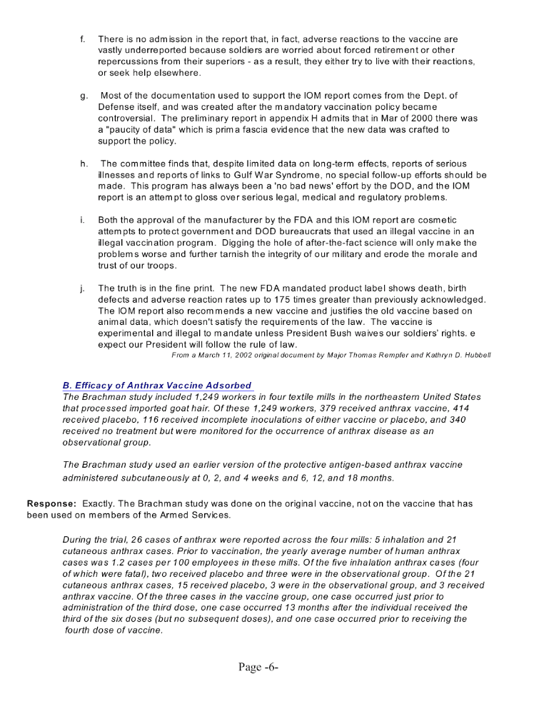
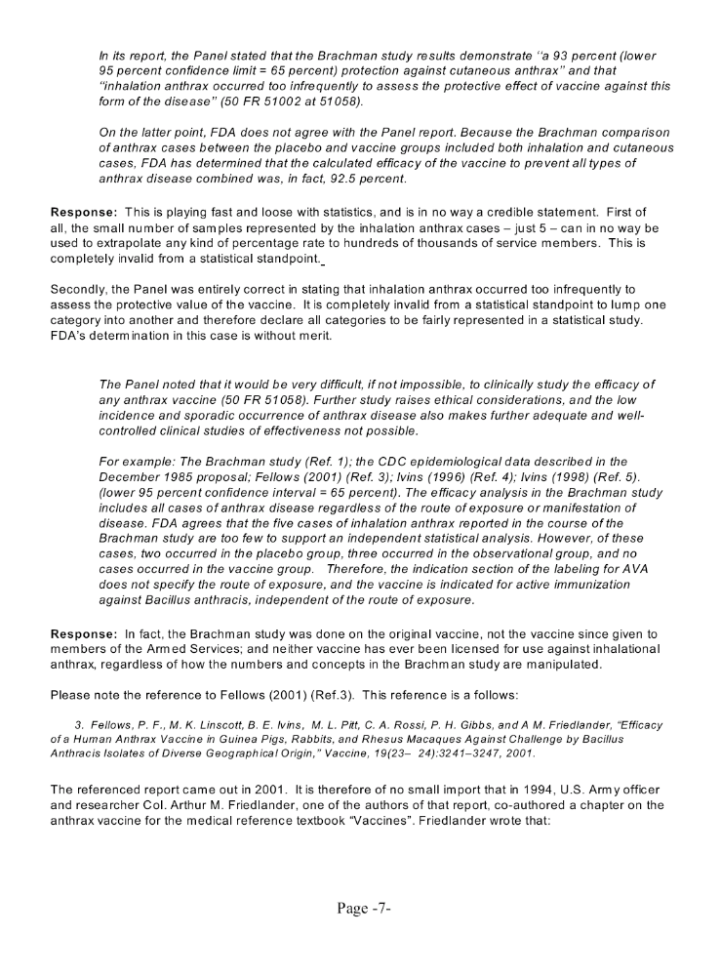
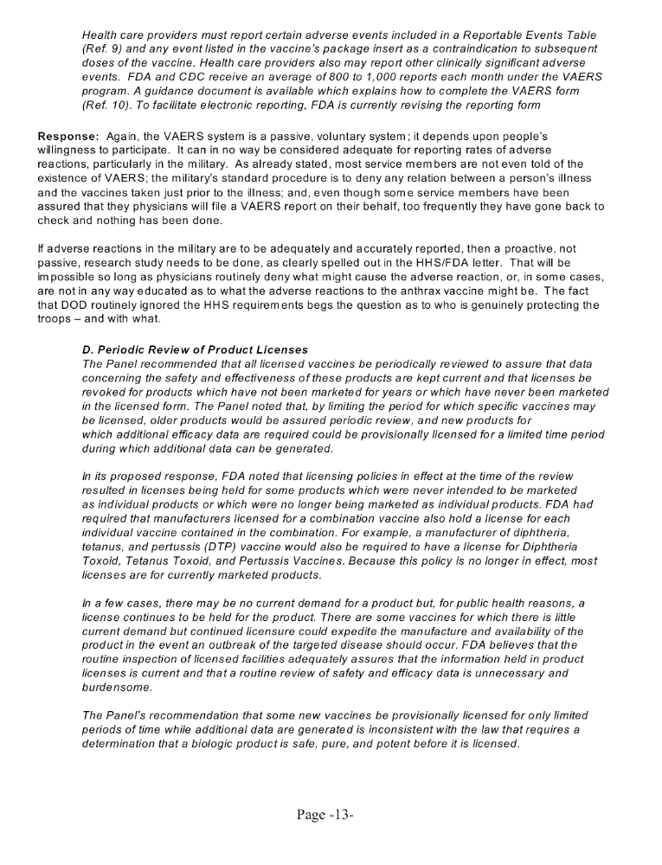
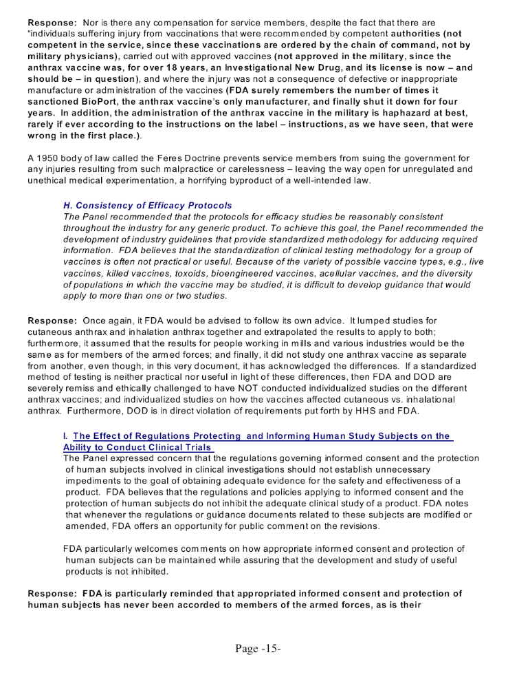
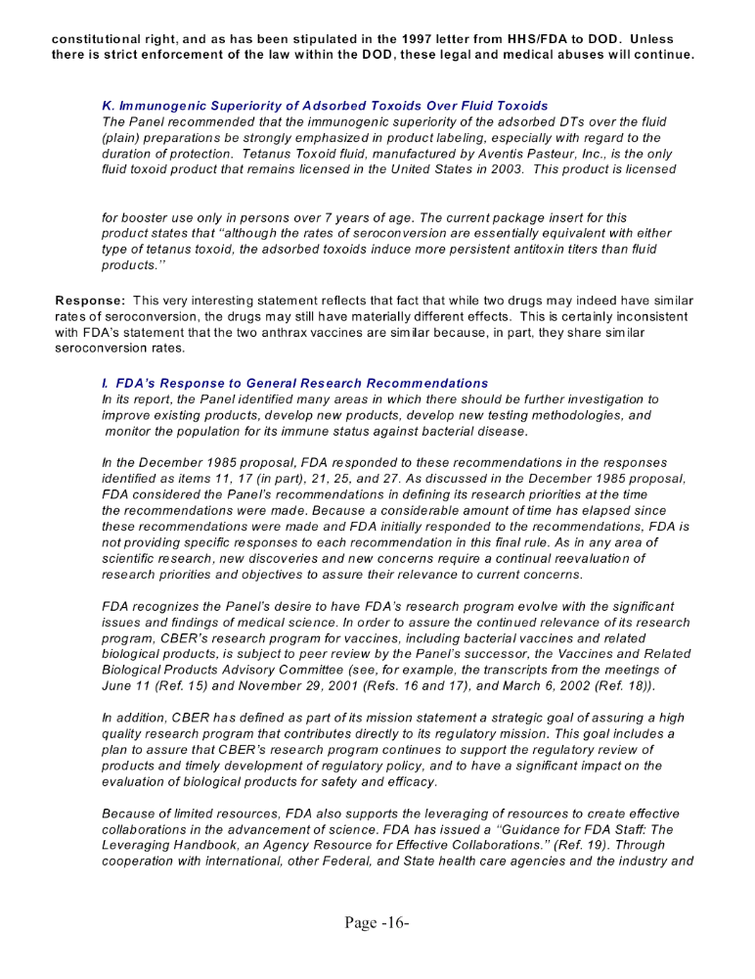
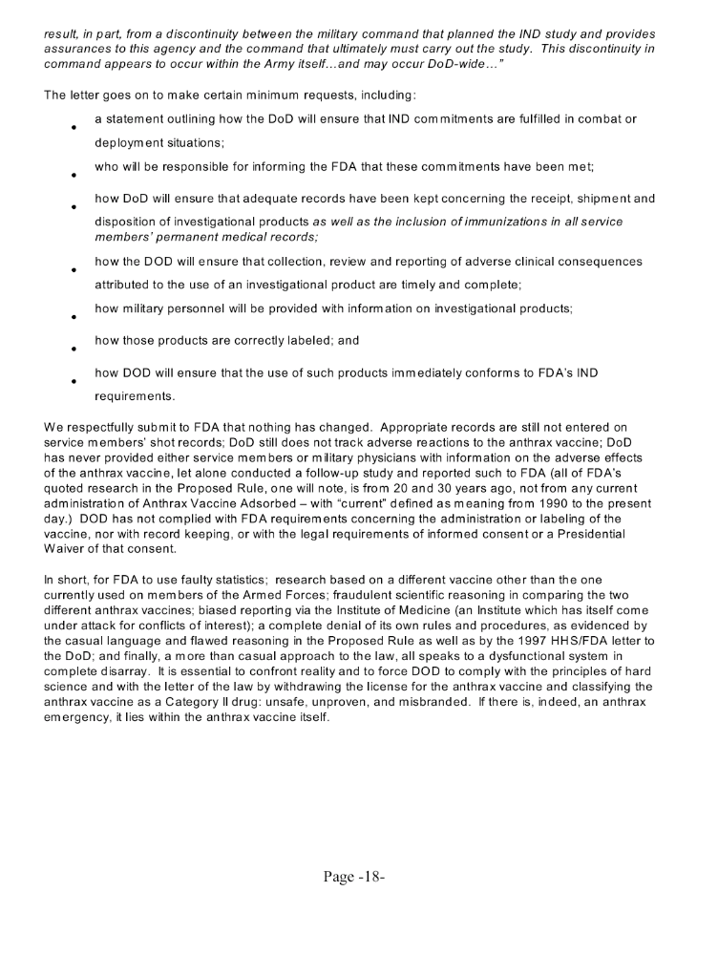
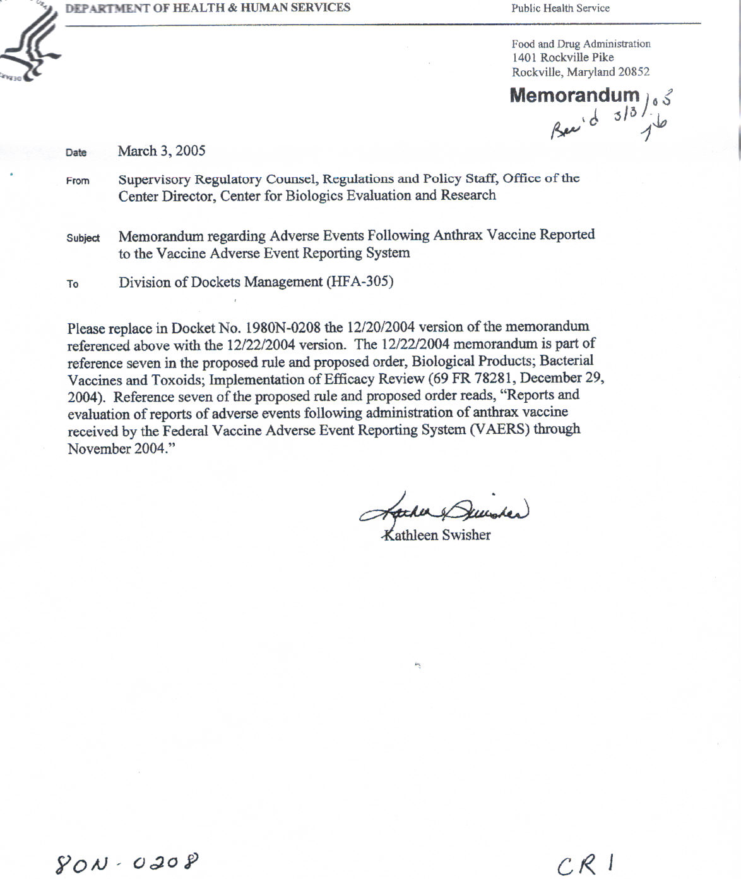
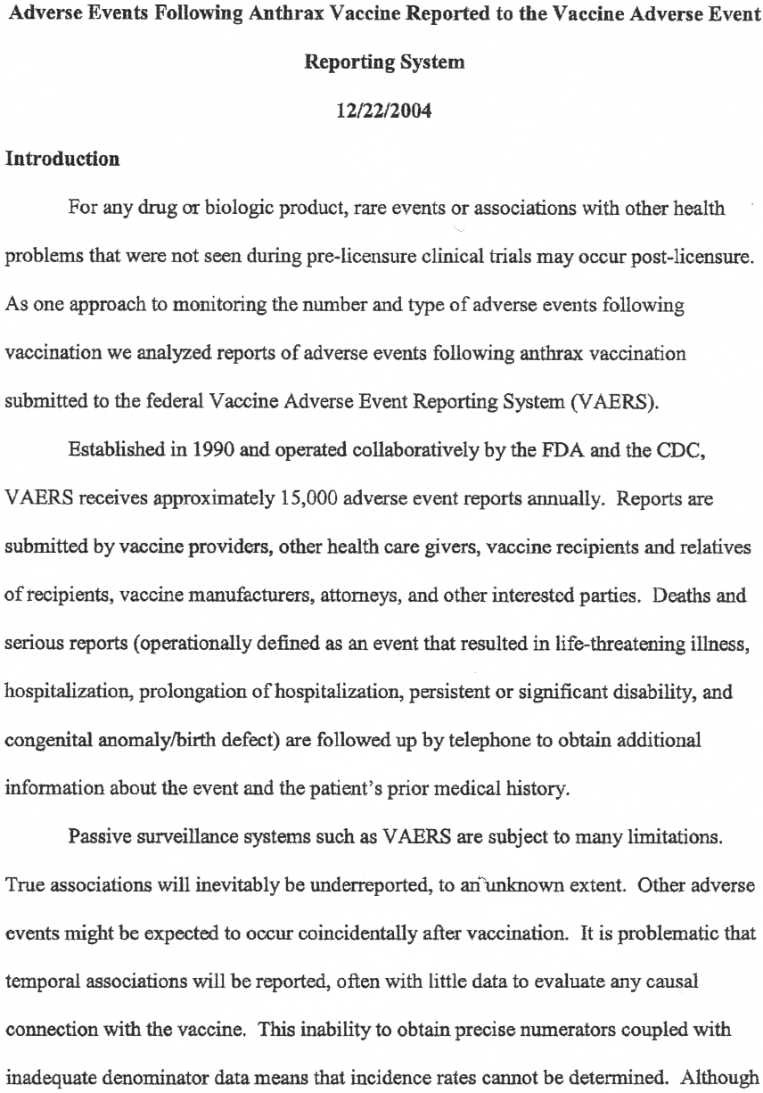
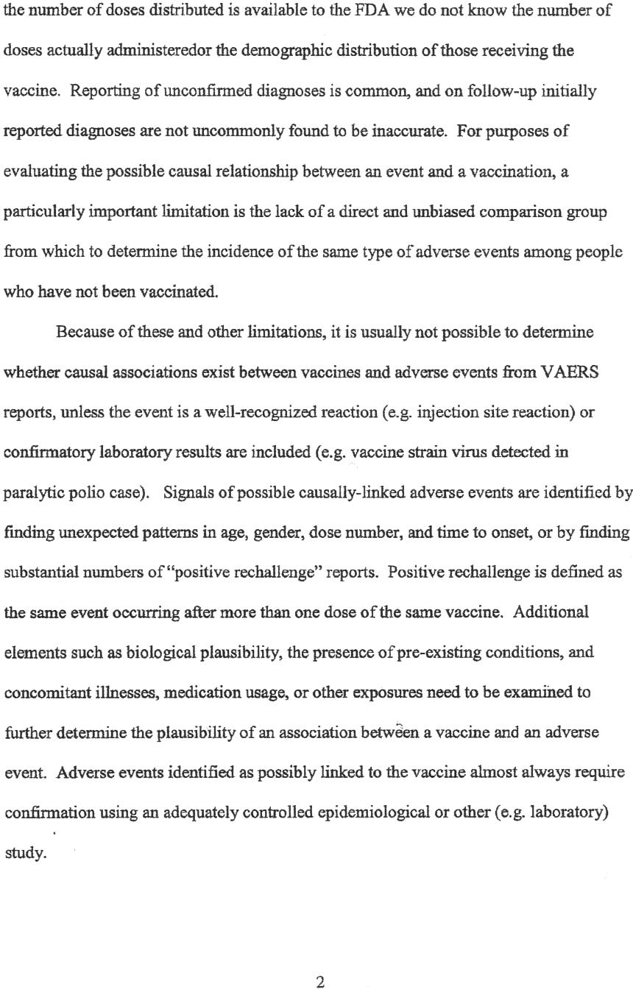

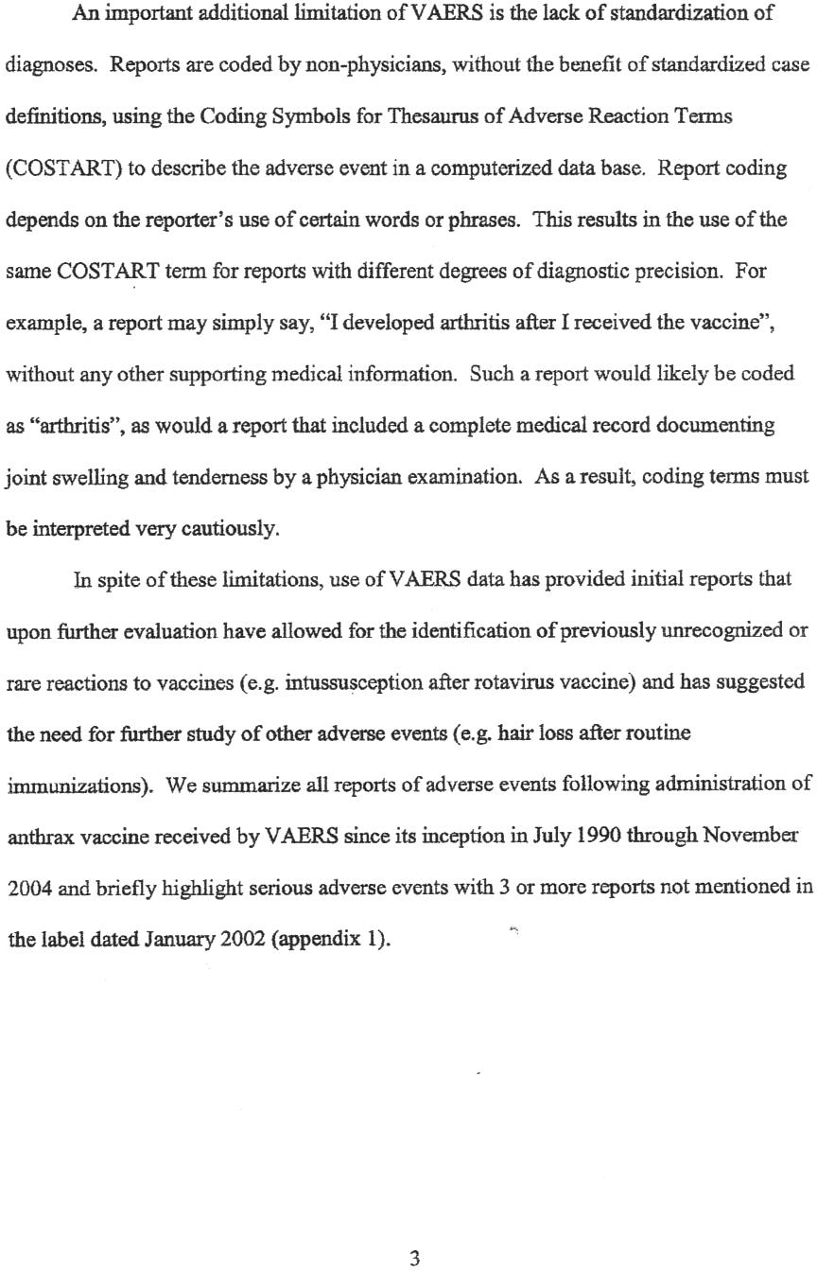

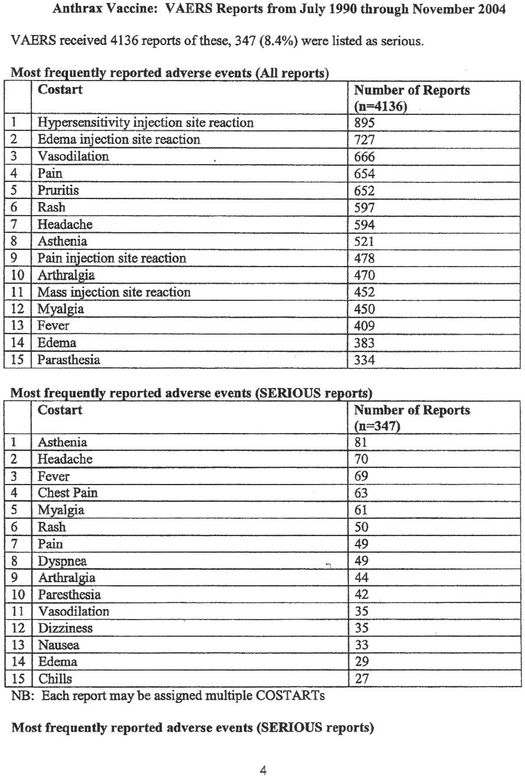

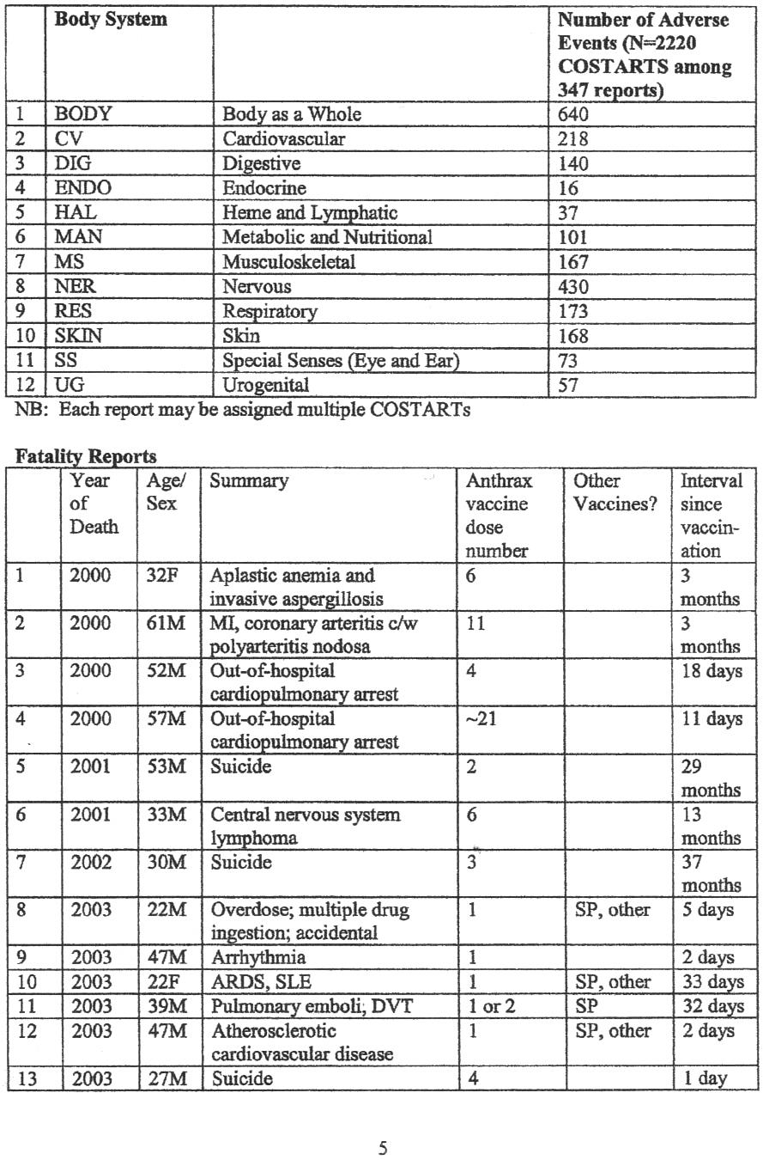

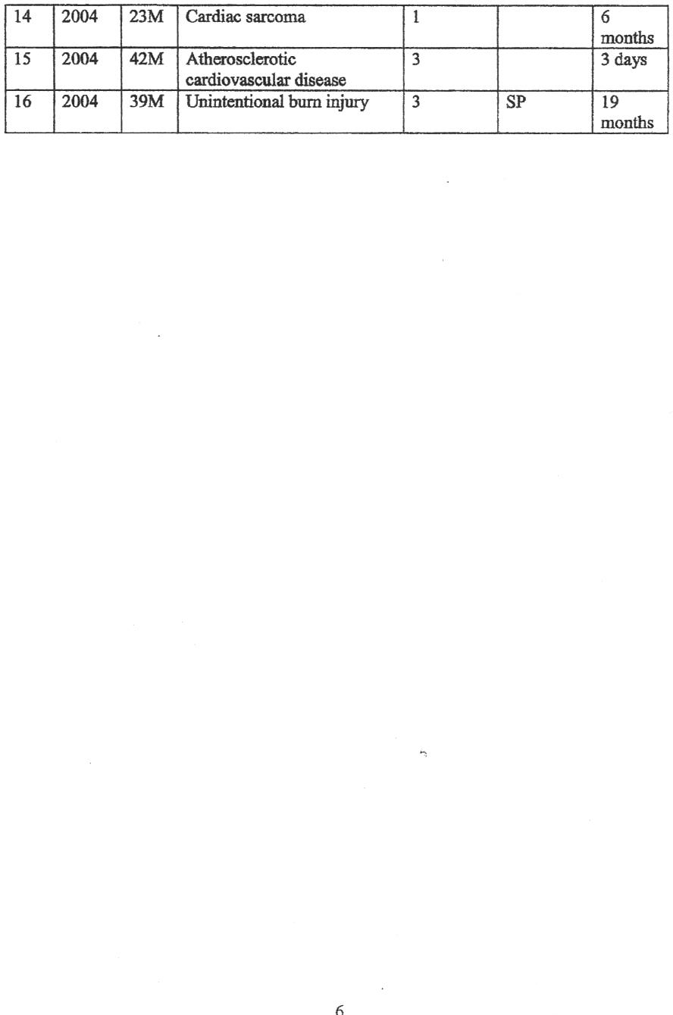

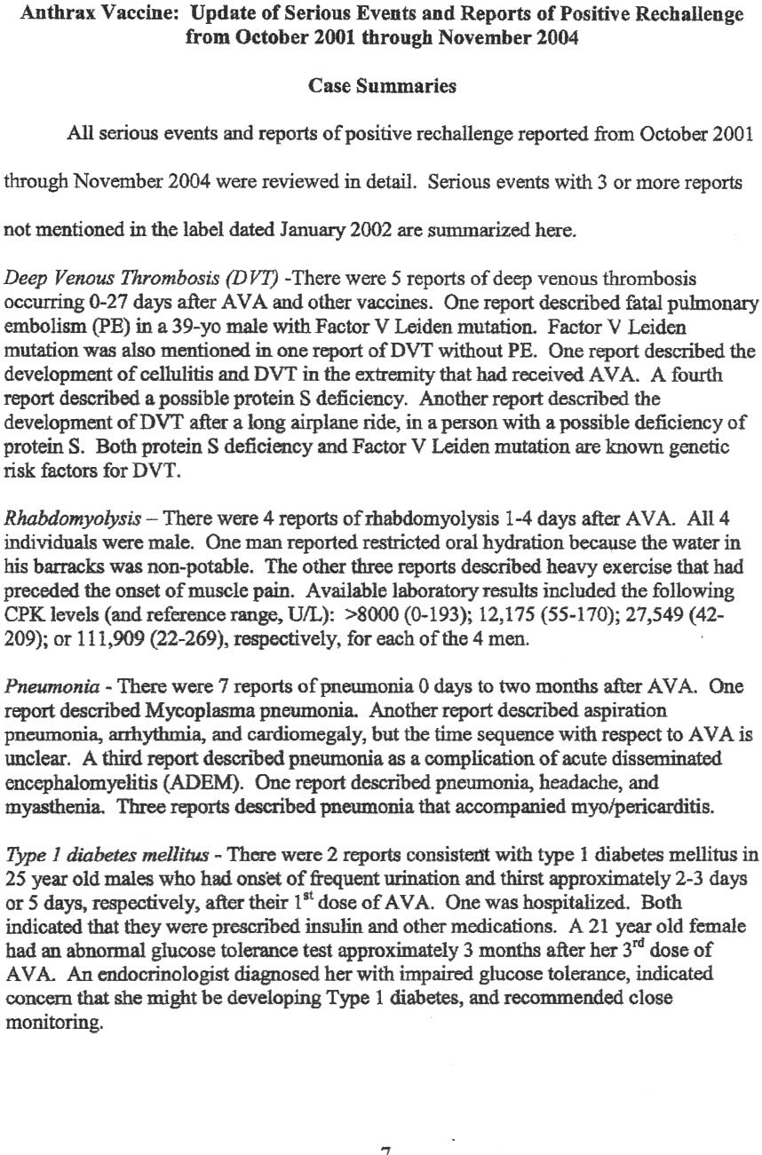

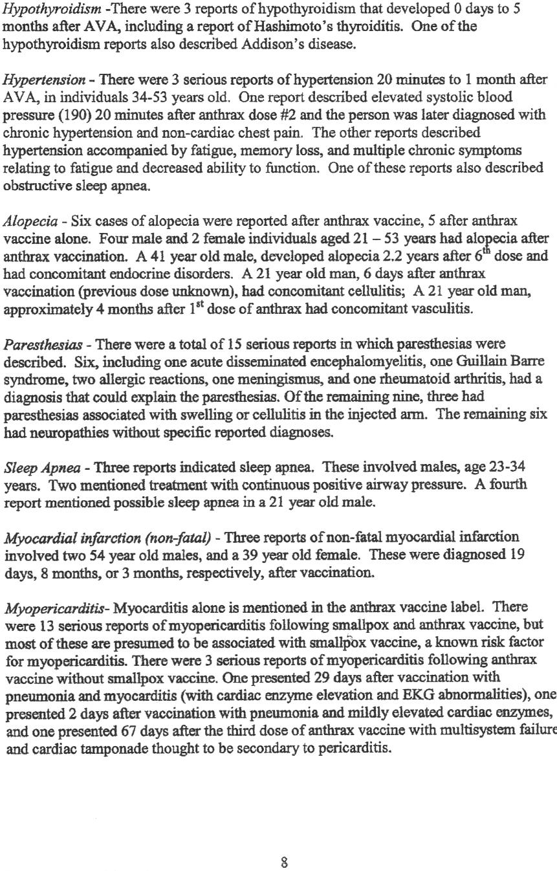

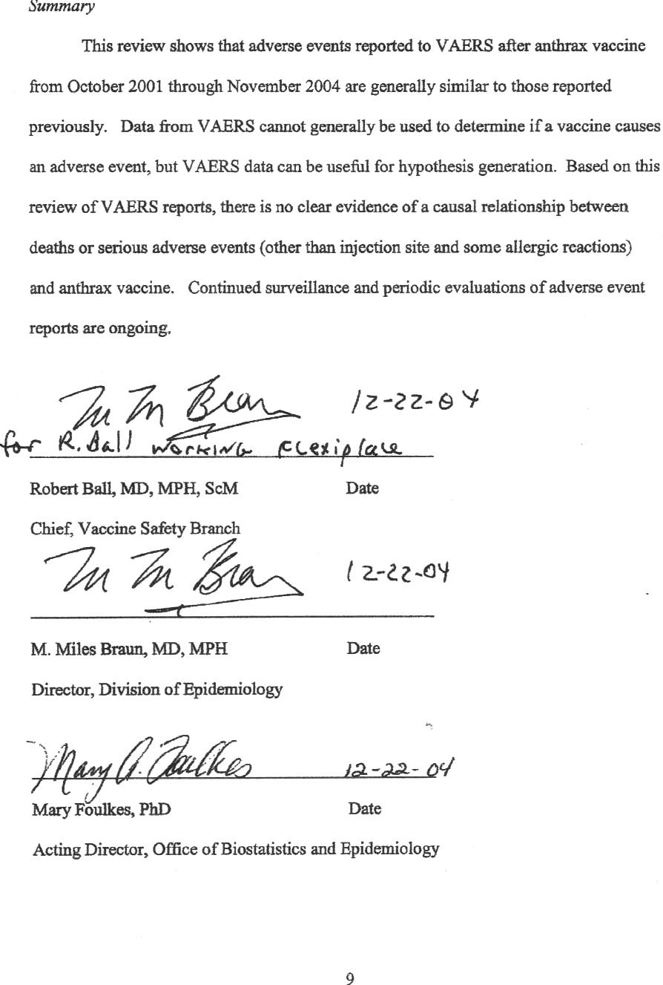

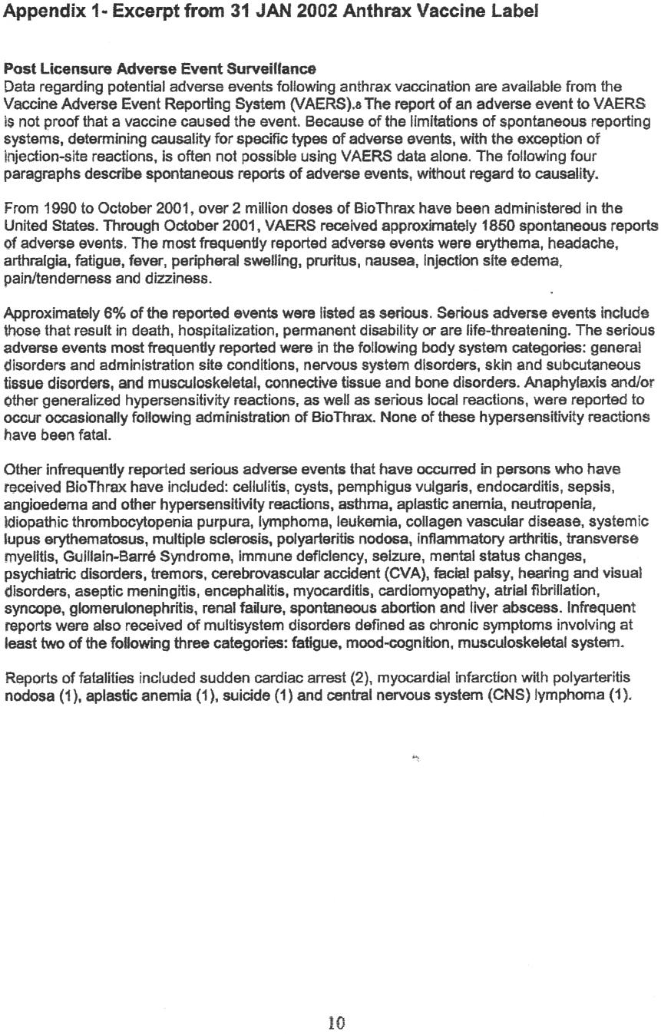

1980N-0208 - Biological Products; Bacterial Vaccines and Toxoids; Implementation of Efficacy Review
 |  |  |  |  |  |  |  |  | FDA Comment Number : |  |  |  |  |  |  | EC1
 | Submitter : |  |  | Ms. Jessica Akers |  |  |  |  |  |  |  |  | Date & Time: |  |  |  |  | 01/19/2005 09:01:38
 | Organization : |  |  |  |  |  | HHC, 3BCT, 1st AD, U.S. Army
 |  |  |  |  | Government
 | Category :
 |  | Issue Areas/Comments
 |  | GENERAL
 |  | GENERAL
 |  | I would like to make my feelings known about the Anthrax vaccine. I have taken 7 shots of the Anthrax and have had numerous medical problems that were finaly diagnosed as Fibromyalgia with other issues outside the Fibro. I feel that my conditions have been caused from Anthrax and am currently researching this with my physician. I know several others who have similar complaints. I am still on Active duty, but am now facing an MEB due to my inability to continue to function as a soldier. Please stop the use of this Vaccine it is detrimental to our soldiers health and we need to take a look at the long term effects of this drug. Please do not dismiss the correlation between illnesses and the vaccine.

 | 1980N-0208 - Biological Products; Bacterial Vaccines and Toxoids; Implementation of Efficacy Review
 |  |  |  |  |  |  |  |  | FDA Comment Number : |  |  |  |  |  |  | EC2
 | Submitter : |  |  | Mr. Pierre Scott |  |  |  |  |  |  |  |  | Date & Time: |  |  |  |  | 01/19/2005 09:01:01
 | Organization : |  |  |  |  |  | 161 B CO Med Bn
 |  |  |  |  | Individual Consumer
 | Category :
 |  | Issue Areas/Comments
 |  | GENERAL
 |  | GENERAL
 |  | I have spoken with several soilders (38 soldiers) who have had the Anthrax vaccination. In a general conversation format 100% of those vaccinated stated they had adverse medical reactions and do not feel the shot is worth the hazards and hardships incurred. Even military Doctors who administer the shot have confessed to the troops if there is anything slightly wrong with the person (slightly high blood pressure, diabetes undetected, joint problems in a benign state) the vaccination will seek the weakest point and intensify it. In many case rendering a soldier medically non deployable. The injury or illness is amplified which can then mean medical discharge and disability payouts.

 | 1980N-0208 - Biological Products; Bacterial Vaccines and Toxoids; Implementation of Efficacy Review
 |  |  |  |  |  |  |  |  | FDA Comment Number : |  |  |  |  |  |  | EC3
 | Submitter : |  |  | Mr. John Soska |  |  |  |  |  |  |  |  | Date & Time: |  |  |  |  | 01/19/2005 09:01:23
 | Organization : |  |  |  |  |  | none
 |  |  |  |  | Individual Consumer
 | Category :
 |  | Issue Areas/Comments
 |  | GENERAL
 |  | I am totaly against any continuance of approval of anthrax vaccines of the military without proper investigation of it's safety to our military personnel. I have been following this issue since my nephew became ill taking bad vaccines at the start of this program. I had to contact several congressmen before he could get any help from the services. They were about to boot him out of the service after 18 years until we got involved. It is a disgrace to see that so many of our finest young men and women were subjected to this program without their consent. A lot of have been disciplined or kicked out of the service because of the hardnosed policy of the Defense Department. From the early stages at The Michigan Lab, Bioport and other agencies this has been a disaster from the start. I have followed the disappearnace of Scientist Wiley from Harvard and his mysterious trip into the Mississippi River and ending up in Louisiana. I believe he was involved somehow in the anthrax problem at the post offices and the FBI didn't see fit to investigate his trip into the river. It would be a crime to the people at the FDA to give an open license for the Defense Department to continue this program without the oversight of the FDA and consent from the people taking the vaccines. With no WMD's found in Iraq, the possibility of this happening is so low that our servicepeople should not be subjected to this. I am a retired U.S. Navy Chief and probably wouldn't have taken the shot myself. I have four grandchildren that I wouldn't let join the service because of the threat to their health with the vaccines. I believe the services have a lot to offer, but again if you approve this program, it would be like committing a major crime. The Defense Department has blamed a lot of other illnesses on other causes rather than admit it was caused by their vaccine program. Thank you.

 | 1980N-0208 - Biological Products; Bacterial Vaccines and Toxoids; Implementation of Efficacy Review
 |  |  |  |  |  |  |  |  | FDA Comment Number : |  |  |  |  |  |  | EC5
 | Submitter : |  |  | Mrs. Patti Woodard |  |  |  |  |  |  |  |  | Date & Time: |  |  |  |  | 01/19/2005 09:01:40
 | Organization : |  |  |  |  |  | non-combat death disputes Home Of The Brave
 |  |  |  |  | Other Organization
 | Category :
 |  | Issue Areas/Comments
 |  | GENERAL
 |  | GENERAL
 |  | We can't have the anthrax vaccine used without proper testing and licensing. Our troops are not guinea pigs yet this is how the administration and military view and treat our soldiers. The anthrax vaccine must be proven safe. Many soldiers prefer to take their chances of contracting anthrax than go through the horrendous side effects of the vaccine. Please make sure the anthrax vaccine is fully tested and properly licensed before subjecting our soldiers to this toxic vaccine. I am appalled at the actions of the FDA and Defense Department who are pushing the untested unlicensed anthrax vaccine on our soldiers! It is negligent and irresponsible in my opinion. Thank you, Patti Woodard

 | 1980N-0208 - Biological Products; Bacterial Vaccines and Toxoids; Implementation of Efficacy Review
 |  |  |  |  |  |  |  |  | FDA Comment Number : |  |  |  |  | EC10
 | Submitter : |  |  | Mr. Philip Wasden |  |  |  |  |  |  |  | Date & Time: |  |  |  | 01/19/2005 09:01:50
 | Organization : |  |  |  |  |  | Mr. Philip Wasden
 |  |  |  |  | Individual Consumer
 | Category :
 |  | Issue Areas/Comments
 |  | GENERAL
 |  | GENERAL
 |  | Greetings to you. Please consider carefully my comments regarding this critical docket number, 1980N-0208. I plead with you as a Veteran and the father of a Veteran, (S/R Vance G. Wasden) who, have served our Country with dedication, loyalty, and honor. My interest in this matter arises from the results of 100% disability to my son, from a contaminated and aged batch of Anthrax Vaccine. I object strongly to the FDA's conduct in previously illegally attempting to improperly license the anthrax vaccine for the DoD. This simply is unacceptable, and the most recent attempt to re-license the vaccine without appropriate independent expert panel review is similarly improper. I feel the FDA is not above the law and in the words of Federal Judge Sullivan, 'must follow their own rules.' It is too late for my son, his life and health are 'non-recoverable' however, it is not too late for the men and women who may be subjected to the involuntary and indiscriminate application of an unchecked license to administer the Anthrax Vaccine. Thank you for your consideration of my comments both for me and in behalf of my faithful son. Sincerely, Philip Wasden (AF17489547) 4312 N. Peppercorn Rd. Lehi, Ut 84043 801-407-6464

1980N-0208 - Biological Products; Bacterial Vaccines and Toxoids; Implementation of Efficacy Review
 |  |  |  |  |  |  |  |  | FDA Comment Number : |  |  |  |  |  |  | EC7
 | Submitter : |  |  | Mr. Lucas Marshall |  |  |  |  |  |  |  |  | Date & Time: |  |  |  |  | 01/19/2005 09:01:59
 | Organization : |  |  |  |  |  | none
 |  |  |  |  | Federal Government
 | Category :
 |  | Issue Areas/Comments
 |  | GENERAL
 |  | GENERAL
 |  | The Anthrax vaccine needs to be thrown out the window. Our troops do not deserve to be experimented on. If we are giving them immunizations for anthrax why arent we giving them shots for all of the other biological weapons out there? Why dont we just use are soldiers for all kinds of experiments, you did with anthrax why dont we keep doing it? Please put a stop to this.

 | 1980N-0208 - Biological Products; Bacterial Vaccines and Toxoids; Implementation of Efficacy Review
 |  |  |  |  |  |  |  |  | FDA Comment Number : |  |  |  |  | EC4
 | Submitter : |  |  | Mrs. Sarah Morini |  |  |  |  |  |  |  | Date & Time: |  | 01/19/2005 09:01:31
 | Organization : |  |  |  |  |  | Mrs. Sarah Morini
 |  |  |  |  | Individual Consumer
 | Category :
 |  | Issue Areas/Comments
 |  | GENERAL
 |  | I implore you to halt this initiative in it's tracks. As a Veteran of the United States, I have personally seen the detrimental effects the anthrax vaccine has induced in squadrons all over the base where I was stationed. My first sergeant almost DIED from a heart condition he developed after taking the anthrax vaccine. Of course, the cause of the failure was lost somewhere in the long, arduous reporting process. Millions of others with some type of medical malaise due to the vaccine are unreported as well. Therefore, the reported rate of adverse reactions is far, far below what it is in reality. PLEASE DO NOT ALLOW THIS TO CONTINUE !!!!!!!!!!!!!!!!!!!!!!!!!!!!!!!!!!!!!! Sarah Morini

1980N-0208 - Biological Products; Bacterial Vaccines and Toxoids; Implementation of Efficacy Review
 |  |  |  | FDA Comment Number : |  |  |  | EC8
 | Submitter : |  | Ms. Armaiti May |  |  | Date & Time: |  |  |  | 01/19/2005 09:01:53
 | Organization : |  |  | Ms. Armaiti May
 |  |  | Individual Consumer
 | Category :
 | Issue Areas/Comments
 | GENERAL
 | GENERAL
 | Military personnel should not be required to take the Anthrax vaccine, which has undergone multiple changes in its manufacturing process since it was originally tested in humans. The Anthrax vaccine has also proven to cause serious adverse side effects including, blindness, convulsions, blackouts, Gulf War syndrome, and death. It is unconscionable to require our Service men and women to get this vaccine which clearly has dangerous side effects and questionable efficacy. Please see the following attachment for further details: The safety and efficacy of anthrax vaccine have not been established, and the preponderance of the world?s literature shows the vaccine is unsafe, and a contributor to Gulf War Syndrome as acknowledged in the vaccine?s package insert When the DOD?s Anthrax Vaccine Immunization Program was announced in late 1997, published evidence for both safety and efficacy of the anthrax vaccine was lacking. Dr. Peter Turnbull, formerly head of anthrax research at Porton Down, and others had made this information available in the open literature. Rodent challenge studies showed poor efficacy of the UK and US killed human anthrax vaccines against highly virulent strains, and there existed no published safety data, apart from a study of an earlier, unlicensed ?Brachman? (a.k.a. ?Merck?) anthrax vaccine. It contained little information on systemic adverse effects. A later, unpublished CDC `open label? study of the licensed US anthrax vaccine, purported to affirm vaccine safety, used report forms that only collected information on local reactions. Although a nurse at the Alabama factory where the bulk of the study?s anthrax vaccinations were administered had expressed concern about the adverse reactions, and these concerns were discussed at the CDC, she was overruled by the mill?s doctor, and the documentary evidence suggests the matter was then dropped. Reports of several panels that had been charged with investigating Gulf War Syndrome (GWS), and claimed the vaccine had nothing to do with it, were reviewed. The evidence they relied on to draw conclusions about the role of anthrax vaccine was shaky at best. The reports either cited no references to support their vaccine conclusions, or cited only briefings by military officers, not scientific studies. Despite the finding by a Senate committee in 1994 that anthrax vaccine was being considered as a possible cause of GWS, and the statement by the Persian Gulf Veterans Coordinating Board that ?all potential causes [of GWS] that have been identified are being investigated,? when I reviewed the full portfolio of federal research on GWS in 1999, I found that of the 166 studies listed, none looked specifically at anthrax vaccine. Only because the Wessely/Unwin study was designed to investigate all potentially noxious exposures that GW soldiers had faced, had data on anthrax vaccine been captured. The low rate of GWS in French troops, who were unvaccinated, had used prophylactic doxycycline and consumed cleaner, bottled water, needed explanation. The issue of whether small numbers of French troops who did develop GWS were in liaison positions, and were vaccinated alongside US and UK units, has been raised by the French Ministry of Defense, but has not been resolved.
 | Numerous vaccinated but nondeployed Gulf War `era? soldiers in the US have developed similar multisystem illnesses as the deployed soldiers. Dr. Lea Steele was able to analyze this intriguing finding in a study of Kansas Gulf War veterans. She found that nearly 4% of the veterans who had not been deployed, nor vaccinated in preparation for deployment, met her GWS case definition. (She later concluded that this number is approximately the prevalence rate of a similar condition in civilians.) But those who were vaccinated in preparation for deployment, but never actually deployed, had a rate 3 times higher, nearly 12%.

1980N-0208 - Biological Products; Bacterial Vaccines and Toxoids; Implementation of Efficacy Review
 |  |  |  |  |  |  |  |  | FDA Comment Number : |  |  |  |  |  |  | EC12
 | Submitter : |  |  | Mr. Russell Dennis |  |  |  |  |  |  |  |  | Date & Time: |  |  |  |  | 01/19/2005 09:01:06
 | Organization : |  |  |  |  |  | Mr. Russell Dennis
 |  |  |  |  | Federal Government
 | Category :
 |  | Issue Areas/Comments
 |  | GENERAL
 |  | GENERAL
 |  | Dear Sir; I wish to comment in objection to the approval of any anthrax vaccine. I wish I could not understand an FDA that approves a vaccine of questionable effectiveness but I do. The reason is political pressure. While the FDA will refuse approval of drugs that just may save a terminal patient in the misguided concern that they may hurt someone who is already dying, that same FDA ignores it's stringent procedures to rush anthrax approval through....technically "approving" it's forced administration on even unwilling military members. The excuse given is the "good of the service" but that is forgotten once the reactions damage the individual. While other means of protection and treatment exist for anthrax, the military blindly insists on forcing all to take the "approved" vaccine. Then the reactions and complaints are declared to be not related to the vaccine. And those who want to refuse the shots are harassed, prosecuted, fined and abused for wanting to protect themselves, even if they state they are willing to accept the risk of anthrax exposure and rely on antibiotic treatment. The military command structure instead mandates that the "approved" vaccine must be taken by all. On page 30, footnote 9, of the judge's ruling about the illegality of the anthrax vaccine mandate, the judge also captured the DoD's attorney's admitting that the original proposed, and never finalized, licensure of the anthrax vaccine in 1985 didn't contemplate the vaccine's mass use for inhaled anthrax. Attorney for the DoD and FDA: "But it?s absolutely right, Your Honor, that the possibility of weaponized anthrax was not in the minds of the advisory panel and probably not in the minds of the FDA." The judge also transcribed the FDA's original 1985 review of the vaccine, published in the federal Register: "Anthrax vaccine poses no serious special problems other than the fact that its efficacy against inhalation anthrax is not well documented." Considering these facts and admissions, the FDA "must" reform an expert panel to review all new data, never "contemplated" by the original 1985 experts, that the DoD has generated to support a final license. The federal court also cited a Citizen Petition filed on October 15, 2001 (Docket: 01P-0471 Issue the NFR Placement of Anthrax Vaccine as Category II <aoldb://mail/write/template.htm#_top>), in which we identified to the FDA the never finalized state of the anthrax vaccine, while respectfully requesting the Agency do so properly. The FDA did not act on the Petition, instead having to be ordered to do so by a federal judge four years later. Additionally, the FDA has never held the DoD or the manufacturer accountable for the illegal and adulterating manufacturing changes that the vaccine underwent prior to the first Gulf War. These illegal alterations may have made the vaccine up to one-hundred times more potent, though the changes and the vaccine have been excluded from study by the DoD as a possible cause of Gulf War Illness. These unapproved alterations were reported in our Petition, and also to the Government Accountability Office (GAO) who validated the concerns in a report, http://www.gao.gov/new.items/d02181t.pdf. Curiously, the GAO also has reported that adverse reactions to the anthrax vaccine are one-hundred times higher than DoD first acknowledged. I object to any approval of this anthrax vaccine. I object to it's use being forced on anyone over their objections.

 | 1980N-0208 - Biological Products; Bacterial Vaccines and Toxoids; Implementation of Efficacy Review
 |  |  |  |  |  |  |  |  | FDA Comment Number : |  |  |  |  |  |  | EC14
 | Submitter : |  |  | Mrs. Michelle McClellan |  |  |  |  |  |  |  |  | Date & Time: |  |  |  |  | 01/19/2005 09:01:21
 | Organization : |  |  |  |  |  | Mrs. Michelle McClellan
 |  |  |  |  | Individual Consumer
 | Category :
 |  | Issue Areas/Comments
 |  | GENERAL
 |  | GENERAL
 |  | I feel that the FDA needs to follow its own rules on licensure of vaccinations (particularly the anthrax vaccination being administered to military members). This vaccine has caused hundreds, if not thousands of people to become ill and the FDA is stating that it is fully licensed for inhalation anthrax without any tests to prove that. I left the military due to this shot after 10 years as a pilot. I might have stayed had the military made the shot optional. The military is losing many good soldiers, either to illness due to the shot, or to people getting out to avoid becoming sick from the shot.

 | 1980N-0208 - Biological Products; Bacterial Vaccines and Toxoids; Implementation of Efficacy Review
 |  |  |  |  |  |  |  | FDA Comment Number : |  |  |  |  | EC15
 | Submitter : |  | Mr. Michael Harsh |  |  |  |  |  |  |  | Date & Time: |  |  |  | 01/19/2005 09:01:31
 | Organization : |  |  |  |  | US Air Force Reservist
 |  |  |  | Individual Consumer
 | Category :
 | Issue Areas/Comments
 | GENERAL
 | GENERAL
 | My comments relate to the Michigan Department of Health License number 99 as changed to Bioport Corporation License number 1260--Anthrax Vaccine. It also relates to any other Anthrax specific vaccine that may be developed or licensed by any other manufacturer. I have received 8 Anthrax shots as ordered by military authorities manufactured by Bioport. While with some of the shots I have not had much in the way of adverse reactions, the last two shots I received in 2002 and 2003 have caused significant adverse reactions. Both times, I had tenderness, touch sensations ("ants crawling"), heat, a large rash about 4 inches in diameter and a lump at the injection site. The symptons lasted from 2 to 4 weeks. The lump would last months. I would like to see the Anthrax vaccine be listed as Category II (unsafe, ineffective, or misbranded), or at the very least Category IIIB (off the market pending completion of studies permitting a determination of effectiveness). One of my major concerns is that the vaccine has not been proven safe, effective, or even useful for inhalation anthrax. I believe more studies certainly need to be undertaken to ensure the safety and effectiveness of this vaccine for the purpose the military stipulates it is used for. Beyond these studies, I believe an INDEPENDENT, expert panel needs to be convened to substantiate any move of the anthrax vaccine towards Category I status, with special investigation of the risks, indications for use, indications against use, and adverse reactions to the vaccine. Until the additional studies and an independent, expert panel determines with due deliberation that the vaccine should be Category I, we should definitely err on the side of safety and make the vaccine Category II and the very least Category IIIB. In addition to the additional requirements and questions I list above, I would like to see special empahsis placed on the use of squalene in many of the vaccine lots. As a reservist, I am concerned about my personal health due to this vaccine and I'm concerned about the effects it will or may have on future and or current military members. Since we do not have a choice whether we will take the vaccine, we rely on the integrity of the FDA and its processes to determine with all proper and due deliberation the safety and indications for proper use and effectiveness of the anthrax vaccine for inhalation anthrax purposes.

 | 1980N-0208 - Biological Products; Bacterial Vaccines and Toxoids; Implementation of Efficacy Review
 |  |  |  |  |  |  |  |  | FDA Comment Number : |  |  |  |  | EC16
 | Submitter : |  |  | Mr. Anonymous Fearofreprisal |  |  |  |  |  |  |  | Date & Time: |  |  |  | 01/19/2005 09:01:40
 | Organization : |  |  |  |  |  | US Air Force
 |  |  |  |  | Federal Government
 | Category :
 |  | Issue Areas/Comments
 |  | GENERAL
 |  | GENERAL
 |  | I received my first three anthrax vaccinations from lots FAV 030 in Nov and Dec of 1998 mandated by the US military's anthrax vaccination program. FAV 030 has tested positive for squalene. I have also received several other anthrax shots from other lots. I was forced by my military commanders to take some of these shots outside of the licensed schedule for them. I was in my mid-20's when I received the first shots and in extremely good physical condition. Within several months of receiving the injections, I developed seborrheic dermatitis. It has become progressively worse since then and now covers my entire face, head, groin, and underarms. My skin is red, inflamed, itchy, and covered with scales. I can only partially control it with a strong prescription steroid cream and shampoo. Seborrheic dermatitis is an immune disorder. My body's immune system has been triggered to attack it's own skin. The medication I use to control it has it's own set of side-effects and risks. I also developed heart fibrillations which have likewise become more frequent and severe in the years since 1998. Additionally, in the months following the anthrax injections, I suffered bouts of debilitating dizzieness. Finally, I have developed chronic sleep problems. I have not been able to obtain a restful night of sleep in several years. I did not have any of these problems before receiving the anthrax injection. I did not realize there might be a connection between my medical conditions and the vaccine until after talking to fellow military members and reading Gary Matsumoto's recent book, "Vaccine-A". However, the correlation between the timing of the shot and the commencement of my several medical problems is too strong. There is very little doubt in my mind that the anthrax vaccine is the causal factor for my problems. This vaccination program needs to be thoroughly reevaluated and only given to individuals after informed consent.

 | 1980N-0208 - Biological Products; Bacterial Vaccines and Toxoids; Implementation of Efficacy Review
 |  |  |  |  |  |  |  |  | FDA Comment Number : |  |  |  |  |  |  | EC18
 | Submitter : |  |  | Miss. Kelli Root |  |  |  |  |  |  |  |  | Date & Time: |  |  |  |  | 01/26/2005 05:01:48
 | Organization : |  |  |  |  |  | N/A
 |  |  |  |  | Individual Consumer
 | Category :
 |  | Issue Areas/Comments
 |  | GENERAL
 |  | GENERAL
 |  | I was forced to take the anthrax vaccine in may of 2000 and I have been very ill ever since. with no answers or help in getting my health back because nobody will take acountability to what this vaccine does to people. I have been told that there is no cure for my illness and all the docters can do is try to make me comfortable with many different medications. because no one is willing to admit that this vaccine is unsafe. instead of "saving" lives it is taking lives. I loved my career in the military and it was taken from me along with my health and am unable to work or do anything I use to. I went from being very active and healthy to barely being able to get out of bed and some days I don't make it out of bed. please stop this vaccine from destroying more lives. If I could turn back time there is no way in hell I would take the shot, I'd rather go to jail and get a dishonorable discharge from the career that I loved, than be so unhealthy and missorable as i am now. If it wasn't for my sister I would have killed myself a couple of years ago, that is how unbearable my life is thanks to the anthrax vaccine that shouldn't be. I'm going on five years of government b.s. and trying to get my life back and was told recently that was never going to happen.

 | 1980N-0208 - Biological Products; Bacterial Vaccines and Toxoids; Implementation of Efficacy Review
 |  |  |  |  |  |  |  |  | FDA Comment Number : |  |  |  |  | EC19
 | Submitter : |  |  | Mr. Matthew Drinkwater |  |  |  |  |  |  |  | Date & Time: |  |  |  | 01/26/2005 05:01:56
 | Organization : |  |  |  |  |  | Mr. Matthew Drinkwater
 |  |  |  |  | Individual Consumer
 | Category :
 |  | Issue Areas/Comments
 |  | GENERAL
 |  | I am writing to express my disapproval with the FDA's attempt to avoid the normal approval process by failing to form an expert panel to review the new data that the Department of Defense (DoD) has generated to support full and final licensure of the anthrax vaccine. The federal judge's October 27, 2004 ruling (http://www.dcd.uscourts.gov/Opinions/2004/Sullivan/03-707c.pdf) specifically delineated that the FDA "must" follow their own rules. According to the court, when FDA experts "review the labeling" of a vaccine the Agency follows a "two- stage" process whereby an expert review panel reviews the scientific data and submits a report to the FDA Commissioner prior to a proposed rule. Currently the FDA appears to be circumventing their normal requirement for an expert review panel, moving directly to a proposed ruling for full vaccine licensure. I also wanted to note that the FDA has never held the DoD or the manufacturer accountable for the illegal and adulterating manufacturing changes that the vaccine underwent prior to the first Gulf War. These illegal alterations may have made the vaccine up to one-hundred times more potent (the GAO has reported that adverse reactions to the anthrax vaccine are one-hundred times higher than DoD first acknowledged). The FDA's conduct in previously illegally attempting to improperly license the anthrax vaccine for the DoD is unacceptable, and that the most recent attempt to re-license the vaccine without appropriate independent expert panel review is similarly improper.

 | 1980N-0208 - Biological Products; Bacterial Vaccines and Toxoids; Implementation of Efficacy Review
 |  |  |  |  |  |  |  |  | FDA Comment Number : |  |  |  |  | EC20
 | Submitter : |  |  | Ms. Gina Etlinger |  |  |  |  |  |  |  | Date & Time: |  |  |  | 01/26/2005 05:01:04
 | Organization : |  |  |  |  |  | Ms. Gina Etlinger
 |  |  |  |  | International Public Citizen
 | Category :
 |  | Issue Areas/Comments
 |  | GENERAL
 |  | GENERAL
 |  | As a former member of the Armed Forces I received my first injection of the Anthrax Vaccine in December 2003 at Fort Hood, Texas and the second injection in February 2004. Following both injections I suffered from flu-like symptoms, low-grade fever, fatigue and muscle aches. Four months after the second injection I realized that my left, upper arm was completely numb and realized that my energy level never returned to normal. After numerous visits to the medical facilities available to me in Iraq and Germany I was diagnosed with severe depression. I declined to take further injections but was ordered to do so regardless of medical opinion and was in the process of undergoing court martial when the pentagon was ordered to stop the mandatory vaccines. I have since received an Honorable Discharge but my health continues to suffer from what I believe is an adverse reaction to the vaccine. I was diagnosed with Bradycardia (low heart-rate) while in Germany. My heartrate was discovered to be a low 48 bpm with no explanation. The physician merely scratched his head and said he did not know or understand the cause of my low heartrate. I also suffer from light-headedness, dizziness, lower back pain, joint pain, occasional blurred vision, difficulty concentrating, trouble sleeping and chronic fatigue. The military does not deny that I have these symptoms but claim these symptoms are a result of depression not the vaccine. I disagree. I believe that the anthrax vaccine is very harmful and toxic to the human body and implore those in a position to demand further research before deciding that the vaccine is safe to administer. I wish I had refused the vaccine before my very first injection. I honestly believe I would not be plagued with my current health problems had I not received the vaccine. I wish I had known more about all of the other soldiers who suffered adverse reactions following injections of the anthrax vaccine. Please, please do not continue the forced anthrax vaccinations.

 | 1980N-0208 - Biological Products; Bacterial Vaccines and Toxoids; Implementation of Efficacy Review
 |  |  |  |  |  |  |  |  | FDA Comment Number : |  |  |  |  |  |  | EREG4
 | Submitter : |  |  | Dr. Galo Grijalva |  |  |  |  |  |  |  |  | Date & Time: |  |  |  |  | 02/07/2005 07:02:29
 | Organization :
 |  |  |  |  | Health Professional
 | Category :
 |  | Issue Areas/Comments
 |  | GENERAL
 |  | GENERAL
 |  | As a physician having done immunology research, and having survived 6 years of Air Force active duty, I am knowledgeable about the immune system, and the pathologic beurocracy that is the military. Having allowed the DoD to use this vaccine in the first place shows how the FDA is a corrupt and irresponsible cog of a dysfunctional system. The vaccine that was illegally given to our soldiers was not the same vaccine that was originally liscenced, nor was it used for what it was liscenced for. Both those facts by FDA law should have required re-examination of the process. The change in manufacturing happened more than once.In addition, it is now known fact that MF59, a squalene based adjuvant, is part of the vaccine. At least some of it that was distributed to unknowing soldiers. MF59 is an illegal substance, and the DoD has used it in the vaccine and will likely continue to do so.The FDA has much to explain and in view of the recent scandal with Vioxx, the other cox-2 inhibitors, and the other dangerous drugs the whistleblower talked about, it has lost the trust of the people.The anthrax vaccine is a monumental travesty, and a raping of an unsuspecting and patriotic force. To allow the DoD to continue its illegal experimentation, and illegal use of adjuvants is something that must be stopped. I urge you to consider the large number of military personnel that have been injured by the vaccine, those that have died, and those that will continue to be injured if this program continues. Like I experienced in active duty, there is ZERO accoutability for those who make tragic mistakes while hiding behind the vail of national interests, or security. The vaccine is dangerous, illegal, and should not be used. Ken Allibeck, the Russian scientist who headed Biopreparat has published his acknowledgement that bioengineered anthrax would be resistant to any vaccine or antibiotics. The effort to create an effective vaccine, if that is even possible, needs to be undertaken by leaders in the field. Not some military reject with no oversight, no accountability, and no integrity. The FDA has failed the American citizen in protecting them from bad medicine. Please do not let us down again. Look at the facts, follow the law, hold people accountable.Galo A. Grijalva M.D. FACS

 | 1980N-0208 - Biological Products; Bacterial Vaccines and Toxoids; Implementation of Efficacy Review
 |  |  |  |  |  |  |  |  | FDA Comment Number : |  |  |  |  | EREG5
 | Submitter : |  |  | Mrs. Teresa Jones |  |  |  |  |  |  |  | Date & Time: |  |  |  | 02/07/2005 07:02:51
 | Organization : |  |  |  |  |  | Anthrax Vaccine
 |  |  |  |  | Drug Industry
 | Category :
 |  | Issue Areas/Comments
 |  | GENERAL
 |  | GENERAL
 |  | My name is Teresa Jones, I am a mother of a Soldier who served his country in 96-98. He has been disabled 100% since taking the Anthrax Vaccine LotNo. FAV020 he took 4 shots. When he took the 4th shot he began to seizure and has not stopped the seizures. He had a reaction after each vaccine given but was continued in the shots regime his health was ignored. He has been told he has a spot on the artery coming from the brain stem which is next to the nervous system, this is one of the symptoms of the vaccine. The VA Doctor can not say what this is nor will they pay for my son to have a 2nd opinion. We are having to go outside the VA system to get him help. We will not take this is the end of your road for an answer He has had more seizures than we care to talk about, and continues to have seizures. My son is an example why this vaccine should not be given the soldiers were not made aware of the risk. Joe was not made aware of any risk, nor was he given a choice to take or not to take the vaccine. This vaccine was ruled illegal and now the company is trying to make more, Why!! would you make millions of shots of Anthrax vaccine when there are so many different types of Anthrax. Why would they not be making Cipro to combat if they are afraid of an Anthrax vaccine out break. Does that not make more sense. If it can be cured with antibiotics. I just wonder what is the motive behind the Anthrax vaccine. More than likely $$$$ I have yet to hear from the BIO-Port manufacture who made the vaccine when I tried to reach them to find out what I could do to help my son after he took there vaccine. They would not talk with me. If the vaccine is made for the public like I hear it is going to be, I will not take it and I will campaign against it you can take that to the bank. Please rethink about approving this vaccine. My son's name is Joseph Jones, he testified in front of Congress http://www.avip2001.net/DOCS/Jones001003.pdfI hope you find it within your heart not to allow this vaccine to be made for the public. From a mom on a mission to save her son Teresa Jones 109 South Rainbow Bridge Cedar Park Texas 78613 512-258-9165 tmomintexas@yahoo.com

 | 1980N-0208 - Biological Products; Bacterial Vaccines and Toxoids; Implementation of Efficacy Review
 |  |  |  |  |  |  |  |  | FDA Comment Number : |  |  |  |  |  |  | EREG6
 | Submitter : |  |  | Mr. Roger Meyer |  |  |  |  |  |  |  |  | Date & Time: |  |  |  |  | 02/07/2005 07:02:20
 | Organization : |  |  |  |  |  | US Army Officer
 |  |  |  |  | Federal Government
 | Category :
 |  | Issue Areas/Comments
 |  | GENERAL
 |  | GENERAL
 |  | I was ordered to take the anthrax vaccine and experienced life altering side effects from this vaccine. I took 3 of the 6 shots and after each shot I experienced joint pain which increased in severity and duration with each successive shot. I developed muscle twitching after the third shot and have been evaluated and documented at Walter Reed Medical Facility in Washington D.C. I have since been separated from the Air National Guard and continue to have the muscle problems every few minutes. It is a constant reminder of this unneccesary vaccine which I was forced to take and the ongoing "research" that is being conducted on our troops. I have been in contact with both my Congressman and Senator who defer to the powerhouse DOD. My own Senator Frist told his workers when the Hart building was tainted with an anthrax letter not to take the vaccine but to take Cipro, an antibiotic. This "bio weapon" has yet to show itself in any of our conflicts. As a matter of fact, the only place it has emerged is in the U.S. I truly feel I am part of an ongoing research project and until it happens to you or someone in your family, you will not fully understand how violated this DOD policy and vaccine leaves you feeling. I will have reminders daily for the rest of my life!

 | 1980N-0208 - Biological Products; Bacterial Vaccines and Toxoids; Implementation of Efficacy Review
 |  |  |  |  |  |  |  |  | FDA Comment Number : |  |  |  |  | EREG8
 | Submitter : |  |  | Mr. Gregory Potts |  |  |  |  |  |  |  | Date & Time: |  |  |  | 02/07/2005 07:02:44
 | Organization :
 |  |  |  |  | Individual Consumer
 | Category :
 |  | Issue Areas/Comments
 |  | GENERAL
 |  | GENERAL
 |  | As a member of the armed forces who has been FORCED against my will to take four anthrax shots, I strongly object to the idea of approving this vaccine for further use. Clearly, there is no evidence that should mandate MANDATORY use. Furthermore, the outstanding efficacy of anti-biotic treatment post-exposure sure (with Cipro, or equivielent) should adequately give reason not to subject so many of us to unnecessary vaccinations.Please....Please stop these mandatory shots. Informed consent is what I am asking for. Is that so bad ??Major Gregory Potts509-280-8012

 | 1980N-0208 - Biological Products; Bacterial Vaccines and Toxoids; Implementation of Efficacy Review
 |  |  |  |  |  |  |  |  | FDA Comment Number : |  |  |  |  |  |  | EREG9
 | Submitter : |  |  | Mr. Linda Rogers |  |  |  |  |  |  |  |  | Date & Time: |  |  |  |  | 02/07/2005 07:02:52
 | Organization : |  |  |  |  |  | http://www.lindro.com
 |  |  |  |  | Individual Consumer
 | Category :
 |  | Issue Areas/Comments
 |  | GENERAL
 |  | GENERAL
 |  | My son had his second shot at Ft. Dix, NJ, although he had shown a reaction to the first shot which he received at another base. He had to be rushed to a civilian emergency room with symptoms similar to mengitis. He could have died. He is now in Iraq so he cannot testify for himself. He did say that many in his unit had reactions to the shots although not as severe as his.Please consider more testing to render this vaccine harmless to recipients.

 | 1980N-0208 - Biological Products; Bacterial Vaccines and Toxoids; Implementation of Efficacy Review
 |  |  |  |  |  |  |  |  | FDA Comment Number : |  |  |  |  |  |  | EREG11
 | Submitter : |  |  | Mrs. Deanna Austin |  |  |  |  |  |  |  |  | Date & Time: |  |  |  |  | 02/07/2005 07:02:16
 | Organization :
 |  |  |  |  | Individual Consumer
 | Category :
 |  | Issue Areas/Comments
 |  | GENERAL
 |  | GENERAL
 |  | Licensed by the FDA has lost its meaning. Because you did not follow your own guidelines in licensing the anthrax vaccine and have plans to shortcut the process again I have lost all faith in the FDA. Because of all the prescription drugs that have had harmful effects on people's health and been pulled from the market, I no longer have faith in any recent drug licensed by the FDA. Lately, prescription drugs advertised on television have a longer list of side effects than benefits. I am not going to take these medicines, especially when some of the rare side effects can be TB or death. I don't care how rare a side effect is when it is that serious my family is not going to take the chance. Because of what I see as the sloppy licensing of prescription drugs and the illegal licensing of the anthrax vaccine I will not try any drug that has been licensed by the FDA unless it has been in use for several years and proven by trial to be safe. I am changing from FDA approved medicines to herbs where I can. Approved by the FDA no longer assures a medicine is safe, so I feel better going the natural route. The anthrax vaccine has been proven beyond a shadow of a doubt to be harmful and even deadly and the licensing of this vaccine is irresponsible and should be criminal. I know I am not the only one who feels this way. For every one of us that take the time to write there are hundreds who do not. Instead of catering to the big drug companies and the government the FDA should do its job and protect the American people from harmful drugs. A long time ago licensed by the FDA meant one could take a medicine and know it is as safe as humanly possible. Licensed by the FDA now is just so many empty words It seems the list of side effects has gotten longer and more serious over the years. Maybe if you wouldn't license these dangerous drugs the drug companies would work a little harder to make safer medicines.

 | 1980N-0208 - Biological Products; Bacterial Vaccines and Toxoids; Implementation of Efficacy Review
 |  |  |  |  |  |  |  |  | FDA Comment Number : |  |  |  |  |  |  | EREG12
 | Submitter : |  |  | Ms. Kimberly Coryat |  |  |  |  |  |  |  |  | Date & Time: |  |  |  |  | 02/07/2005 07:02:23
 | Organization : |  |  |  |  |  | USAFR Retired
 |  |  |  |  | Individual Consumer
 | Category :
 |  | Issue Areas/Comments
 |  | GENERAL
 |  | GENERAL
 |  | Without proper medical research protocol, the FDA obviously pushed through licensing of the anthrax vaccine for the DoD under extreme political pressure. The anthrax vaccine was flawed and untested when introduced to the military in 1998 and hundreds have fallen sick as a result. A handful have died and other suffer disabilities so severe their lives are ruined. Shame on the FDA for bowing to political pressure rather than stand up for rigorous testing of the highest medical standards.If the FDA can not remove itself from political and economic pressures, it fails to be trusted by the public, the medical community and future political groups. The FDA exists for public safety and needs to return to that function.

 | 1980N-0208 - Biological Products; Bacterial Vaccines and Toxoids; Implementation of Efficacy Review
 |  |  |  |  |  |  |  |  | FDA Comment Number : |  |  |  |  | EREG13
 | Submitter : |  |  | Mrs. Debbie Vick |  |  |  |  |  |  |  | Date & Time: |  |  |  | 02/07/2005 07:02:31
 | Organization : |  |  |  |  |  | MS ANG
 |  |  |  |  | Individual Consumer
 | Category :
 |  | Issue Areas/Comments
 |  | GENERAL
 |  | I was ordered to take three Anthrax vaccines in Oct and Nov 1999. Lot numbers 043 and two from 024. Since that time, I have had serious health problems, most of which cannot be diagnosed. Those consist of constant and sometimes excruciating migrating pain all over my body and chronic fatique syndrome, as well as many other symptoms. I have always been healthy with no known health problems before the vaccine. I didn't attibute my symptoms to the vaccine for almost a year, when I started hearing of others suffering from similar if not identical symptoms. There is no doubt in my mind that the Anthrax vaccine is unsafe and has caused this decrease in the quality of my life. I have been made exempt from any future vaccinations for Anthrax, but I am constantly fighting the medical board to keep my career in the armed forces. I am very disappointed in the manner in which this vaccine has been viewed by the FDA and our government. I am currently taking ten prescription drugs daily because of the symptoms I suffer and I worry that they may not have been scrutinized any better.

 | 1980N-0208 - Biological Products; Bacterial Vaccines and Toxoids; Implementation of Efficacy Review
 |  |  |  |  |  |  |  |  | FDA Comment Number : |  |  |  |  |  |  | EREG18
 | Submitter : |  |  | Mrs. Mary Boylan |  |  |  |  |  |  |  |  | Date & Time: |  |  |  |  | 02/07/2005 07:02:17
 | Organization :
 |  |  |  |  | Individual Consumer
 | Category :
 |  | Issue Areas/Comments
 |  | GENERAL
 |  | GENERAL
 |  | It is a matter of public record that some lots of the anthrax vaccine were tested and found to contain the oil squalene, which, when injected into humans (and lab animals) causes serious immune system disorders. This use of an experimental drug without informed consent on military personnel was and is unethical at worst, negligent at best. At very least a careful record of the administration of such vaccines, and the side effects and reactions to same should have been monitored carefully by doctors, researchers, and scientists studying their effects; and first and foremost those receiving it should have been informed that it was an experimental new drug, and given the choice to refuse or accept it. There should have been an antidote ready for those who experienced severe reactions to it, and the Pentagon should have immediately stopped the use of it, instead of denying that there was a problem. The honorable action is to admit a mistake and correct it, not to try to cover it up with lies and half-truths. I am the parent of two young men who volunteered and served honorably in the military, but had the courage and integrity to refuse to submit to this madness, and were subsequently punished and given general discharges. It is too bad that to save face, the military establishment would endanger the lives of so many young and not so young Americans. For shame, especially on the miltary medical staff.

 | 1980N-0208 - Biological Products; Bacterial Vaccines and Toxoids; Implementation of Efficacy Review
 |  |  |  |  |  |  |  |  | FDA Comment Number : |  |  |  |  |  |  | EC21
 | Submitter : |  |  | Dr. Mary Cummings |  |  |  |  |  |  |  |  | Date & Time: |  |  |  |  | 02/07/2005 07:02:27
 | Organization : |  |  |  |  |  | Dr. Mary Cummings
 |  |  |  |  | Academia
 | Category :
 |  | Issue Areas/Comments
 |  | GENERAL
 |  | GENERAL
 |  | The current anthrax vaccine should absolutely not be approved for inhalation anthrax. There is absolutely no evidence that the current vaccine is effective against inhalation (weaponized) anthrax and to allow this to happen is essentially a huge step down an ethical slope of impropriety. Just because the DOD wants a vaccine which is approved for cutaneous anthrax to be used for inhalation anthrax is absolutely no reason for the FDA to break its own rules. Military personnel should not be treated as second class citizens and as guinea pigs because of a weak policy based on no scientific evidence. Until the DOD and FDA can show results from a new study with the updated vaccine that proves it is effective against inhalation anthrax and does not pose a significant health hazard, then the current rules should not change.

My name is Sarah Berdugo. I am a certified professional engineer, a Captain in the Air Force Reserves, and a veteran. I thank you for the opportunity to comment on Docket No. 1980N-0208, Biological Products; Bacterial Vaccines and Toxoids; Implementation of Efficacy Review.
I have several concerns about the content of this Docket and its effects on vaccine recipients based on my review and personal experience. My concerns and questions follow:
- Section IV.A: This Section states that, “During the comment period for the December 1985 proposal, FDA received no comments opposing the placement of AVA into Category I.” Was this lack of comments considered in the decision to approve placement of AVA into Category I? While this information is good to note, it does not verify or even imply tacit approval; there can be many reasons why comments were not received.
- Section IV.A: This Section says that the Panel based its evaluation of the safety and efficacy of AVA in part on “the Brachman study''. This was conducted in the 1950’s. How commonly does the FDA base evaluations on such outdated studies? Many advances in the field of medicine have taken place since this time so that even solid data from the past could be reinterpreted in different ways. For such a controversial vaccine, a new study should be conducted.
- Section IV.A: This Section explains that the Panel based its evaluation of the safety and efficacy of AVA on “the Brachman study”, an open-label safety study conducted by the National Center for Disease Control, and by considering surveillance data on the occurrence of anthrax disease in the United States in at-risk industrial settings. I am concerned about the likelihood that the persons involved in these three sources are not a representative sample of either the military personnel who have been given AVA or the civilian population who may be given AVA in the future. What was the personnel make-up of these three data sources? It seems likely that the participants were primarily men. Did they include a statistically significant number of both genders, different races, and persons of different weight and of different ages? This is very important because a vaccine must be made strong enough to be effective in your largest and least sensitive individual while ensuring the safety of the smallest and most sensitive (for example, expecting mothers).
- Section IV.A: This Section says that, “In its proposed determination that the data support the safety and efficacy of AVA, FDA has identified points of disagreement with statements in the Panel report.” What are the FDA-identified points of disagreement and how did the FDA answer them or find them acceptable such that they continued to support the safety and efficacy of AVA?
- Section IV.B: This Section says that “the Brachman study” used an earlier version of the protective antigen-based anthrax vaccine. How commonly does the FDA base the safety and efficacy of a vaccine on the results of studies from a different version of that vaccine? How can the FDA be sure that the change from the earlier version of the vaccine to the current one did not alter or negate its efficacy? In addition, there have been many reports of adverse reactions to the AVA by military personnel. How can the FDA be sure that the change from the earlier version of the vaccine to the current one did not alter or negate its safety?

- Section IV.B. Note 5: The Panel said that it would be very difficult, if not impossible, to clinically study (and therefore determine) the efficacy of any anthrax vaccine. Based on this information, how can the Panel and the FDA place the vaccine in Category I, “Licensed biological products determined to be safe and effective and not misbranded.”
- Section IV.B. Note 5: If the Panel thought it would be difficult or impossible to clinically study (and therefore determine) the efficacy of the anthrax vaccine, how did it determine that it was possible and acceptable to determine the safety?
- Section IV.B. Note 5: The Panel noted that efficacy studies raise ethical considerations. Why is this a concern for studies, but not for administration, without information or consent, to military personnel?
- Section IV.B. Note 5: The Panel noted that, “…the low incidence and sporadic occurrence of anthrax disease also makes further adequate and well-controlled clinical studies of effectiveness not possible.” If the incidence is low and occurrence of anthrax sporadic, why did the FDA push for quick acceptance of the vaccine; why did the DoD implement mandatory vaccination of all troops; and why is this vaccine being considered for administration to the general public-especially in light of the availability of antibiotics as a remedy?
- Section IV.B: Data was collected on the occurrence of anthrax disease in at-risk industrial settings by the CDC and summarized for the years 1962-1974. Some individuals, from whom data was collected, received an earlier version of the anthrax vaccine. This data was included as supportive of the effectiveness of AVA. How can the FDA be sure that the change from the earlier version of the vaccine to the current one did not alter or negate its efficacy? In addition, why was this collected data not also included as supportive of the safety of AVA?
- Section IV.C: The CDC’s open-label study included textile employees, laboratory workers, and other at-risk individuals. Again, I am concerned about the likelihood that the persons involved in this study are not a representative sample of either the military personnel who have been given AVA or the civilian population who may be given AVA in the future. What was the personnel make-up of this study? Did it include a statistically significant number of both genders, different races, and persons of different weight and of different ages?
- Section IV.C: In its report, the Panel found that the CDC data ``suggests that this product is fairly well tolerated with the majority of reactions consisting of local erythema and edema. Severe local reactions and systemic reactions are relatively rare.'' The underlined language used by the CDC provides a weak recommendation. Is there a standard method or standard language by which such recommendations are accepted or is it a subjective process? If it’s the former, please explain the method.
- Section IV.C: The DoD conducted a small, randomized clinical study of the safety and
immunogenicity of AVA. Were the results of this study the driving factor in updating the product label to reflect a much greater percentage of adverse reactions than originally printed? Why was a small study conducted when a larger data set was available? What were the results of this study? Did the results support the efficacy, as well as the safety of AVA?

- Section IV.C: This Section says that post licensure adverse event surveillance data available from the Vaccine Adverse Event Reporting (VAER) further support the safety of AVA. While the VAER system was an important step in post-vaccine accountability, it cannot support the safety of AVA. From experience, I know that many, if not most, military personnel who have had adverse reactions to AVA did not complete a VAERS. This is for many reasons: uninformed/misinformed about VAERS; fear of reprisal; military culture which discourages speaking out, “making waves”, and acknowledging personal health problems; previous inability to submit the form anonymously. This data should either be removed as a supporting source or should be supplemented by a survey from all military members who received the vaccine.
- Section IV.F: It is stated that, “the labeling seems generally adequate.” This is a very weak acknowledgement. Either the labeling is or is not adequate. At some point during administration of AVA, the product label was updated to reflect a much greater percentage of adverse reactions than originally printed. This is not consistent with the statement that “labeling seems generally adequate.” How was the labeling determined to be adequate?
- General: The largest data pool to-date on the safety of AVA is available in the form of military members who have been vaccinated since 1998. To ensure the safety of future military and civilian personnel, the FDA should perform a comprehensive survey using this data. The survey would need to be very carefully crafted to ensure that leading questions were not asked while at the same time identifying problems that may have been attributed to other causes, to ensure that a representative sample of different individuals was included, and to ensure that there was an anonymous environment that encouraged open and honest participation.
- General: New data during the course of administering AVA to military personnel resulted in updating the AVA product label to reflect a much greater percentage of adverse reactions than originally printed. Why didn’t this new data also cause concern that other aspects of AVA’s safety and efficacy could be understated or incorrect?
- General: The circumstances under which these comments are being collected verify that the anthrax vaccine is very controversial. Many military personnel have quit their careers, faced punishment, or lost their health or perhaps even lives. According even to this Docket, incidence of anthrax is low and unlikely. I strongly urge that the FDA work with the DoD to re-evaluate the ratio of risk-to-need in order to determine if this vaccine is necessary for the military. If it is determined to be, I strongly urge that the FDA/DoD perform further studies (see General comment above) to validate safety and efficacy. In addition, I recommend that the FDA work with the Department of Veterans Affairs to ensure that the vaccine is not approved for use until studies on the cause and treatment of adverse reactions are performed and a clear avenue for receiving support (treatment, disability, etc.) is established for these individuals.
Thank you for the opportunity to comment.
Sarah E. Berdugo
Sarah E. Berdugo

 | 1980N-0208 - Biological Products; Bacterial Vaccines and Toxoids; Implementation of Efficacy Review
 |  |  |  |  |  |  |  |  | FDA Comment Number : |  |  |  |  |  |  | EREG20
 | Submitter : |  |  | Mr. John Hubble |  |  |  |  |  |  |  |  | Date & Time: |  |  |  |  | 02/08/2005 05:02:05
 | Organization :
 |  |  |  |  | Individual Consumer
 | Category :
 |  | Issue Areas/Comments
 |  | GENERAL
 |  | GENERAL
 |  | I was in the Air Force for eight years. In 2000 I was selected to deploy to Saudi Arabia for 90 days. This was my third deployment to the Middle East in my career. I was told that I would be given the Anthrax Vaccine before and during my deployment. I thought it odd that it wasn.t needed during my first two deployments. My Wife and I had heard some concerns from other soldiers and their families about the vaccine so we began looking into it ourselves. We were amazed at how blatantly against the law this was. However, at the time it wasn't worth risking my career over trying to refuse. I began my injections and immediately we saw severe localized reactions around the injection site. We even took pictures. My arm was inflamed, swollen and red as an apple. I received two injections state side and my third immediately after stepping off of the plane in Saudi Arabia. After my third injection I began having problems. There were huge gaps in my memory. I couldn't remember anything from specific days that were only a couple days past. The skin on my fingers and hands began to separate like from a blister only there was no fluid involved. I could peel my fingers like a banana. This wasn't dry skin mind you, it was thick and moist and pliable. I developed lesions on my arms. I had heard the stories of other soldiers when they went to doctor.s office with concerns about the effects of this vaccine, so when I went I made no mention of the vaccine. I was given different diagnoses every time I went in. I was prescribed all sorts of creams, ointments and antibiotics, none of which worked. My mom had started me on a strong regiment of herbs and vitamins to build and strengthen my immune system before I started the shots. I continued on these and it still took me over two years to recover. I still take these today over four years later. My wife says that I still have occasional memory losses. You have no idea what it is like to no longer be able to trust your own brain. I have had several friends in the Air Force who took the vaccine and are now disabled and were forced to leave the service. My last assignment was in Korea. I had follow-on orders to Italy for three years. What a dream that would have been to live for three years in Italy. I canceled those orders and left the Air Force when I found out that I would have to take more of the shots. I feel cheated that I had to make a choice between serving my country and getting out all based on a vaccine that was never intended or tested for the use that it was being used. Should I also remind you that your agency cited Bioport every time you inspected them for failures large and small? There is no real threat of Anthrax use and even if it is used then it can be treated with antibiotics like Doxycycline, just like when it was used thru the Post Office after 9/11. That was a weaponized form of Anthrax and with treatment it was what, 30% effective? Please do not change the policies based on political pressure. Please declare this experimental vaccine what it is; untested and unsafe.

 | 1980N-0208 - Biological Products; Bacterial Vaccines and Toxoids; Implementation of Efficacy Review
 |  |  |  |  |  |  |  |  | FDA Comment Number : |  |  |  |  |  |  | EREG21
 | Submitter : |  |  | Mr. Thomas Kaufmann |  |  |  |  |  |  |  |  | Date & Time: |  |  |  |  | 02/08/2005 05:02:16
 | Organization :
 |  |  |  |  | Individual Consumer
 | Category :
 |  | Issue Areas/Comments
 |  | GENERAL
 |  | GENERAL
 |  | Two years ago, while serving in the Air Force, I was informed that we would receive the anthrax vaccine prior to our deployment for the Iraq war. I was well aware of the weakness of this vaccine which required a six shot series to develop sufficient immunization against the disease. When I was told that with only one shot of the series we would all be deployed I became quite apprehensive. I then read about positive test results of squalene in lots of this vaccine and refused to receive it. I'm convinced that the presence of an adjuvant was the explanation for the single-shot requirement. Now that there is proof of servicemen having developed anti-squalene antibodies post vaccination, I'm not at all regretful of my actions. I keep in touch with many of the friends I made while serving and have had many inform me of "gulf war syndrome" symptoms which they now experience (migraine headaches, aching joints, and chronic fatigue). With the current development of better vaccines to this disease and the lack of a threat, this weak and controversial vaccine need not and should not be licensed. If it is necessary to force its licensing, then why haven't antibiotics to combat this disease been stocked and supplied to the locations of our troops? Apparently the threat is not so real.

 | 1980N-0208 - Biological Products; Bacterial Vaccines and Toxoids; Implementation of Efficacy Review
 |  |  |  |  |  |  |  |  | FDA Comment Number : |  |  |  |  |  |  | EREG22
 | Submitter : |  |  | Mr. SCOTT JOHNSON |  |  |  |  |  |  |  |  | Date & Time: |  |  |  |  | 02/08/2005 05:02:45
 | Organization : |  |  |  |  |  | US ARMY HQ Co WRAMC DTHC PENTAGON HEALTH CLINIC
 |  |  |  |  | Federal Government
 | Category :
 |  | Issue Areas/Comments
 |  | GENERAL
 |  | GENERAL
 |  | To Whom It May Concern,Ladies and gentlemen, I am an Allergy & Immunology Technician and the NCOIC for the Pentagon Health Clinic Allergy, Immunology, and Travel Medicine section. I have observed and documented the moderate to severe reactions that patients have had with the Anthrax Vaccine. It is very disturbing that soldiers are forced to take a shot that we have no evidence whatsoever for protection against inhaled Anthrax. The reality is that no country has used Smallpox or Anthrax as a weapon but, they could. Yet, the American news agencies publicise that all the troops are vaccinated against "this and that", what country would use a biological agent that we are already vaccinated against? If our so called Senior leaders really were concerned, they would Vaccinate the Congress, Senate, and House immediately. I do believe that Washington, DC has been the only country/people that the Anthrax has been used against! And I ask how many people died? It is a shame how we let politics stand in the way of reality. There is only hypothetical evidence that the Anthrax Vaccination is safe and effective on humans!

 | 1980N-0208 - Biological Products; Bacterial Vaccines and Toxoids; Implementation of Efficacy Review
 |  |  |  |  |  |  |  |  | FDA Comment Number : |  |  |  |  |  |  | EREG23
 | Submitter : |  |  | Mr. David Lyles |  |  |  |  |  |  |  |  | Date & Time: |  |  |  |  | 02/08/2005 05:02:20
 | Organization :
 |  |  |  |  | Individual Consumer
 | Category :
 |  | Issue Areas/Comments
 |  | GENERAL
 |  | GENERAL
 |  | I am a retired Air Force Staff Sergent; the reason that I am retired is from the Anthrax Vaccine. On October 17, 2003 I suffered from an adverse reaction to Lot No. FAV077. In a 24 hour period I went from a healthy 29 year old, to a non-ambulatory male. My team of neurologists diagnosed me with Guillain-Barre Syndrome, which is an autoimmune deficiency syndrome that affects your nervous system. In essence what was happening to my body was, due to the Anthrax vaccine, my immune system was attacking my nervous system.It has been about 16 months now and I require a cane to walk, my military career is over, I suffer from short term memory loss, muscle aches and, numbness in my lower body. From everything that I have read, the most effective way to combat BioAnthrax has been antibiotics. The tests that were run on this vaccine are too old and out dated. The shot at first had a 0.5% rate of side effect and now has a 0.5% to 35% rate of side effect. That is an enormous difference. It really makes me wonder why this shot is given, especially if your chances of being injured by the vaccine are far greater than being infected with Anthrax. It is time for this shot to be exposed and stopped. The risk is too great. After all, there wasn't any WMD found, so what is the risk now. Why haven.t any senior members of our government taken the vaccine? I see them all the time heading out to the Middle East for troop moral. Well, if they are going into those AOR's, then they should require the shot as well. It seems as though they know that something is dangerously wrong with the shot, but they have the option to not get the injection, so should we.I helped to defend this country for almost 10 years both active and reserve. I had three tours to Bosnia and 2 to the Middle East, but in the end I was injured by our own biological weapons.

 | 1980N-0208 - Biological Products; Bacterial Vaccines and Toxoids; Implementation of Efficacy Review
 |  |  |  |  |  |  |  |  | FDA Comment Number : |  |  |  |  |  |  | EREG24
 | Submitter : |  |  | Mr. Robin Koenig |  |  |  |  |  |  |  |  | Date & Time: |  |  |  |  | 02/08/2005 05:02:35
 | Organization : |  |  |  |  |  | AFRES
 |  |  |  |  | Federal Government
 | Category :
 |  | Issue Areas/Comments
 |  | GENERAL
 |  | GENERAL
 |  | The current anthrax vaccine produced by Bioport has not been proven effective against inhalational weaponized anthrax. It was only approved for cutaneous anthrax and is therfore being used "off label" and must have informed consent from recipients. The severe reaction rate has proven to be much higher than previously reported and has caused much controversy and loss of moral in the US military. Presently there is no imminent need to be taking this controversial vaccine. The US has toppled Saddam Hussein's government and is currently engaged with several disjointed groups of insurgents who are incapable of weaponizing anthrax to any level requiring the vaccination of all US troops. The FDA needs to stand by the regulations and standards they implemented to protect US citizens from undue physical harm caused by poor vaccines and drugs. I urge the FDA to do the job they are expected to do and not rollover to pressure by the DOD.

 | 1980N-0208 - Biological Products; Bacterial Vaccines and Toxoids; Implementation of Efficacy Review
 |  |  |  |  |  |  |  |  | FDA Comment Number : |  |  |  |  |  |  | EC25
 | Submitter : |  |  | Mr. Steven Fisher |  |  |  |  |  |  |  |  | Date & Time: |  |  |  |  | 02/08/2005 06:02:04
 | Organization : |  |  |  |  |  | Mr. Steven Fisher
 |  |  |  |  | Individual Consumer
 | Category :
 |  | Issue Areas/Comments
 |  | GENERAL
 |  | GENERAL
 |  | I am a disabled Line of Duty 27 year military servicemember with a 70% compensable VA disability rating directly related to the anthrax vaccine I received in 1999 & 2000. To require military personnel or private citizens to submit to a program such as this without informed consent is a travesty and a burden upon our healthcare system. Men and women have died from complications directly related to this vaccine. Numerous service members have suffered debilitating injuries without quality follow-up healthcare. This country developed the biological agent without a quality antidote. It appears there is an effort out there to market not only the biological agent but also now the so-called antidote. The antidote is now causing a continual rise in the disabled. My unit alone: Out of approximately 150 personnel who received the vaccine, there were 8 reported cases of pneumonia (shots were given in the summer), 1 report of polio like symptoms, 1 report of mono + parvo + lymes + pneumonia + lupus, 1 report of MS, 1 report of rheumatoid arthritis, 1 report of brain lesions, 1 report of toxic shock syndrome during surgery because of immune dysfunction, 1 suicide, 1 report of CFS & Fibro + other disabling injuries, 1 resignation of a flight crew member. The numbers are still mounting. Service members will rarely refuse the direct order to be vaccinated. The weight rests upon us as responsible parties to continually assess the risks and develop a clear mandate

 | 1980N-0208 - Biological Products; Bacterial Vaccines and Toxoids; Implementation of Efficacy Review
 |  |  |  |  |  |  |  |  | FDA Comment Number : |  |  |  |  |  |  | EREG26
 | Submitter : |  |  | Mr. James Conley |  |  |  |  |  |  |  |  | Date & Time: |  |  |  |  | 02/16/2005 07:02:01
 | Organization : |  |  |  |  |  | Army
 |  |  |  |  | Individual Consumer
 | Category :
 |  | Issue Areas/Comments
 |  | GENERAL
 |  | GENERAL
 |  | There was a rumor going around that a young lady died December 1998 after receiving the anthrax shot. Then a soldier, also a friend of mine, was medically discharged after he received his anthrax shots due to major skin problems. This was more than any one person needed to see or hear to verify that anthrax was a huge problem. I didn't have any reactions until I received my 2nd shot Lot No. FAV033. This lot is to my knowledge NOT FDA approved. Here are the symptoms and problems I have had since then;white bumps on my hands reocurring rashes on my neck and armsbreakout of a mumps like rash on my backserious fatigueheadaches lack of sex drivewhite bumps on my genitalsa lump or two around testiclesa stinging feeling all over my body when i rush or dophysical exercisei have mood swings real bad where i snap for no reasonI am not allergic to anything and never had been. I know after 30 your body goes through some changes but this is different. I have not felt the same since 1999 and I am not the only one. I have talked to many different people that have the same problems that never told anyone. If there was such a threat for an anthrax attack, why the heck hasn't it happened? Why are we(department of defense) crying wolf to the FDA when the only real threat came from one of our own people with anthrax in envelopes. If there was ample reason to warrant a possible threat, then I and others would understand. There is no threat of an anthrax attack. The only threat there is, is the threat of more soldiers being injected with this so called safe vaccine that has hurt many. I urge someone, some agency to do a nation wide campaign to find all soldier that were injected. Then give all of them a toll free hotline to call if they have been having any reactions or symptoms that alot of us have. You know people are not even aware of this website. LET'S GET SOMETHING DONE!

 | 1980N-0208 - Biological Products; Bacterial Vaccines and Toxoids; Implementation of Efficacy Review
 |  |  |  |  |  |  |  |  | FDA Comment Number : |  |  |  |  |  |  | EREG27
 | Submitter : |  |  | Mrs. Karrie Page |  |  |  |  |  |  |  |  | Date & Time: |  |  |  |  | 02/16/2005 07:02:19
 | Organization :
 |  |  |  |  | Individual Consumer
 | Category :
 |  | Issue Areas/Comments
 |  | GENERAL
 |  | GENERAL
 |  | We ask so much of our military personel; time away from their loved ones, intense physical and psycological demands, and even the ultimate sacrifice of laying down their lives for our simple freedoms that we all take for granted. How than can we ask them to be guinea pigs as well? At no point in all the documents that you sign when entering the military does it say " I agree to let the governemt stick me with whatever half-cocked, unproven, untested vaccine they can conjure." I know it doesn't say that, I served in the Navy for two years before I was discharged for refusing to take the anthrax vaccine. I was stationed on-board the USS Dwight D Eisenhower in late October 1998 when we headed into the Gulf. We were told just a few days before we entered the Gulf that we would be given the anthrax vaccine. The Captain and Chief Medical Officer broadcast an in- ship Q & A session that didn't directly answer anything and in fact lead me to even more questions. Questions about the effectivness of the vaccine against inhalation anthrax, or about the short and long term side effects of the vaccine. The answers that were given by the CO were evasive and indierct. This evasivness along with the few articles that I could find at the time on the subject confirmed my decision to refuse this unproven, unnecessary vaccine. I was sent to Captains Mast where I received a reduction in rate and 60 days restriction. After I served my restriction I was discharged from the military. The Navy spent tens of thousands of money to train me and then kicked me out because I didn't want to be their guniea pig. I just couldn't let them use my body in such a way, I was going to be in the military for at least six years, but I couldn't jeopordize the rest of my life on a shot in the arm with an unproven vaccine. And I wasn't the only one to refuse and I wasn't the only one who didn't want to take the shot. When I was on restriction you had to wear a bright yellow ID tag that let everyone know you weren't to leave the ship. So while I was on the mess decks or just walking around on the ship,complete strangers would come up to me and ask me why I was on restriction. When I told them I had refused the vaccine, many just looked at me in awe. Many had wanted to refuse but had a family to support so couldn't take the reduction in rate that would accompany a Captain's Mast. What an awful choice to have to make our military personel face- be a guinea pig or we will take food out of your childrens mouths. Take a shot in the arm or you won't be able to make your mortgage payments. It's the ultimate bully technique. And the fact that the government is still forcing our military to make that decision, makes me sick. Until tests and studies show that the vaccine is effective against inhalation anthrax and until the side effects can be correctly computed, this vaccine should not be mandatory. Why would we even want to put our military in such a compromised position? So the government has this shot.. they aren't entirely sure it is going to protect our troops and they aren't quite positive that the shot itself won't do them serious harm, but they have to take it any way. The entire anthrax vaccine program is ludicrous. How does harming our troops protect our nation? How does serving as a member of the armed forces constitute being a guinea pig?

 | 1980N-0208 - Biological Products; Bacterial Vaccines and Toxoids; Implementation of Efficacy Review
 |  |  |  |  |  |  |  |  | FDA Comment Number : |  |  |  |  |  |  | EREG28
 | Submitter : |  |  | Dr. William Mueller |  |  |  |  |  |  |  |  | Date & Time: |  |  |  |  | 02/16/2005 07:02:28
 | Organization : |  |  |  |  |  | USAF
 |  |  |  |  | Health Professional
 | Category :
 |  | Issue Areas/Comments
 |  | GENERAL
 |  | GENERAL
 |  | I believe the anthrax vaccine should be used only on a voluntary basis. This vaccine has proven to be inappropriate for large scale immunications and the Federal Government and US Military have done servicemembers a disservice by making this vaccine series mandatory. Voluntary acceptance of this vaccine protocol is a reasonable solution for both the military and the individual servicemembers.

 | 1980N-0208 - Biological Products; Bacterial Vaccines and Toxoids; Implementation of Efficacy Review
 |  |  |  |  |  |  |  |  | FDA Comment Number : |  |  |  |  |  |  | EC26
 | Submitter : |  |  | Mr. Enzo Marchese |  |  |  |  |  |  |  |  | Date & Time: |  |  |  |  | 02/16/2005 07:02:38
 | Organization : |  |  |  |  |  | Mr. Enzo Marchese
 |  |  |  |  | Individual Consumer
 | Category :
 |  | Issue Areas/Comments
 |  | GENERAL
 |  | GENERAL
 |  | The FDA is the final "safety net" for the proper licensure, distribution and use of vaccines. I am outraged at the complete lack of proper protocol with respect to the Anthrax Vaccine demonstrated since the early 80's and continuing to this day. It is clear the FDA is allowing outside agencies (especially the DOD) to influence and negatively impact it's mission to protect the citizens of the U.S. from adulterated and unlicensed vaccines. The FDA has an obligation to make decisions free from outside influence to protect the integrity of the process. An expert panel should be convened immediately to review the vaccine's efficacy and process by which the Anthrax Vaccine was allowed to be administered under such a cloud of uncertainty and obvuscation! These comments have also been submitted to my Senators from Texas and U.S. Representative. Thank you for your prompt and professional attention to this critical matter.

 | 1980N-0208 - Biological Products; Bacterial Vaccines and Toxoids; Implementation of Efficacy Review
 |  |  |  |  |  |  |  |  | FDA Comment Number : |  |  |  |  |  |  | EC27
 | Submitter : |  |  | Mr. Patrick Ross |  |  |  |  |  |  |  |  | Date & Time: |  |  |  |  | 02/16/2005 07:02:51
 | Organization : |  |  |  |  |  | USAFR (Ret)
 |  |  |  |  | Individual Consumer
 | Category :
 |  | Issue Areas/Comments
 |  | GENERAL
 |  | GENERAL
 |  | I am against any further licensing of the Anthrax Vaccine Absorbed. The current product is not only being used for purposes other than was approved on the original label, but is also an investigational new drug by the definition of your own regulations. The originally licensed vaccine was approved only for cutaneous anthrax exposure and not inhalation exposure. The Brachman study used to jusify licensing in the first place specifically states the number of inhalation cases was insufficient to use statistically. No further studies have been performed and animal studies do not fulfill FDA regulations and law. The vaccine in current use was altered by Bioport without FDA approval and forced vaccination of military personnel is illegal according to USC 1107. Furthemore, HHS secretary Thompson's order allowing DOD to resume vaccination without informed consent is illegal. Executive order 13139 requires the PRESIDENT to waive informed consent and ONLY the President. President Bush has not done so. This vaccine should be classified an IND by the FDA's own regulations and Bioport's license must be revoked. This vaccine is mislabelled with respect to the incidents of side affects and their occurence. The GAO found the number of side affects to be at least 100 times higher than the labeling states. Senate staffers were given a five page waiver to sign following the Anthrax letters at the US Senate. Postal workers were given the opportunity to receive the vaccine and almost all of them declined due to the extremely high rate of side affects. I personally know over 15 individuals who were permanently hurt by this vaccine. The list of potential side affects includes some of the most serious illnesses known to man and include DEATH. The FDA has a responsibility to the safety of the entire US population to revoke the license for this vaccine since it is being stockpiled for civilian use in the event of a large scale biological attack. The vaccine is not now licensed for use following exposure to anthrax and should not be. This vaccine is unsafe and should be taken off the market. It has permanently maimed and even killed as many people, if not more than, Vioxx and the FDA finally pulled it off the market. DOD desire to use this vaccine is irrelevant to the responsibility and the regulations of the FDA. The FDA must follow law and hold the Anthrax Vaccine Absorbed to the licensing requirements established by Congress in the laws governing the FDA.

COMMENT ON DOCKET NUMBER 1980-0208, FEDERAL DRUG ADMINISTRATION February 17, 2005

I, Bruce E. Abraham, oppose the administration of the anthrax vaccine to US service members and DOD contract personnel without their informed consent. I am a US Merchant Marine deck officer soon to be working for a private company on a ship transporting military equipment to the war in Iraq. If the anthrax vaccine is licensed, and the AVIP is resumed, I will be forced to allow myself to be injected with the anthrax vaccine, a substance that has the possibility of ruining the rest of my life. I have been informed that if I decline this injection I will be terminated immediately and blackballed from the industry. This is wrong. The AVA should not be administered without informed consent. If the Deputy Secretary of Defense has really determined that there is a significant potential for a military emergency involving a heightened risk to United States military forces of an attack with anthrax why haven’t the unvaccinated troops and DOD contract personnel been provided with the appropriate antibiotics? Do you think it’s because the DOD has determined that there is no anthrax in Iraq?

After reading Docket # 1980N-0208, pages 78281 to 78293 in Federal Register volume 29, number 249, I have the following questions concerning a few sections in the Supplementary Information.

Section IV.A: It states in this section that the Panel based its evaluation of the safety and efficacy of AVA in part on “the Brachman study''. This study was conducted in the 1950’s. How often does the FDA base its evaluations on such outdated studies? Many advances in the field of medicine have taken place since this time so that even solid data from the past could be reinterpreted in different ways. For such a controversial vaccine, don’t you think a new study should be conducted?
Section IV.A: It states in this section that the Panel based its evaluation of the safety and efficacy of AVA on “the Brachman study. I am concerned about the likelihood that the persons involved in these sources are not a representative sample of either the military or DOD contract personnel who have been given AVA or who may be given AVA in the future. What was the personnel make-up of these data sources? It seems likely that the participants were primarily men. Did they include a statistically significant number of both genders, different races, and persons of different weight and of different ages? A vaccine must be made strong enough to be effective in the largest and least sensitive individual while also ensuring the safety of the smallest and most sensitive.
Section IV.A: It states in this section that, “In its proposed determination that the data support the safety and efficacy of AVA, FDA has identified points of disagreement with statements in the Panel report.” What are these points of disagreement and how did the FDA deal with them or find them acceptable such that the FDA continued to support the safety and efficacy of AVA?
Section IV.B: It states in this section that “the Brachman study” used an earlier version of the anthrax vaccine. How often does the FDA base the safety and efficacy of a vaccine on the results of studies from a different version of that vaccine? In light of the fact that there have been many reports of adverse reactions to the AVA by military and DOD contract personnel, how can the FDA be sure that the change from the earlier version of the vaccine to the current one did not alter or negate its efficacy?
Section IV.B. Note 5: It states in this section that it would be very difficult, if not impossible, to clinically study (and therefore determine) the efficacy of any anthrax vaccine. Based on this information, how can the Panel and the FDA place the vaccine in Category I, “Licensed biological products determined to be safe and effective and not misbranded”? If the Panel thought it would be difficult or impossible to clinically study (and therefore determine) the efficacy of the anthrax vaccine, how did it determine that it was now possible and acceptable to determine it’s safety? The Panel noted that efficacy studies raise ethical considerations. Why is this a concern for studies, but not for administration, without information or consent, to military and DOD contract personnel?
Section IV.C: It states in this section that the Panel found that the CDC data “suggests that this product is fairly well tolerated with the majority of reactions consisting of local erythema and edema. Severe local reactions and systemic reactions are relatively rare.” The underlined language used by the CDC hardly inspires confidence. Why were more recent GAO reports not a consideration, when their findings included in an active surveillance of adverse reactions, that reaction rates were as high as 84%, with systemic reaction rates as high as 24%? http://www.gao.gov/new.items/d02445.pdf Is there a standard method or standard language by which such recommendations are accepted or is it a subjective process? If there is a standard method and language, what is it?
Section IV.F: It states in this section that, “the labeling seems generally adequate.” This is a very weak endorsement. Either the labeling is adequate or is not. At some point during administration of AVA, the product label was updated to reflect a much greater percentage of adverse reactions than originally printed, more than 100-fold. This is not consistent with the statement that “labeling seems generally adequate.” How was the determination made that the labeling seemed to be generally adequate?

I agree with the Findings in Brief , House Report 106-556, 106th Congress, 2d Session, and would like them included in my comment.

THE DEPARTMENT OF DEFENSE ANTHRAX VACCINE IMMUNIZATION PROGRAM: UNPROVEN FORCE PROTECTION, FOURTH REPORT by the COMMITTEE ON GOVERNMENT REFORM
1. The Anthrax Vaccine Immunization Program, AVIP, is a well-intentioned but over-broad response to the anthrax threat. It represents a doctrinal departure overemphasizing the role of medical intervention in force protection.
2. The AVIP is vulnerable to supply shortages and price increases. The sole-source procurement of a vaccine that requires a dedicated production facility leaves DOD captive to old technology and a single, untested company. Research and development on a second-generation, recombinant vaccine would allow others to compete.
3. The AVIP is logistically too complex to succeed. Adherence to the rigid schedule of six inoculations over 18 months for 2.4 million members of a mobile force is unlikely, particularly in reserve components. Using an artificial standard that counts only shots more than 30 days overdue, DOD tolerates serious deviations from the Food and Drug Administration [FDA] approved schedule.
4. Safety of the vaccine is not being monitored adequately. The program is predisposed to ignore or understate potential safety problems due to reliance on a passive adverse event surveillance system and DOD institutional resistance to associating health effects with the vaccine.
5. Efficacy of the vaccine against biological warfare is uncertain. The vaccine was approved for protection against cutaneous (under the skin) infection in an occupational setting, not for use as mass protection against weaponized, aerosolized anthrax.

Regards,
Bruce E. Abraham

 | 1980N-0208 - Biological Products; Bacterial Vaccines and Toxoids; Implementation of Efficacy Review
 |  |  |  |  |  |  |  |  | FDA Comment Number : |  |  |  |  |  |  | EREG29
 | Submitter : |  |  | Mr. David Winnett |  |  |  |  |  |  |  |  | Date & Time: |  |  |  |  | 02/25/2005 12:02:48
 | Organization :
 |  |  |  |  | Individual Consumer
 | Category :
 |  | Issue Areas/Comments
 |  | GENERAL
 |  | GENERAL
 |  | I am a veteran of the 1991 Persian Gulf War (PGW). I am submitting comments regarding the proposal to license Anthrax Vaccine. I feel that there is strong reason to believe that certain ingredients in this vaccine, namely the adjuvant squalene, may cause long term health problems for some recipients. I served during the PGW as a member of the U.S. Marine Corps and was actively engaged in the ground war to liberate Kuwait. I believe that prior to the ground war, I received one or more vaccinations that may have contained squalene. Within the last two years I have been diagnosed with Antiphospholipid Antibody Syndrome and Undifferentiated Connective Tissue Disorder. Im sure you are aware that certain scientific data has strongly indicated a correlation between these autoimmune conditions and the adjuvant squalene. Because of my personal experience I would strongly caution against licensing and use of this or any other vaccine known to contain squalene. I wont go into details regarding the decline in my health that has occurred within the last two years, but suffice it to say that I would not wish these medical problems on anyone. Respectfully Submitted, David K. Winnett, Jr. Captain, US Marine Corps (Retired).

 | 1980N-0208 - Biological Products; Bacterial Vaccines and Toxoids; Implementation of Efficacy Review
 |  |  |  |  |  |  |  |  | FDA Comment Number : |  |  |  |  |  |  | EREG30
 | Submitter : |  |  | Dr. Lynne Shuster |  |  |  |  |  |  |  |  | Date & Time: |  |  |  |  | 02/25/2005 12:02:57
 | Organization : |  |  |  |  |  | NAMI in Buffalo & Erie County
 |  |  |  |  | Consumer Group
 | Category :
 |  | Issue Areas/Comments
 |  | GENERAL
 |  | GENERAL
 |  | The Food and Drug Administration must convene a review panel of for the anthrax vaccine. This vaccine has caused numerous physical and psychological injuries to Gulf War veterans who were given doses of this vaccine.

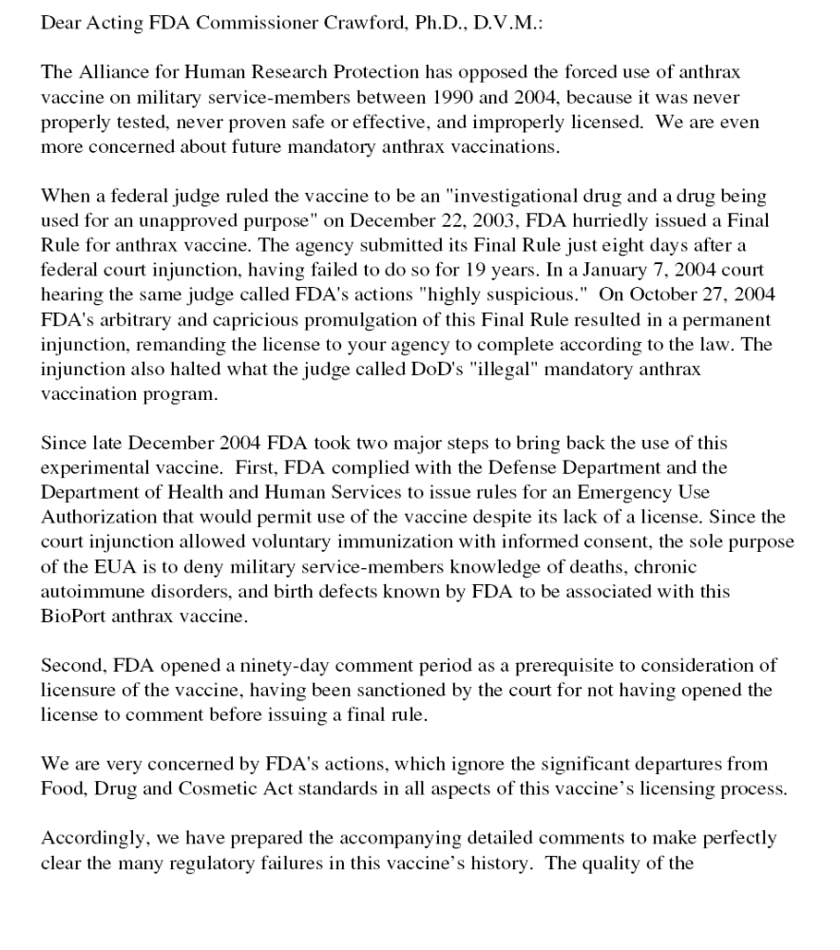
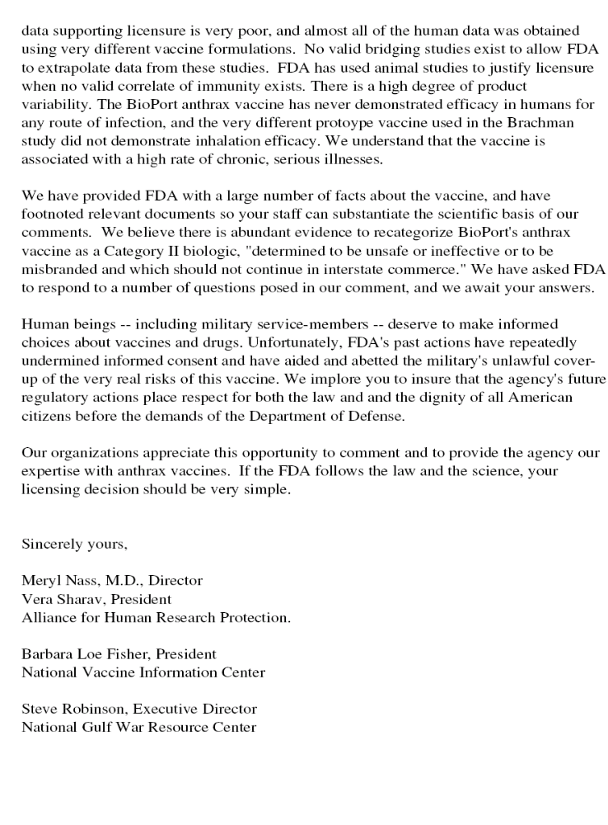
Comments and Questions regarding FDA’s proposed rule and order to license Anthrax Vaccine Adsorbed
http://www.anthraxvaccine.org/final_FDA_sub_32905.pdf

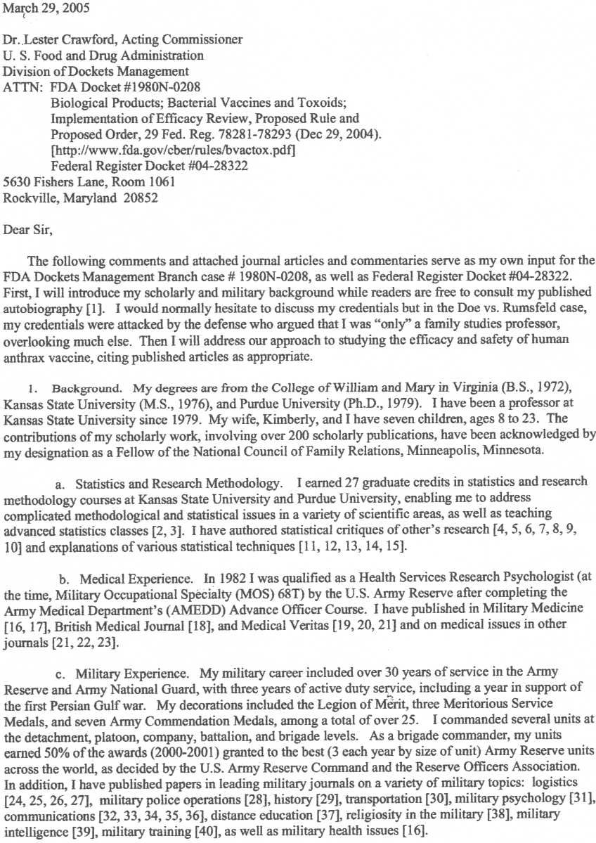
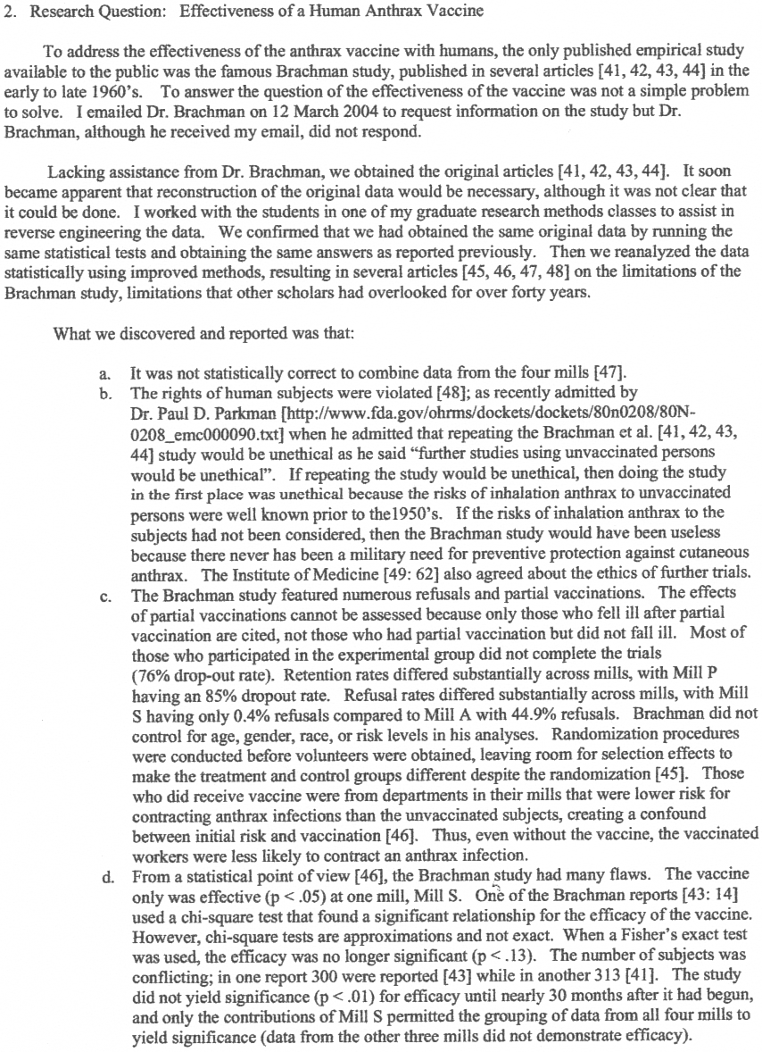

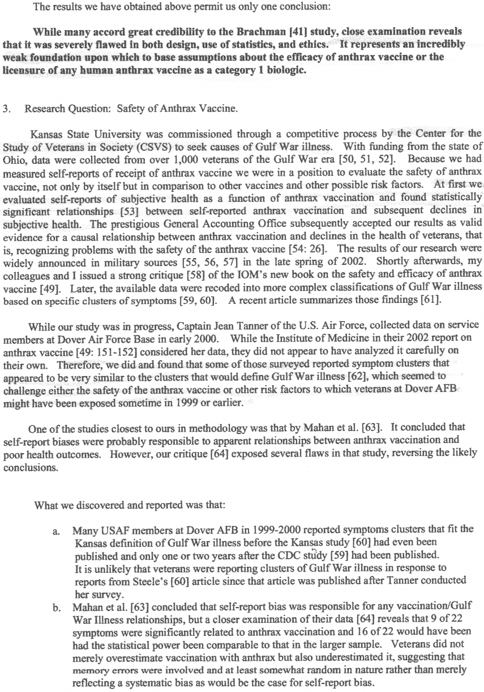
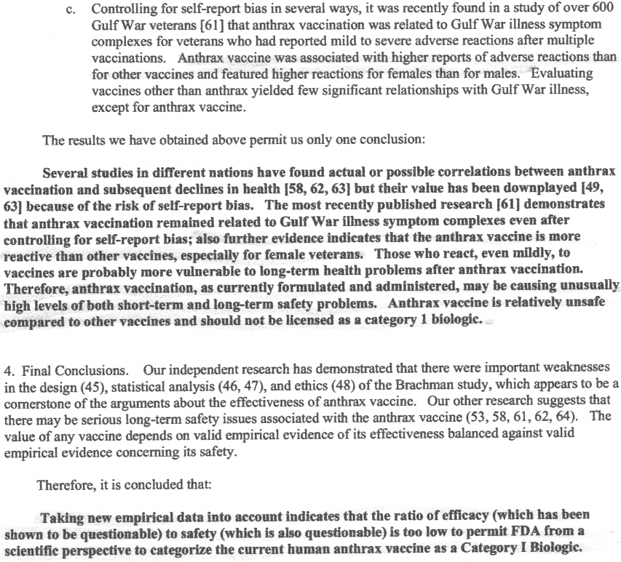

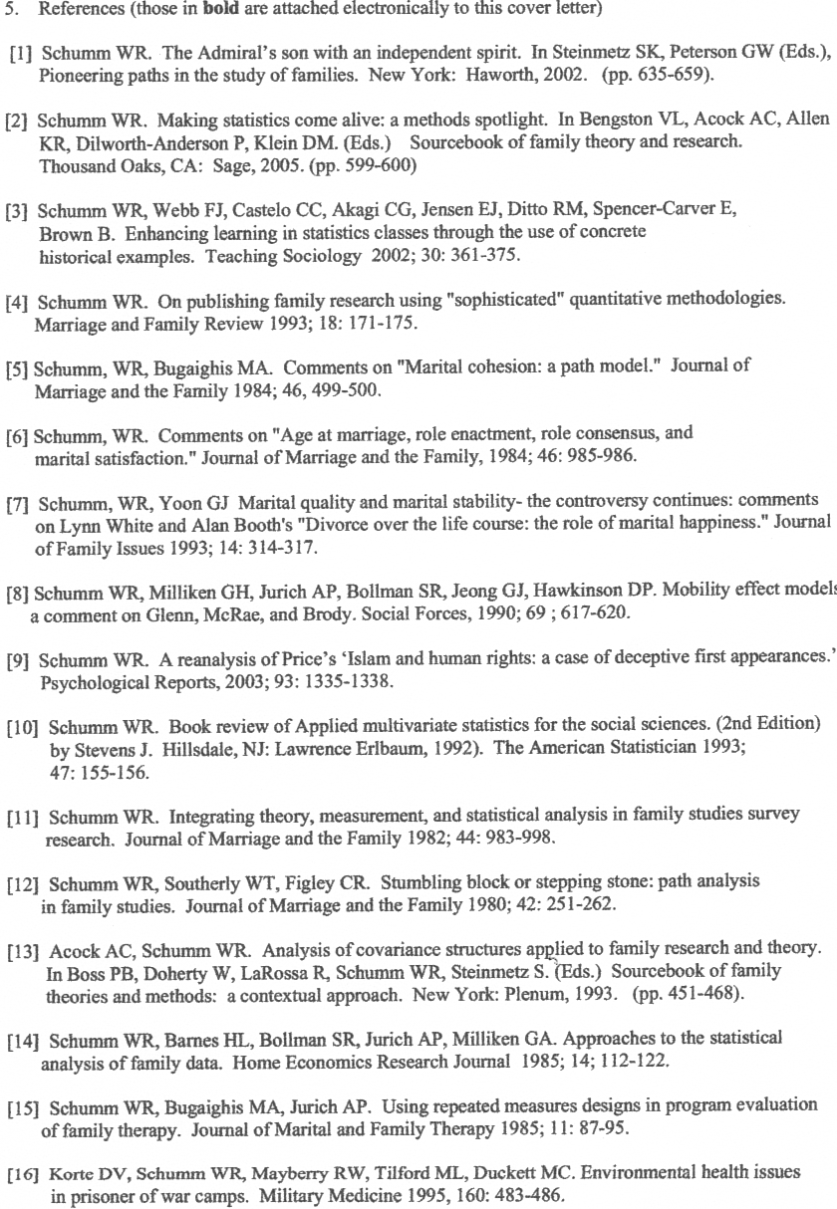
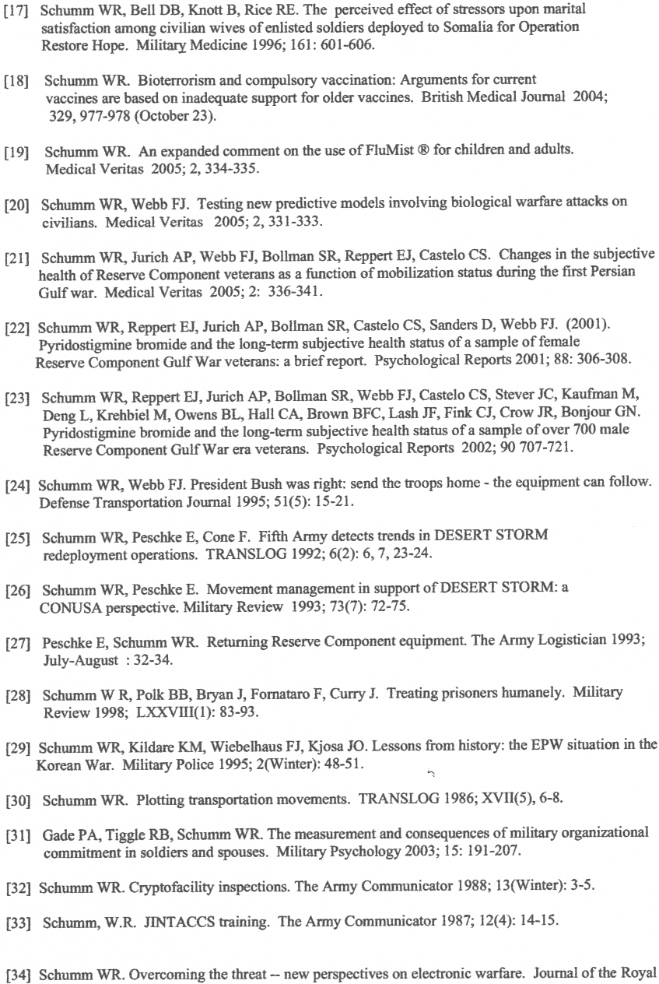
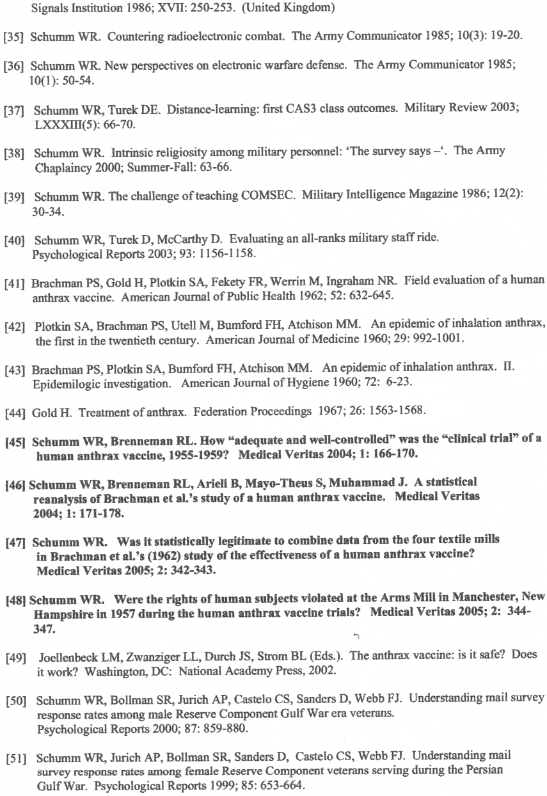
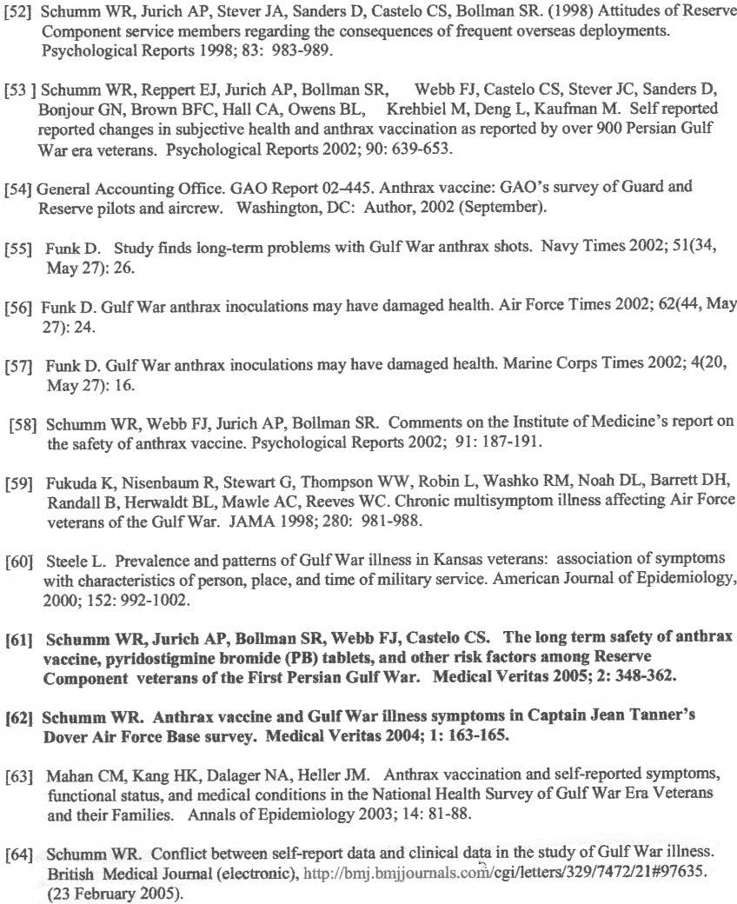

----- Original Message -----
From: Raymond Browne
To: fdadockets@oc.fda.gov
Sent: Sunday, March 13, 2005 10:17 PM

Dear FDA and all others concerned,

I am writing to you under Docket No. 1980N-02. I am a physician who is gravely conerned about the present status of mandatory administration of the Anthrax vaccine to our soldiers. I believe it is imperative that the FDA mandate the anthrax vaccine to be given only on a voluntary basis with the appropriate infromed consent. This should be a permanent mandate.

The 1985 expert review panel's suggestions and the actions taken by the FDA thereafter concerning the anthrax vaccine are obsolete. Since the mandatory anthrax vaccine program began in1998, thousands of military personnel have become disabled from the anthrax vaccine. Thus, with all this data regarding the potental pernicious side effects of the anthrax vaccine, it is imperative that the FDA reasses their previous recommendations.

I have seen statistics indicating that between 5 and 35% of our military have had adverse systemic reactions to the anthrax vaccine. In the general population, anything
greater than 1% would necessitate pulling the vaccine. How can you mandate that this vaccine be administered to anyone with the infromation we now have regarding it's potential side effects?

My sincere hope is that you will carefully re-examine this issue and make the right decision regarding the health of the men and women who so courageously defend our country.

Sincerely yours,

Raymond J. Browne, M.D.

March 15, 2005
FDA
Division of Dockets Management
Attn: Astrid Szeto
5630 Fishers Lane
Rm. 1061
Rockville, MD 20852
Protecting Our Guardians
William W. Arnold, Jr.
1741 Kensington Road
Homewood, Alabama 35209
Dear FDA and all others concerned:
I am writing to you under Docket No. 1980N-0208 because I am a veteran and I am also a friend of current military personnel. I am shocked and outraged that my friends and other defenders of our freedom are being forced, against their will, to be injected with a so-called preventive anthrax drug which has been shown to be dangerous to their health and which has not been positively proven to be effective against this dread disease! It is imperative that the FDA mandate the anthrax vaccine to be given only on a voluntary, informed consent, basis -- and not just temporarily, but permanently. The 1985 expert review panel's suggestions and the actions taken by the FDA thereafter concerning the anthrax vaccine are obsolete in the face of new developments and new science. A new expert panel must be formed by the FDA to investigate the reactogenicity of this dangerous,adulterated, drug/product before more military members are harmed/poisoned/killed/disabled/endangered.
Maj. Reid Armistead of Birmingham, Alabama, and his wife, Marguerite Majilton Armistead, are dear friends of mine. I am enclosing a copy of Marguerite's letter of January 29, 2005, to you. We insist that you honor the detailed concerns.
Yours truly,
William W. Arnold, Jr.

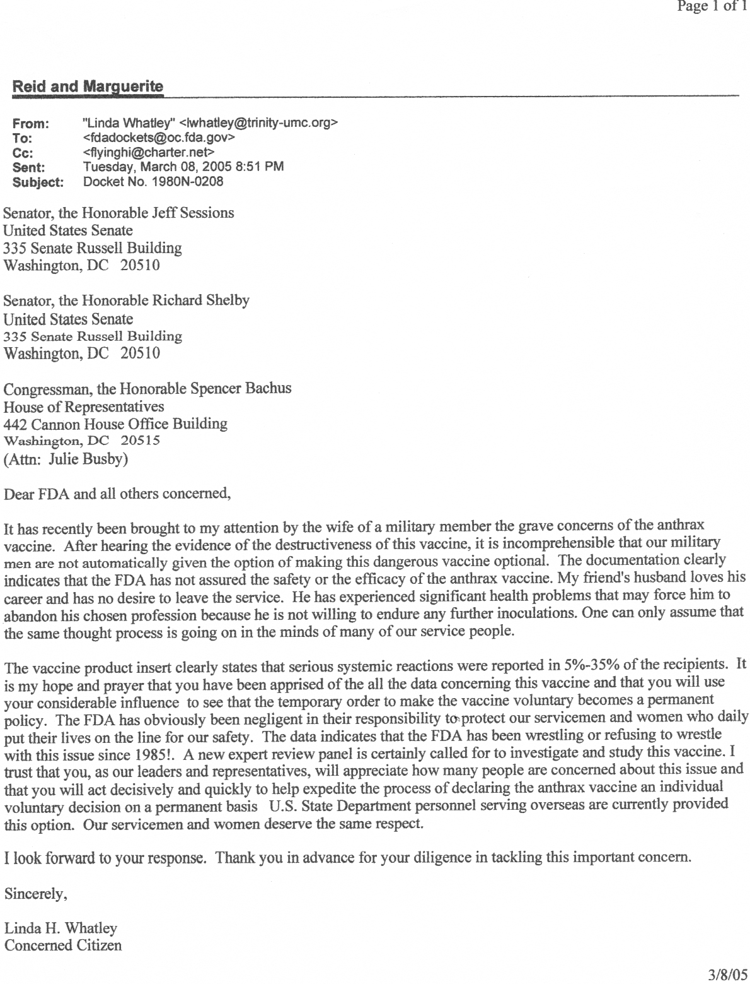

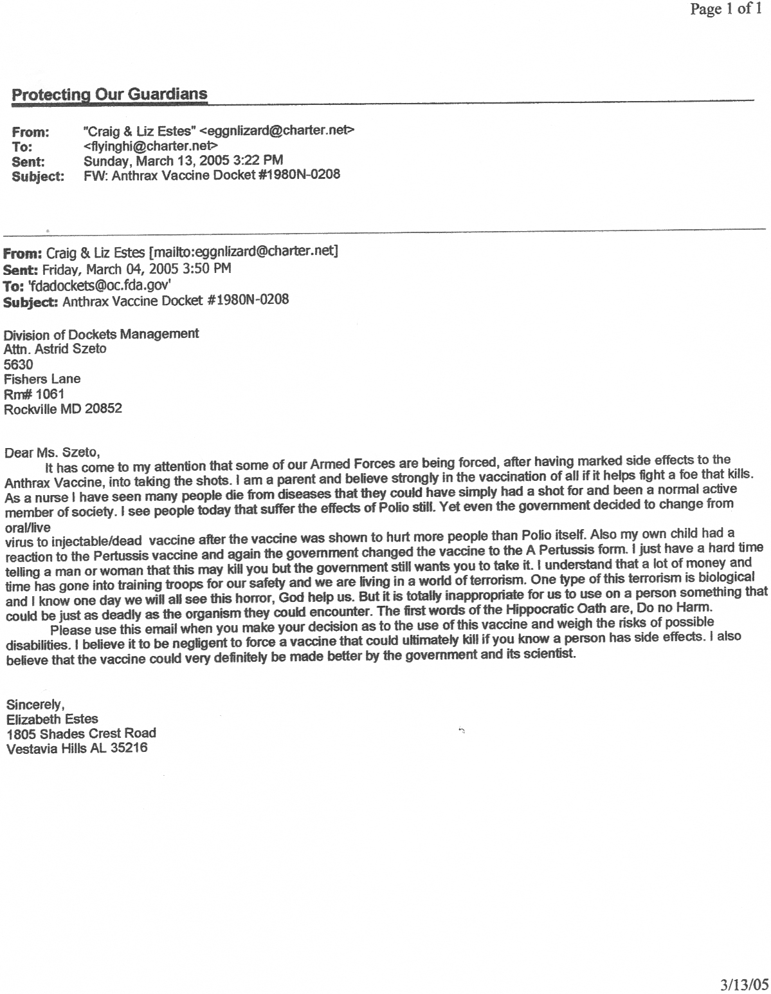
February 23, 2005
FDA
Division of Dockets Management
Attn: Astrid Szeto
5630 Fishers Lane
Rm. 1061
Rockville, MD 20852
Protecting Our Guardians
Paula Veldhuis
Laboratory and Research Specialist, Data Analyst
University of Virginia
Department of Pharmacology
Dear FDA and all others concerned,
I am writing to you under Docket No. 1980N-0208. I am a relative of a member of the US military who has become sick after his mandatory anthrax vaccine. I am extremely concerned that this vaccine is MANDATORY even though adequate clinical trials have not been performed. It is my opinion that the FDA mandate the anthrax vaccine be given only on a voluntary basis. Also, a new expert panel must be formed by the FDA to investigate the reactogenicity of this product before more military members are endangered.

The 1985 expert review panel and the actions taken by the FDA in response to that review panel are obselete/irrelevant in light of new data and new medical developments. The FDA's actions have obviously been insufficient because look where we are today -- lawsuit central.
- FDA's notice claims to see the need for
continual reevaluation of research priorities and objectives [in the face of new discoveries and concerns] to assure their relevance to current concerns. The FDA recognizes the Panel's desire to have FDA's research program evolve with the significant issues and findings of medical science. …This goal includes a plan to assure that CBER's research program continues to support the regulatory review of products and timely development of regulatory policy, and to have a significant impact on the evaluation of biological products for safety and efficacy.
However, in reality, the FDA appears to be avoiding a thorough investigation of all the "new discoveries" and "new concerns", and the new "findings of medical science," on the anthrax vaccine product which must be conducted by a new, 2005, expert review panel. The past 19 years of controversy have generated more data for "regulatory review" and "regulatory policy" as to this biological product's "safety and efficacy." The FDA appears to be short-cutting the court order by Judge Sullivan. The FDA notice states, "FDA is not considering comments on the Panel's report in this proposed rule and proposed order," but rather comments "on FDA's responses to the Panel's report, not on the Panel's report directly" -- which concerned numerous bacterial vaccines, not just the anthrax vaccine.
Since the mandatory anthrax vaccine immunization program (AVIP) began in 1998, thousands of military members have become disabled from the anthrax vaccine. News reports reveal that between 7 - 10 people have died from this hazardous vaccine. When the anthrax vaccine makes 5-35% of our 2.4 million military members have adverse systemic reactions, how can our nation possibly be safe and secure? We are talking about 120,000 to 840,000 people. This is not national security. This is a vulnerability in our national defense.

The link to the anthrax vaccine product insert is http://www.fda.gov/cber/label/biopava0131022LB.pdf
- The product insert states:
Across these studies, systemic reactions were reported in 5-35% of vaccine recipients and included reports of malaise, chills, rashes, headaches and low-grade fever.
...Pregnancy
PREGNANCY CATEGORY D
.... Approximately 6% of the reported events were listed as serious. Serious adverse events include those that result in death, hospitalization, permanent disability or are life-threatening. The serious adverse events most frequently reported were in the following body system categories: general disorders and administration site conditions, nervous system disorders, skin and subcutaneous tissue disorders, and musculoskeletal, connective tissue and bone disorders. Anaphylaxis and/or other generalized hypersensitivity reactions, as well as serious local reactions, were reported to occur occasionally following administration of BioThrax. None of these hypersensitivity reactions have been fatal.
Other infrequently reported serious adverse events that have occurred in persons who have received BioThrax have included: cellulitis, cysts, pemphigus vulgaris, endocarditis, sepsis, angioedema and other hypersensitivity reactions, asthma, aplastic anemia, neutropenia, idiopathic thrombocytopenia purpura, lymphoma, leukemia, collagen vascular disease, systemic lupus erythematosus, multiple sclerosis, polyarteritis nodosa, inflammatory arthritis, transverse myelitis, Guillain-Barré Syndrome, immune deficiency, seizure, mental status changes, psychiatric disorders, tremors, cerebrovascular accident (CVA), facial palsy, hearing and visual disorders, aseptic meningitis, encephalitis, myocarditis, cardiomyopathy, atrial fibrillation, syncope, glomerulonephritis, renal failure, spontaneous abortion and liver abscess. Infrequent reports were also received of multisystem disorders defined as chronic symptoms involving at least two of the following three categories: fatigue, mood-cognition, musculoskeletal system.
Reports of fatalities included sudden cardiac arrest (2), myocardial infarction with polyarteritis nodosa (1), aplastic anemia (1), suicide (1) and central nervous system (CNS) lymphoma (1).

- The FDA notices admits the anthrax vaccine "has not been employed in a controlled field trial." It is unacceptable to license a vaccine for mandatory use by millions of people that has not had a proper controlled field trial. Even the 2002 report from the Institute of Medicine admits that "data are limited." The anthrax vaccine needs to be tested on a large control group to see what the long and short term effects are, what the effects on the offspring are, and in what ways it effects immune-systems. Some answers are long overdue in this matter.

- The scientific community bases the safety and efficacy of the anthrax vaccine on a study from the 1950s and 60s, the Brachman study. However, in 2004, Dr. Walter R. Schumm of Kansas State University published several reports (in Medical Veritas 1, pages 163-178) that debunked the Brachman study. He can be contacted at his office, 785/532-1494.

- The anthrax vaccine license must be revoked because it is illegal. The old anthrax vaccine was made from a different strain of bacteria (the FDA notice says it was "a mutant of the Vollum strain," but is now a vague culture from a cow in FL). The new anthrax vaccine is also made from a different manufacturing process and has an altered formula. The old anthrax vaccine was intended for use among about 20,000 livestock handlers and veterinarians, but the new one is mandatory for 2.4 million military members. The old vaccine was intended to protect against cutaneous exposure, but the new use of the vaccine is against inhalation anthrax. Yet the new anthrax vaccine is being given under the license for the old vaccine formula. Therefore, a new license is in order for this very different product with a very different purpose/application.

- According to Sammie Young, a former FDA inspector for decades, the anthrax vaccine was never made or approved for inhalation anthrax. He also said that FDA regulations were broken when Bioport shipped the anthrax vaccine in interstate commerce because it was "adulterated."

- These unapproved alterations of the anthrax vaccine were reported to the FDA in a Citizen Petition filed on Oct. 15, 2001 (Docket: 01P-0471 Issue the NFR Placement of Anthrax Vaccine as Category II). The FDA took approximately a year to respond to the Petition and did not hold the DoD or BioPort accountable for their illegal actions. This is unacceptable! The FDA must do its job, instead of waiting for the courts to settle the matter. The Citizen Petition was also sent to the General Accounting Office, which confirmed the concerns in a report of its own (http://www.gao.gov/new.items/d02181t.pdf).

- The anthrax vaccine, and all future drugs, must be voluntary on a permanent basis -- not mandatory. That is to say, the anthrax vaccine must only be given with informed consent. Then, if a military member suffers an adverse reaction s/he can stop the 6 shot regimen without sacrificing his/her career, and before the next shot leads to disability or death.

- The FDA notice claims to welcome "comments on how appropriate informed consent and protection of human subjects can be maintained while assuring that the development and study of useful products is not inhibited." To quote Barbara Loe Fisher, "If we value individual human life, then as a society, we'll not place ourselves in the position of demanding risk-taking and sacrifice of a minority of individuals for the theoretical benefit of the majority, even if we have the power to force that sacrifice." If the FDA really values individual human life, it will preserve the right to informed consent and protect human subjects.

The scientific justification for a voluntary anthrax vaccine is that everyone's immune system is unique. People's biochemistry varies from person to person, varies with age, and varies with gender. Because of such diversity, people react differently to drugs and vaccines. For instance, children receive different vaccine dosages and have pediatric medicines made just for them. In the case of the anthrax vaccine, Ret. Lt. Col. Heemstra asserts that women have a reaction rate two to three times higher than men (see "Information Paper for America's Policy Makers" by Rempfer and Dingle, W. Suffield, CT, Oct. 26, 1999, p. 7). In a DOD meeting in May 1999, Dr. Renata Engler, Colonel, Chief of Allergy-Immunology Dept. at Walter Reed Army Med. Center, acknowledged that there are sex and age differences in vaccine reaction. She went on to say that "since women do tend to be the bulk who get autoimmune disease," women in the military who have strong reactions should be checked "early" for a predisposition to autoimmune disorders that could be triggered by this [anthrax] vaccine" (see Sheila Weller's article in Self, Oct 2001, p.220). Women comprise approximately 16% of the military. These differences in biochemistry and immunity must be taken into consideration. As Barbara Loe Fisher said in 2001, at a conference in Washington, DC, it is imperative to study the biological predispositions and mechanisms that lead to adverse reactions, vaccine injury, and death. Fisher also recommended more funding go into the research arm of the FDA. It unlawful, unreasonable, irresponsible, and reckless for the FDA to allow any vaccine or drug to be mandatory, administered without informed consent, across the board. One size does not fit all. Thus, the FDA must insist that individuals make their own choices under the supervision of their own doctors.

In conclusion, the facts indicate that FDA action to protect the military and the public from the anthrax vaccine is long overdue. A sick military cannot defend democracy. The FDA needs to do three things: conduct a new expert review panel to do thorough testing and to look at the new medical developments concerning just the anthrax vaccine, not 40 others; fix the licensing fraud so that the new, and very different, version of the anthrax vaccine is not using the license for the old version; and mandate that the anthrax vaccine only be given on a voluntary basis, permanently. Our military members deserve the right to have informed consent concerning what is put into their bodies. Thank you for the opportunity to take a stand for what is right and decent and reasonable in this vaccinenightmare.

Sincerely,
A concerned citizen,

Paula Veldhuis
Laboratory and Research Specialist, Data Analyst
University of Virginia
Department of Pharmacology

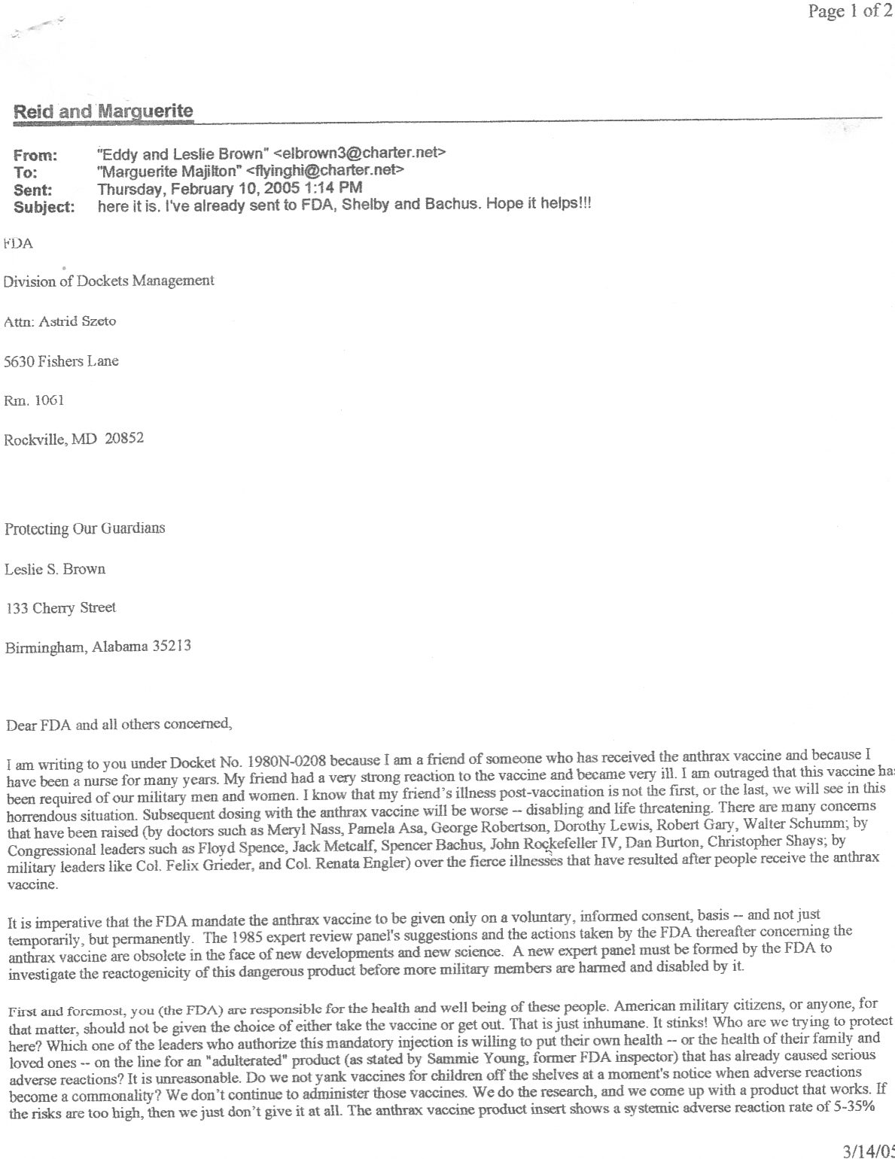

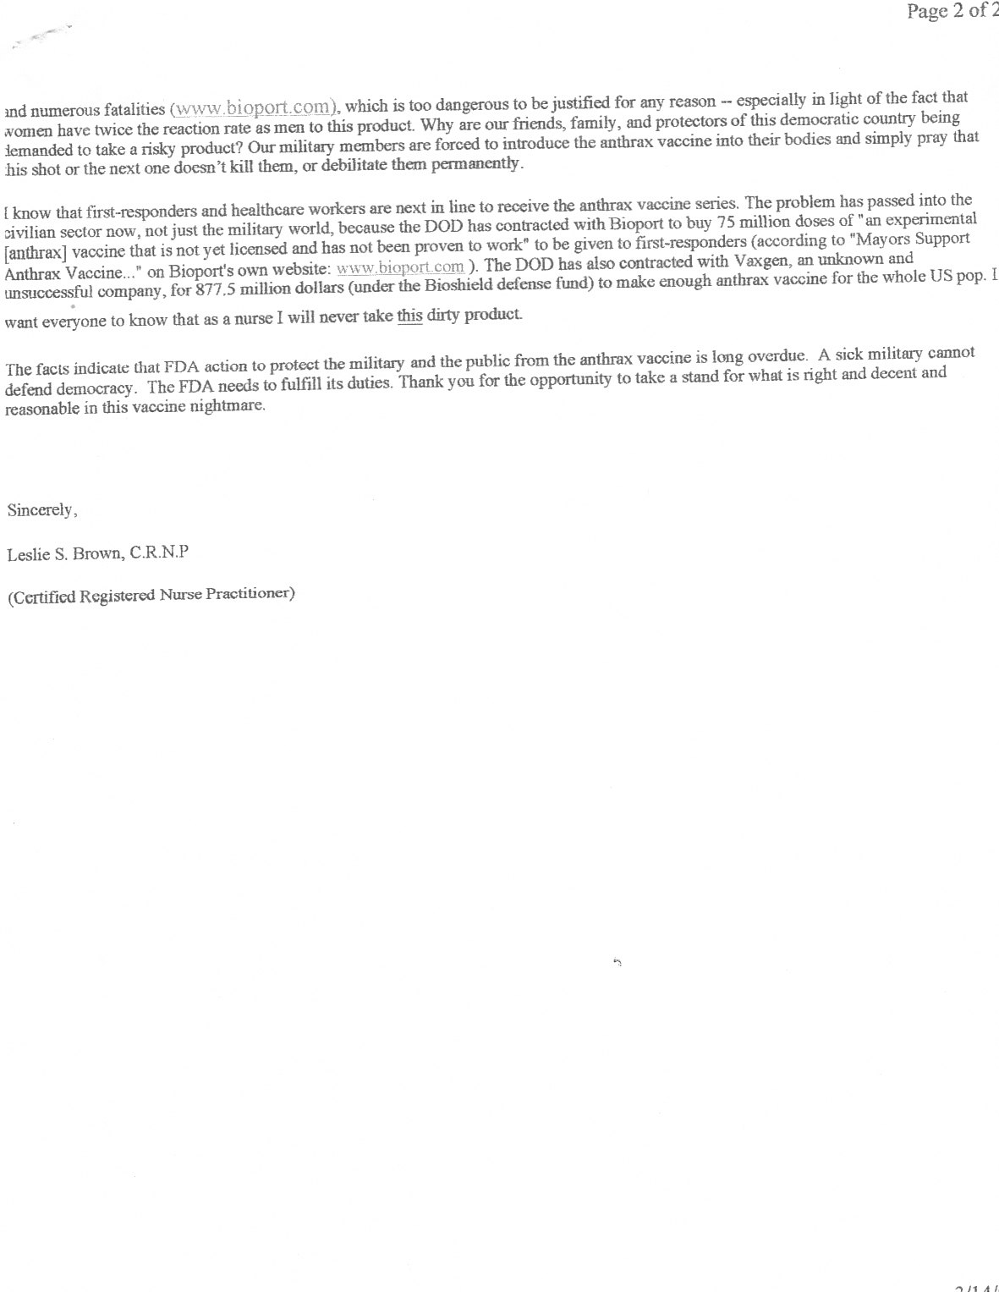

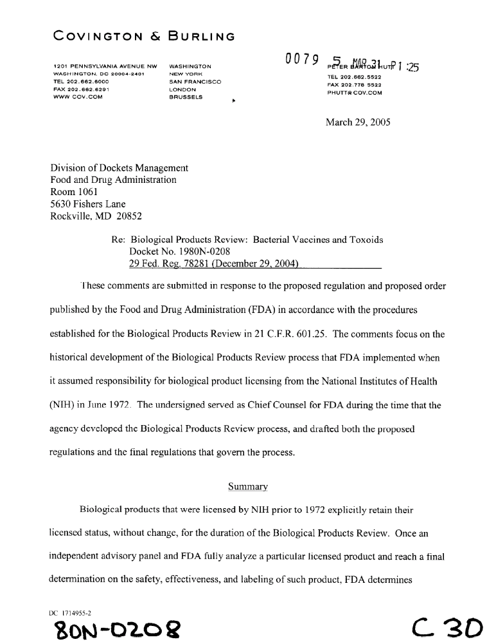

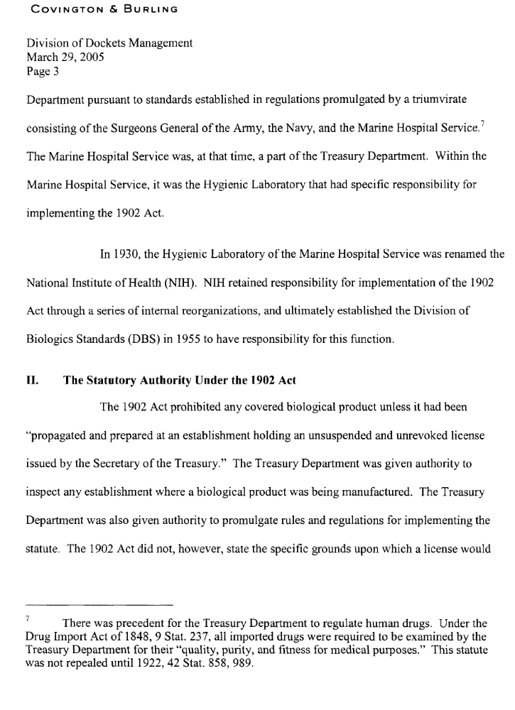

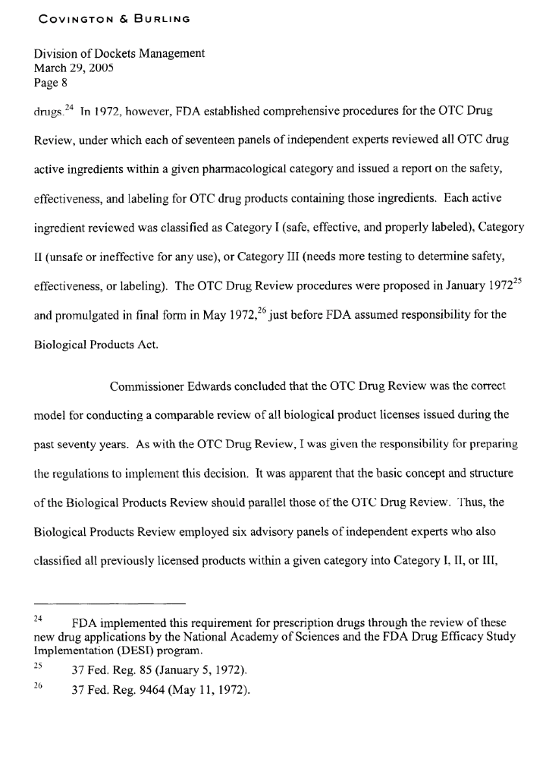

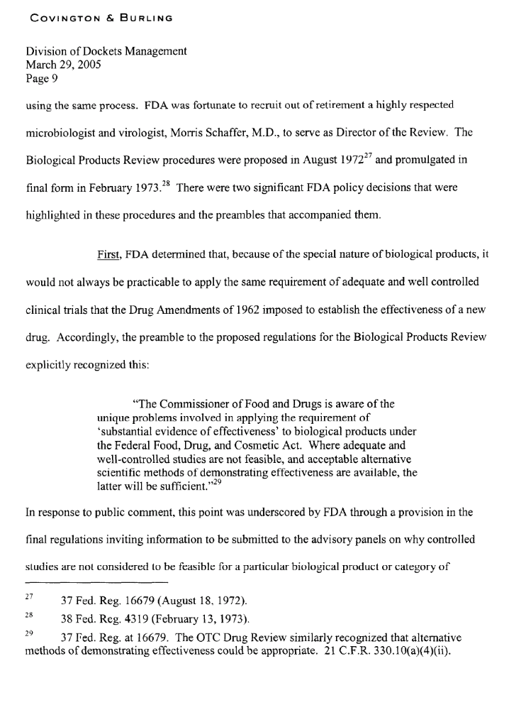

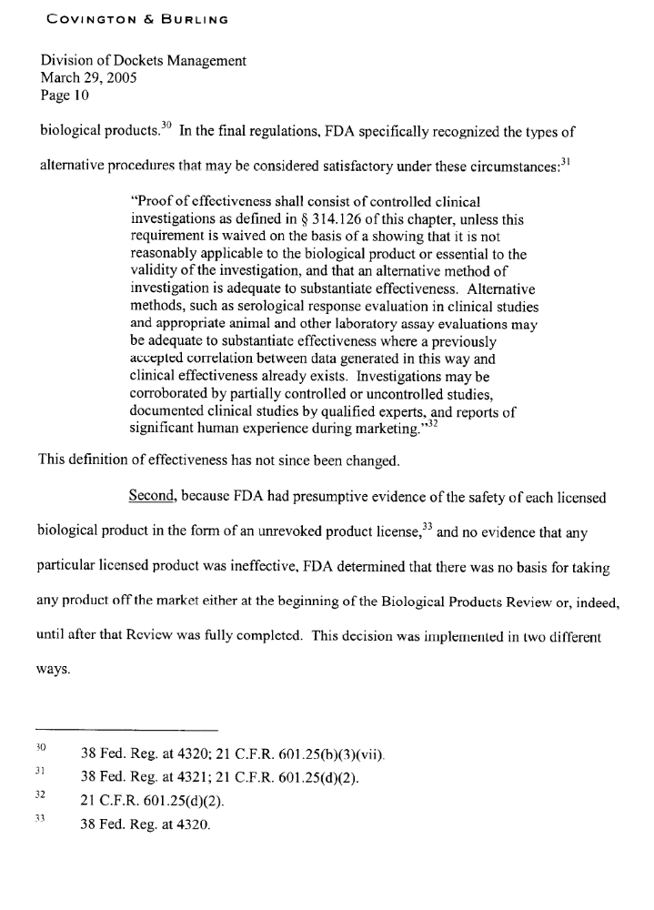
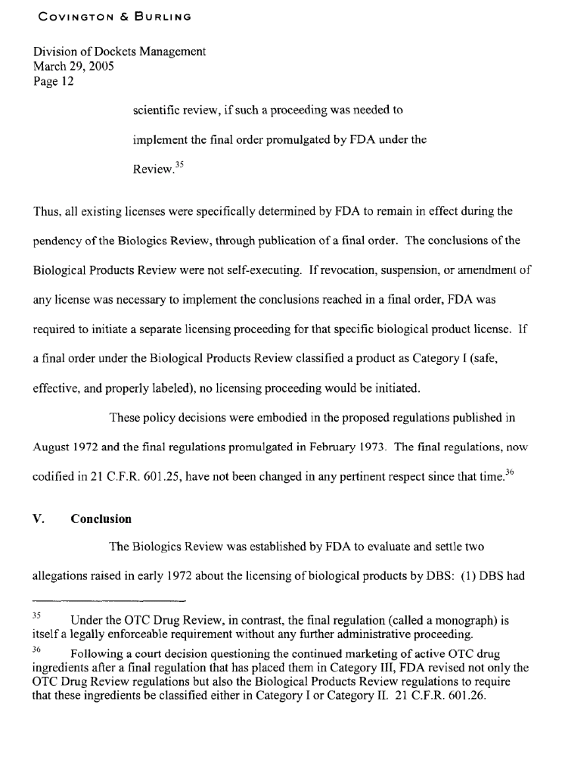

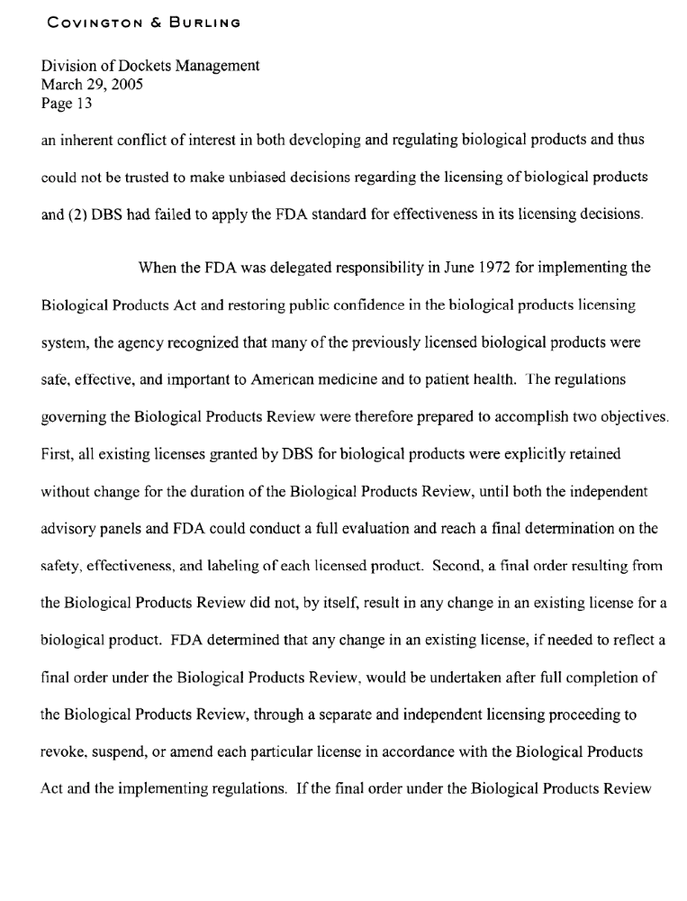

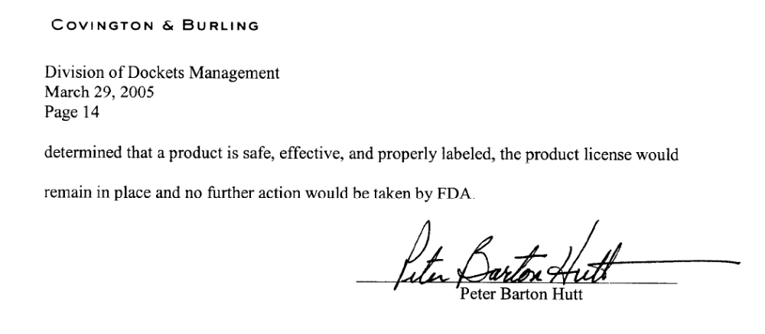

In spite of all the letters sent in during the FDA’s 90-Day comment period, the FDA went ahead and approved the anthrax vaccine:

http://www.foxnews.com/story/0,2933,178890,00.html


FDA: Anthrax Vaccine Given to Military is Safe, Effective
Thursday , December 15, 2005
WASHINGTON —
The Food and Drug Administration on Thursday confirmed its previous finding that the anthrax vaccine being given to members of the U.S. military is safe and effective.
The drug has been at the center of a multiyear lawsuit that began when six members of the military challenged the Pentagon's use of a mandatory vaccination against anthrax in some military troops.
Published in the Federal Register Thursday, the FDA review on the Anthrax Vaccine Absorbed, or AVA, "determines AVA to be safe and effective and not misbranded."
FDA spokeswoman Julie Zawisza said the agency found no evidence to alter its previous determination that the vaccine was safe.
"We believe the vaccine is safe and effective for intended use, which would include (prevention of) inhalation anthrax," she said. The agency also received public comments about the vaccine, but Zawisza was unable to characterize them Thursday.
Since 1998, 1.2 million troops have been vaccinated against anthrax in six-shot regimens. Hundreds of service members had been punished or discharged for refusing them until U.S. District Judge Emmet Sullivan in December 2004 suspended the vaccinations after he found fault in the FDA's process for approving the drug. Several months later Sullivan said the Pentagon can resume giving vaccinations, but only to troops who volunteer for them.
Thursday's findings were the result a court-ordered review of the drug.
Earlier this month, the Bush administration appealed to reinstate mandatory inoculations for many military personnel.
Dr. William Winkenwerder, Assistant Secretary of Defense for Health Affairs, released a statement saying the military will continue to provide anthrax vaccines on a voluntary basis. Service members will still be able to refuse the vaccines.
"The threat of anthrax as a weapon remains real. It is very important to provide our service members with maximum protection against this threat, particularly when operating in certain areas of the world," he said.
He added that, "For people at increased risk of exposure, the benefits of the vaccine far outweigh the risks when all factors are considered. Vaccination against anthrax is the best round-the-clock protection available to protect our forces at risk."

http://online.wsj.com/article/SB117288538061625591.html
THE WALL STREET JOURNAL Report Blasts FDA's System To Track Drugs Consultant Says Mission Is Hobbled by Missteps; Agency Disputes Claims
By ANNA WILDE MATHEWS
March 3, 2007; Page A1
The Food and Drug Administration has bungled its effort to build a new system for detecting the side effects of medicines after they go on the market, delaying its implementation by at least four years, according to a report commissioned by the agency itself. As a result, the agency must continue to rely on its existing "dysfunctional" computer system as a primary tool for tracking the safety of medications sold in the U.S., according to the November 2006 report, which hasn't been made public. The situation is "frustrating and undermining...the post-marketing drug safety work" of its staff "because they lack some of the basic tools they need to perform their jobs, e.g. a computing system that meets their requirements," says the report. It was prepared by the Breckenridge Institute, a research and consulting firm in Breckenridge, Colo.
The FDA's drug-tracking system, called the Adverse Event Reporting System, consists of a database and other software and hardware that amass and help sift reports of potential side effects that have been filed by drug makers, doctors and others. The data are the FDA's main way to detect drug- related hazards, and can lead to changes in label warnings or even withdrawals of drugs from the market. But, the report says, FDA safety experts waste time -- an average of 45 minutes per day -- dealing with the inefficiencies and snags caused by the current software. The Adverse Event Reporting System is overwhelmed by the growing volume of adverse-event reports, which exceeds 400,000 a year, the report says. The FDA track record on drug safety has faced harsh scrutiny in the wake of major problems, including the 2004 withdrawal of the painkiller Vioxx after it was linked to cardiovascular problems. Such incidents underscore the importance of monitoring drugs after they go on the market, where some end up being prescribed to millions of patients. In clinical trials conducted before FDA approval, drugs typically are tested on thousands of people at most -- not enough to turn up every potential danger.
The FDA has sought to upgrade the technology used in its safety-tracking program for years. But efforts that date back at least to 2003 haven't produced the planned successor to the Adverse Event Reporting System, dubbed AERS II. Instead, the Breckenridge report says a new system isn't likely to be up and running until 2009 at the earliest, and that the FDA has wasted an estimated $25 million on its efforts. The report argues that the FDA could have had a new Adverse Event Reporting System working in 2005 if it had simply relied on off-the-shelf software.
A document prepared by FDA officials in response to the report, which is marked as a draft, said it is "riddled with editorial conclusions based on misleading or incorrect facts." Douglas Throckmorton, deputy director of the agency's drug center, said the current Adverse Event Reporting System "is a system that is working" despite "exploding" amounts of data. "Is it the best it can be? Of course not," he said. The FDA wants to develop a replacement"as quickly as anyone else does, but we want it to be done right."
Echoing other recent outside examinations of the FDA, the Breckenridge analysts say the "root cause" of the problems can be found in the culture of the agency's drug regulators. More specifically, the report largely blames a "lack of effective leadership and management" by the center's Office of Information Technology, which it says mishandled the initiative through bureaucratic infighting, flawed planning and duplicative work performed by outside contractors.
Mark Bodnarczuk, executive director of the Breckenridge Institute, said he stands by the contents of the document. After it was completed, the FDA asked him to delete much of it, he said: "What they asked me to do was gut the report, and I refused to do it." The FDA's Dr. Throckmorton said he believes Breckenridge was asked by FDA to extend its work, at no cost, which would have "given us an opportunity to talk about those misunderstandings, those inaccuracies."
FDA contracting practices, as well as the agency's handling of drug safety, are already the focus of congressional investigations. Senate Finance Committee Chairman Max Baucus, a Montana Democrat, and ranking Republican Charles Grassley of Iowa have sent a letter to the FDA about the computer-system issue. Mr. Baucus said the report raises "troubling questions," and Mr. Grassley said the report is evidence of a "broken- down process" at the agency. In the House Energy and Commerce Committee, Democrats John Dingell and Bart Stupak, both of Michigan, are also examining FDA contracting.
According to the Breckenridge report, the agency by June 2004 was considering moving forward with a package of off-the-shelf software. That potentially could have allowed AERS II to be up and running in 2005, at a one-time cost that had been projected at about $4.5 million, according to the report.
But, the report says, an official in the drug center's information-technology office in June 2004 advocated a different approach: a system that could track adverse events from all products regulated by the agency, such as medical devices, rather than just drugs. Later, the report says, the information-technology office commissioned further analysis, including assessments of what a new adverse-event tracking system would need, with some work done by contractors.
The need for the new analysis was questioned by officials who worked in drug safety at the FDA, who argued they "could not wait two more years...to repeat the process they had just completed," according to the report. That analysis was nonetheless carried out. The Breckenridge report contends it "did not add any value" and helped delay a new system.
The FDA's Dr. Throckmorton said the agency is already moving to address issues related to its safety culture. Yesterday, the agency formally unveiled its plan to publicize emerging safety issues on its Web site.
As for the delay of AERS II, Dr. Throckmorton said, "based on what I know, those timelines were caused by the complexity of it, the need to get it right, and the need to consider integration into a larger system," rather than by strategic or management errors. He added that the integrated approach was endorsed at high levels of the FDA. Generally, analyzing goals is "absolutely essential" in developing a good system, he said, adding that the FDA "considered" the earlier off-the-shelf software package and"rejected it."
[Non-text portions of this message have been removed]

